MEAN Stack Notes

Technologies

1. GIT
2. HTML
3. CSS
4. Javascript
5. ES6+
6. Typescript
7. Angular
8. MySQL
9. MongoDB
10. Node.js & Express.js
11. DevOps
12. Micro Front end
13. Case study.

GIT:

It is a version controlling system.

It helps to collaborate each others work in a team.

There will be two repositories in the GIT

1. Remote: Will have access to everyone
2. Local: Local to the particular individual

Git provides commands to update each others work

1. push: It tries to update the remote repository from the local repository
2. pull: It tries to update the local repository from the remote repository
3. clone: It creates a copy of remote repository in the local repository, it is done for the first time before you can enter push/pull
4. merge: It is used to manually merge the updates in the local repository from the local branch
5. add: It is used to add the changes to the staging area, only the changes in the staging area can be committed and pushed
6. commit: it is used to commit the changes, it creates one unique id which is used at the time of merging
7. status: It is used to see the changes done in the local repository, it shows the changes in the staging area and the changes not in the staging area

Git branches:

It is a pointer of particular commits, by default git gives you one branch called master/main branch, but every individual must work in custom branch not in the master branch

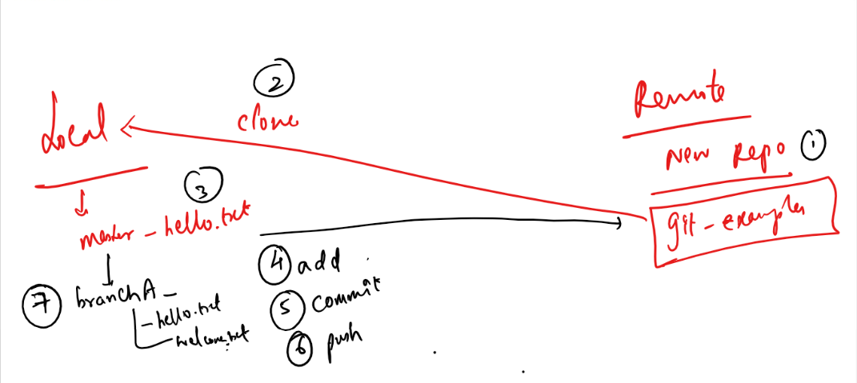

You must have a single .git folder which represents the git repository in the parent directory, but nested repositories you must not have ie.., an enclosing folder having .git and the sub folder also havening .git.

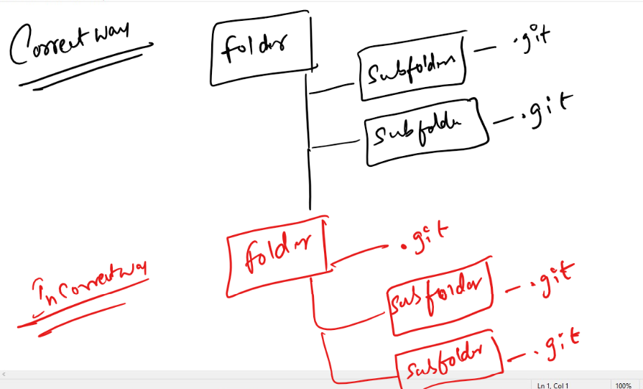

Steps to work with GIT

1. Create a GIT account & login
2. Create a remote repository & name it

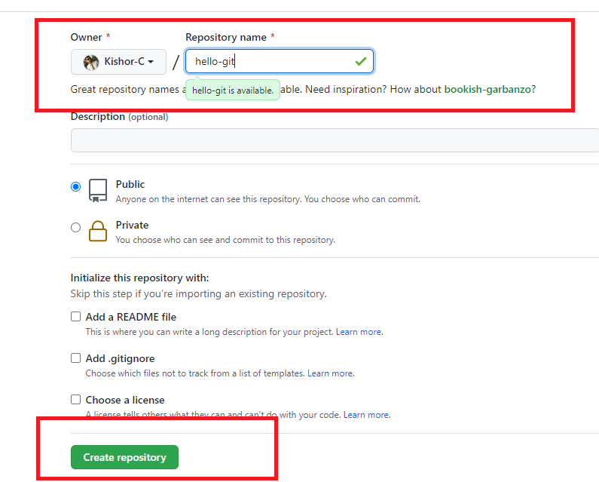

1. After you create the repository you will see the empty repository in the git website

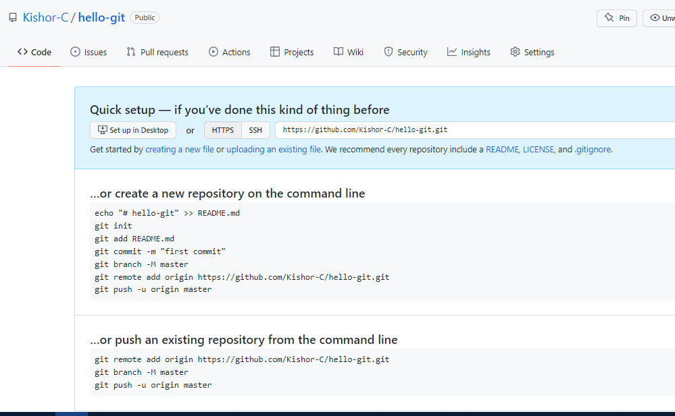

1. Clone the Remote repository in the local machine

Command: git clone URL

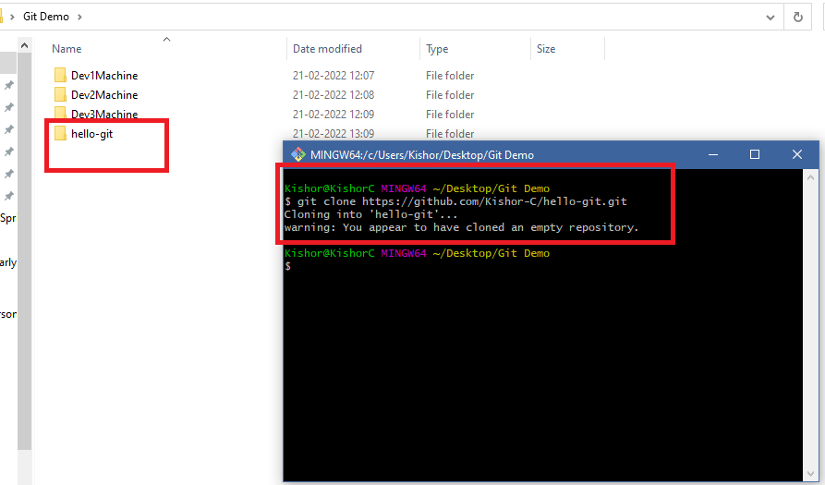

Note: You don’t see the branch name in the GIT bash, because you need to navigate to hello-git

1. Navigate to the local repository cloned

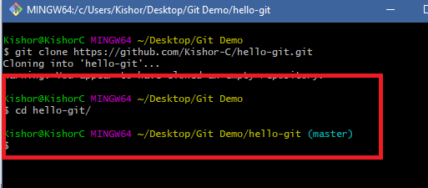

1. Create a custom branch when you want to do any changes/updates

Command: git branch branch_name

Command: git checkout branch_name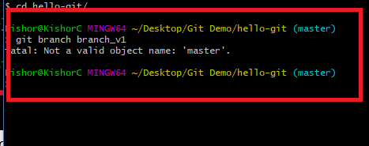

Note: You may get this fatal error, when there are not commits in the master, i.e., if its empty repository you can’t create branch

To avoid this in the master branch create 1st commit

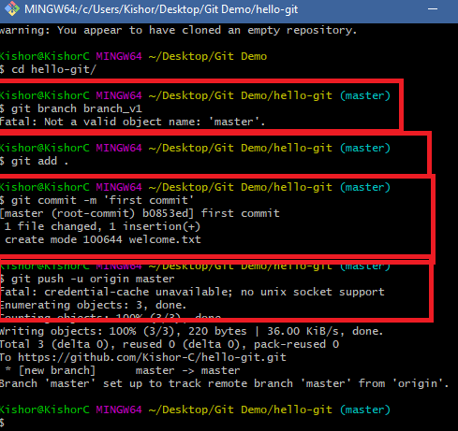

In the Remote you can see that first commit

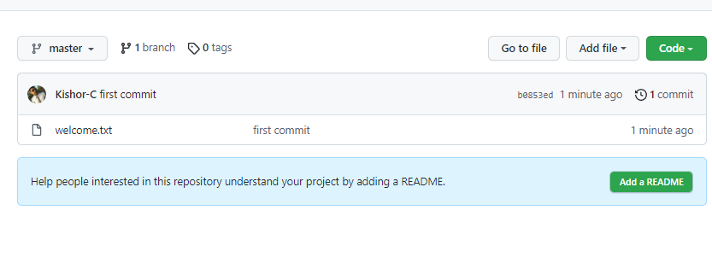

Note: It doesn’t ask you to create pull request, as we pushed master branch

1. Now we can create a custom branch and push that branch to the Remote repository

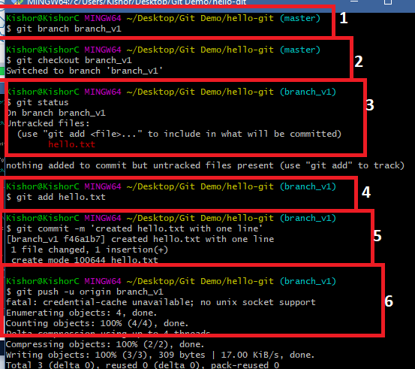

1. Now you can see a pull request in the Remote repository

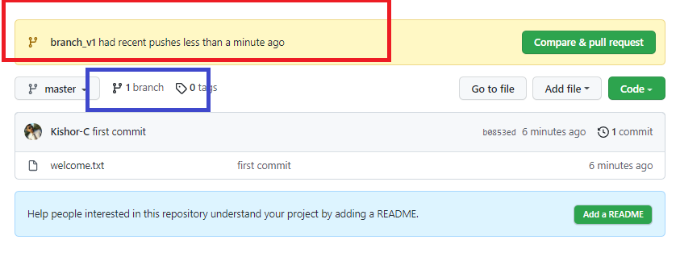

Note: Sometimes you may not see the recent push branch with Compare & Pull request, in that case you click on the branch highlighted in blue color

1. You can click on compare & pull request to update the remote or close pull request when there’s a conflict, in either of the case you must delete custom branch in remote repository.

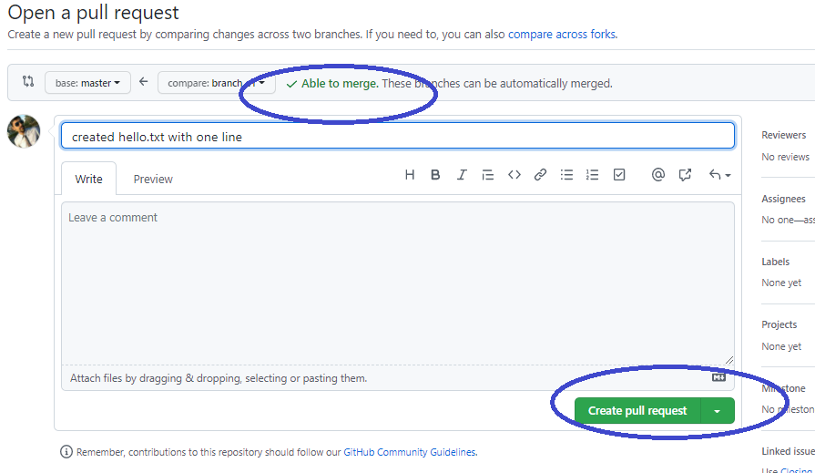

Merge the branch & delete

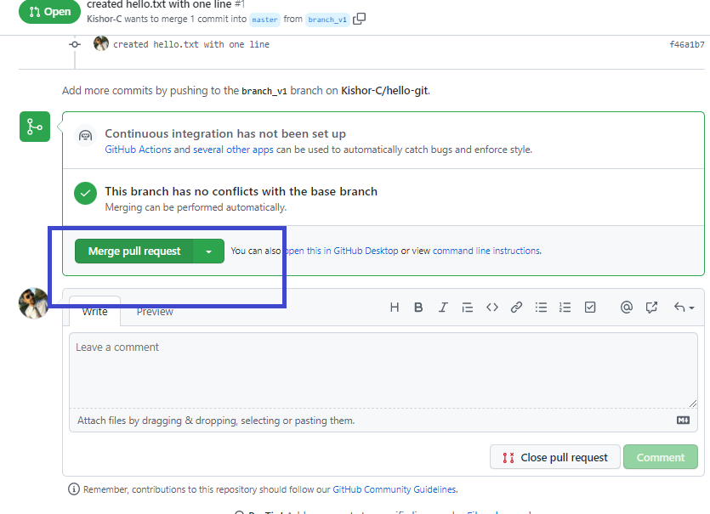

Delete branch

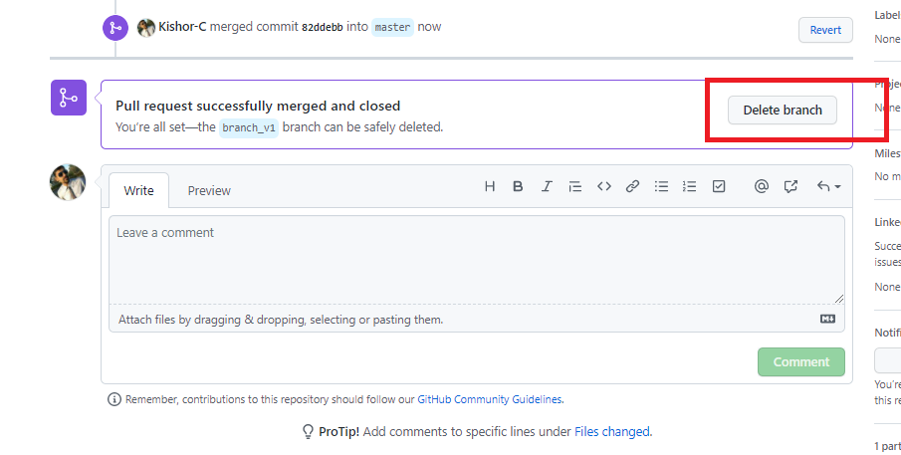

1. You can see the changes in the remote

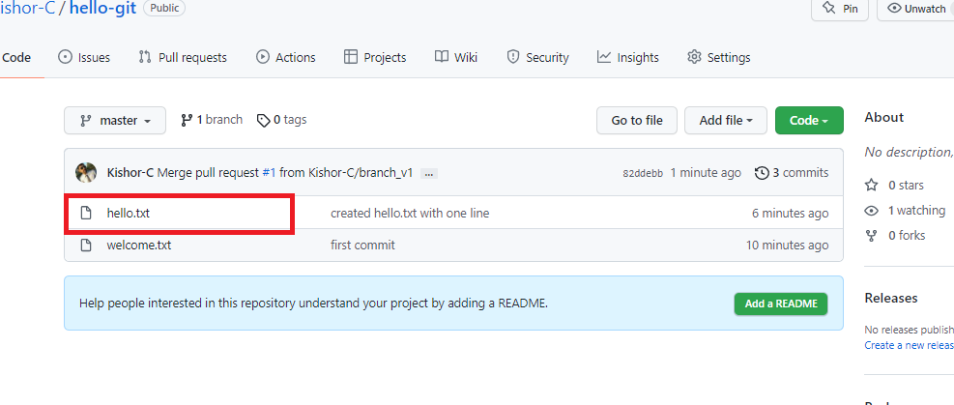

1. If you get a conflict then the local repository must pull the changes of master to its master branch, suppose for the below changes we get conflict when we try to update

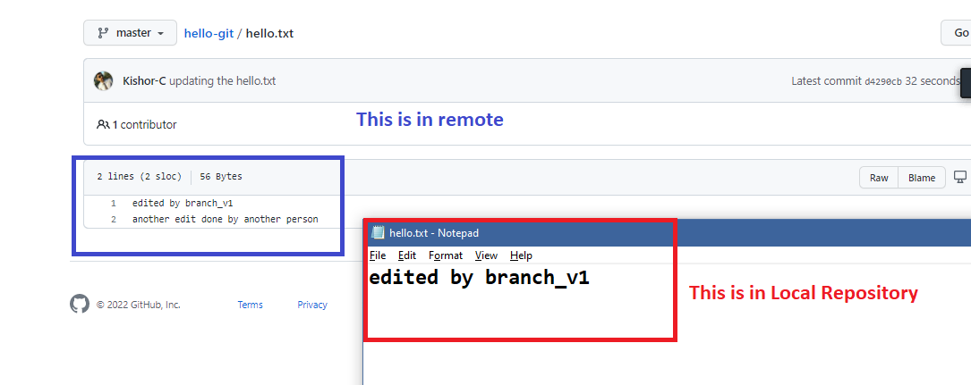

1. Add some content to the hello.txt & try to push the branch

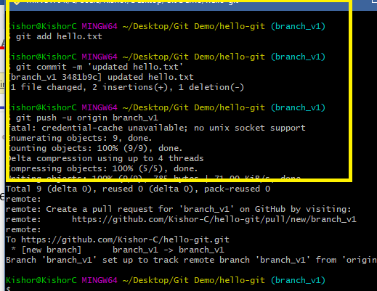

1. In the remote we see a pull request, but it can’t merge as remote master & the custom branch has conflict

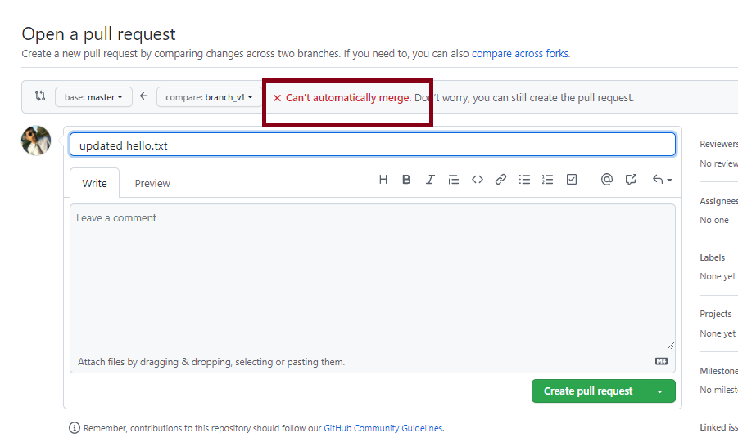

1. Close the pull request & delete the branch in the remote

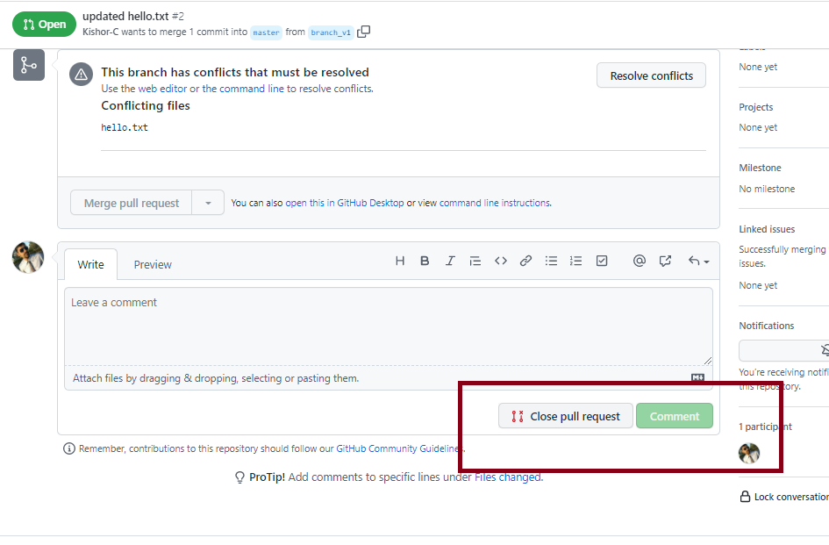

1. Local master must pull the remote master, then the custom branch should merge the local master and resolve the conflict
   1. Checkout to master: git checkout master
   2. Pull the remote master: git pull
   3. Checkout to custom branch: git checkout branch_v1
   4. Merge the master with custom branch: git merge
   5. You will get conflict, edit that file, add & commit & push, you will the conflict file as below:

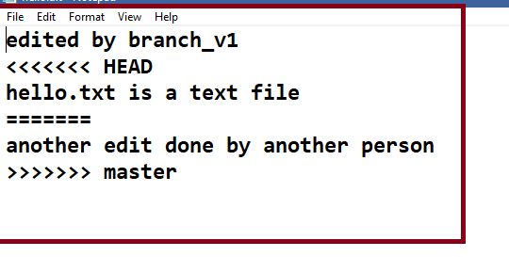

* 1. All the steps performed.

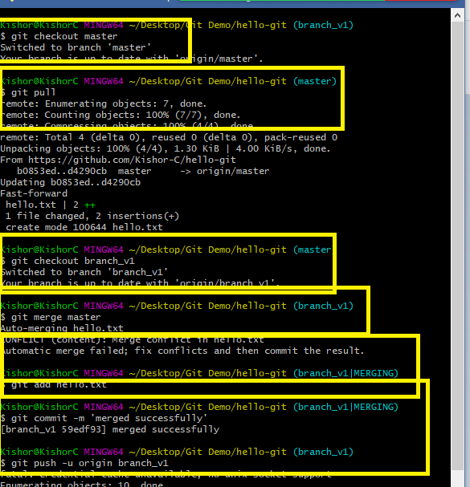

1. Now you can see the pull request in the remote

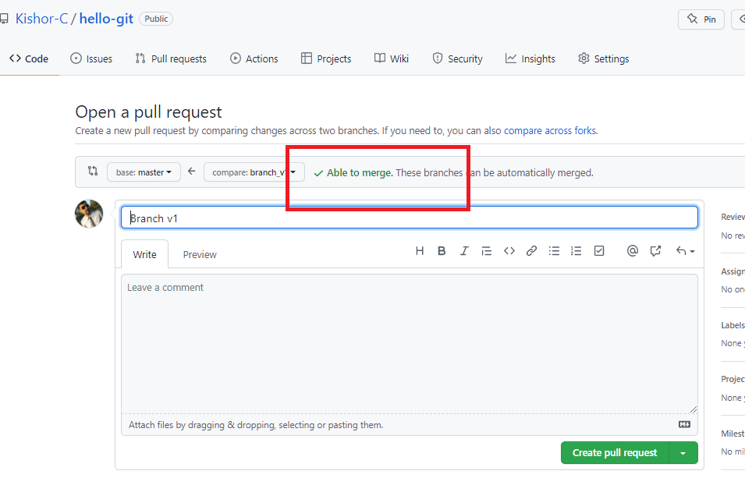

1. Create pull request & merge it and delete the branch in the remote, if required delete it in the Local also

Command: git branch -D branch_name

Note: Checkout to different branch to delete

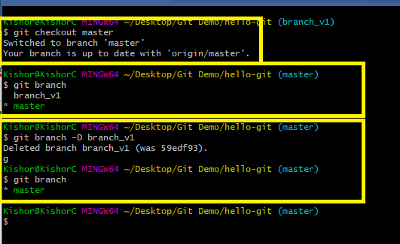

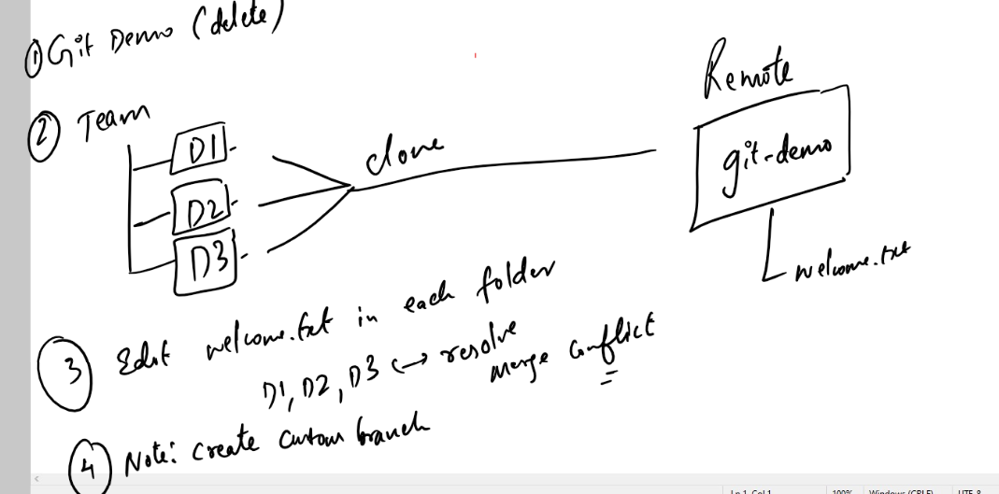

Summary:

1. There are 2 ways you can create the local repository
2. using git clone remote-url
3. using git init & add remote url in the local repository
4. Important commands of Git
   1. git clone: creates a copy of remote repository in the local machine
   2. git init: creates a local repository
   3. git log: shows all the commits done with date, time, message & author information
   4. git status: shows all the tracked & untracked updates
   5. git add: adds the update to the staging area
   6. git commit: commits the updates in the staging area
   7. git push: pushes the branch to the remote from the local repo
   8. git pull: pulls the branch from the remote to the local repo
   9. git merge: merges the branch with another checked out branch

.gitignore:

It is a file used by git to ignore the files/folders to be tracked.

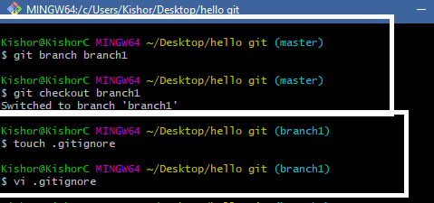

Add the content to .gitignore as mentioned below

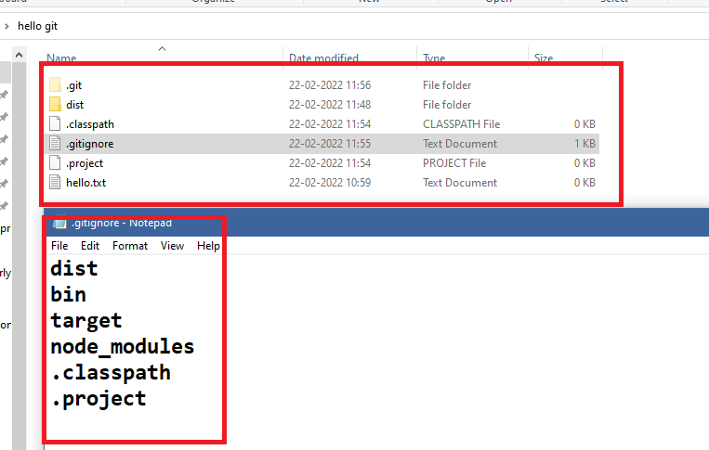

Create some folders and files like dist, .classpath, .project and so on in the local repository

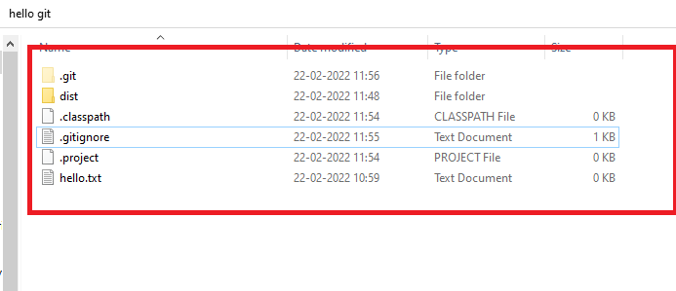

If you use git status you can see dist, .project & .classpath wouldn’t be tracked because its mentioned in gitignore

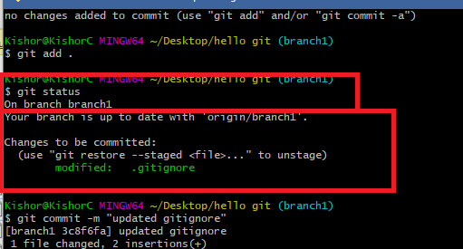

This .gitignore will be pushed to the remote, so that other developers would also get this file, it means everyone will have .gitignore file in their local machine, but the list of files/folders mentioned in the .gitignore wouldn’t be tracked at all from any machine.

Git Cycle

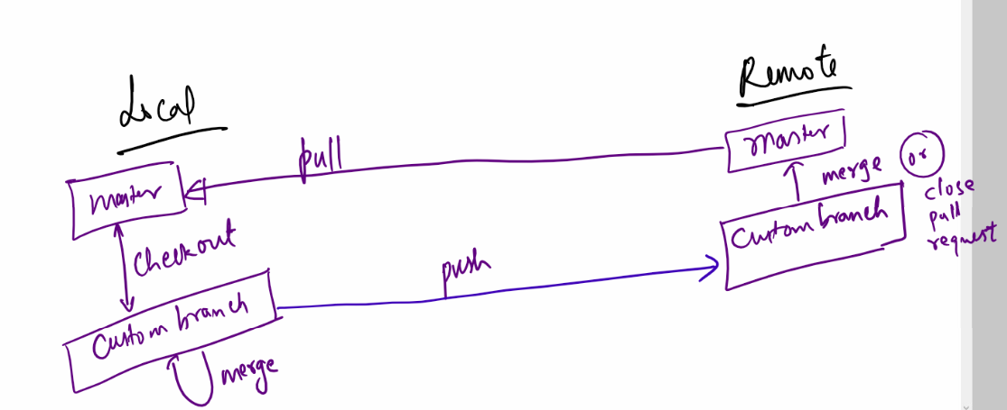

Git Organization:

It allows group of people to collaborate their work, only the members within group can update the repository inside the organization.

Steps:

1. Create the organization
2. Name the organization & fill all the details
3. Add the members by entering their username of git
4. Select the required options what you are going to with the organization, like manage code, collaborate work, team-size and so on
5. Change the role of members to owner.
6. Create one repository which all these members can access.

Activity

1. Create a team of 5 members (Trainer will do it)
2. Choose a team leader (Trainer will do it)
3. Team leader must create organization
4. Team leader will add members & members will accept the invitation
5. Team leader will change each members role
6. Team leader will create a repository
7. Team leader will create a file called hello.txt & pushes the master to the remote
8. Everyone in the team including the team leader edits hello.txt with their names and pushes their custom branch
9. Team leader will merge their custom branch or close the pull request depending on the scenario
10. Someone in the team will create another file welcome.txt and each members should pull that file and write their names again in welcome.txt and push that update to the remote, team leader will again merge or close the pull request

Summary:

* Git is a centralized version controlling system
* Git will have two types of repositories - local & remote
* You can initialize the git repository either using git clone or git init
* Fork is used to clone the repository at the remote/server side
* You must always work in custom branch
* Important GIT commands:
  + clone
  + init
  + push
  + pull
  + add
  + status
  + log
  + merge
  + branch
  + checkout
  + commit
* touch, vi, ls, mkdir, cd, these are unix related commands, you use this without git command

ex: ls

HTML:

It stands for Hyper Text Markup Language, it is mainly used to create websites and show the contents in the websites.

HTML uses tags which are called as markup to display the content, these content can be a text, a table, an image, a form, heading and so on

HTML as lot of predefined tags, these tags can be understood by browser

Note: HTML is the default language the browser can understand, along with HTML browser can understand CSS & Javascript

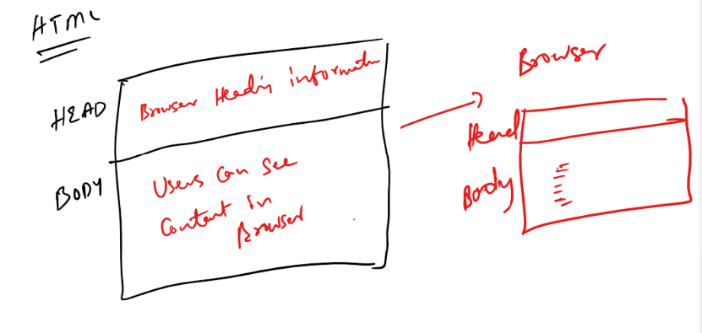

Softwares required

1. Editor: Notepad or VS Code
2. Browser: To render/display HTML content.

HTML has lot of inbuilt tags, all these tags is understood by browser, some of the tags are:

html, head, title, body, h1, h2, h3, h4, h5, h6, p, table, form, div, span, input, b, i, a, img, br, hr, select, option, video, audio, canvas, article, header, footer, section, nav, aside, mark, pre, marquee, sub, sup, script, style, meta, link, ol, ul, li,

Note:

1. HTML doesn’t show any error if there’s a mistake
2. HTML is case insensitive i.e., if you have a <body> then you can close using </Body>
3. But most preferred case is lower case

first.html

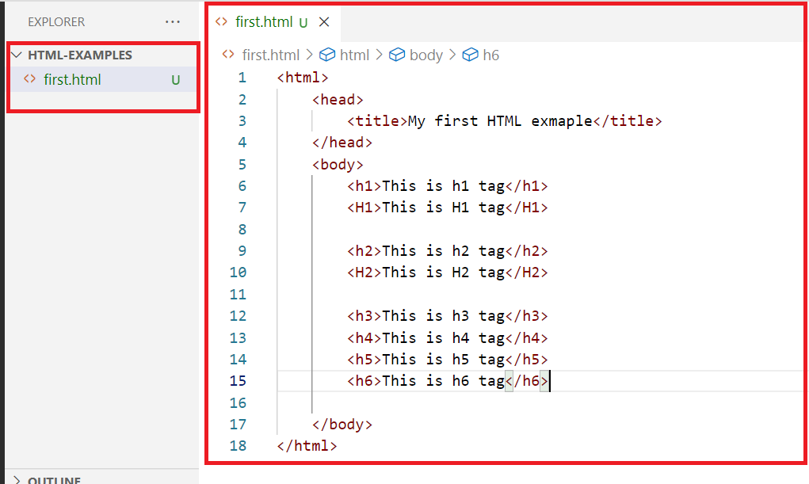

Output:

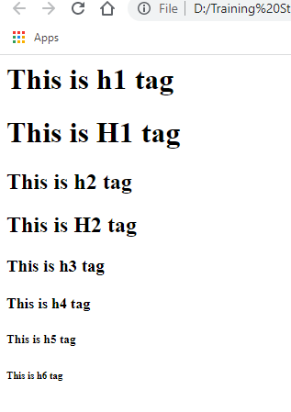

<!Doctype html>

This declaration is recommended so that browser will understand immediately what document its loading.

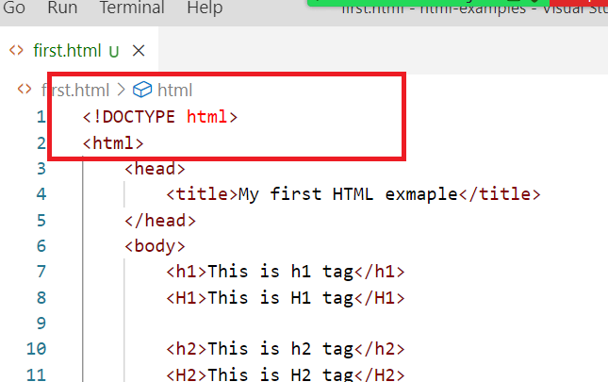

Note: In VSCode you can type html, to automatically have html template

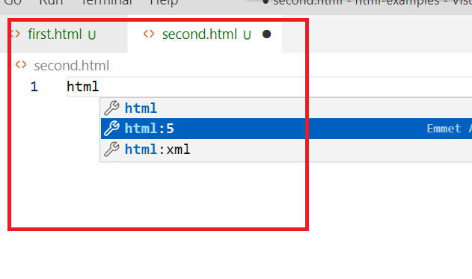

Once you select html: 5 you will get the below template

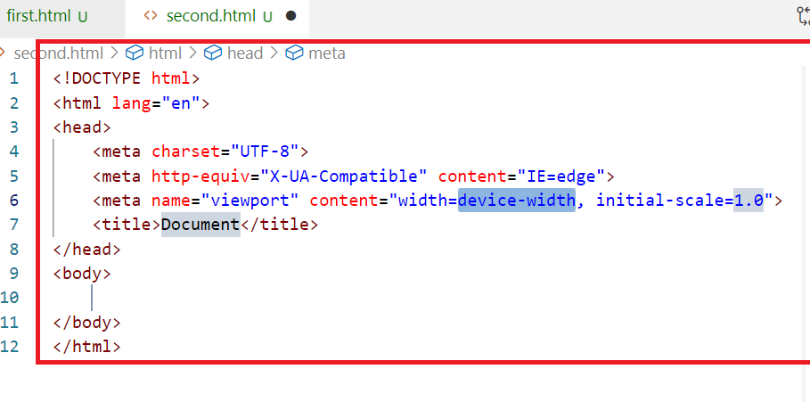

Understanding <p>, <b>, <i>,<marquee> <img>, <br>, <hr>

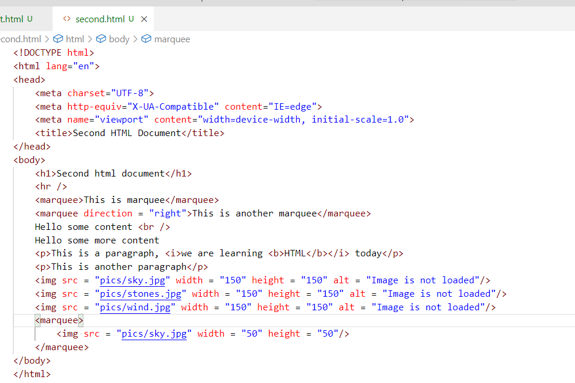

Note: There is a pics folder created in the location where we have html files

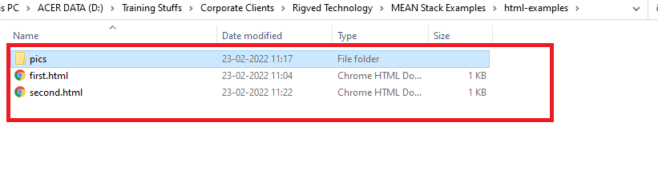

Output:

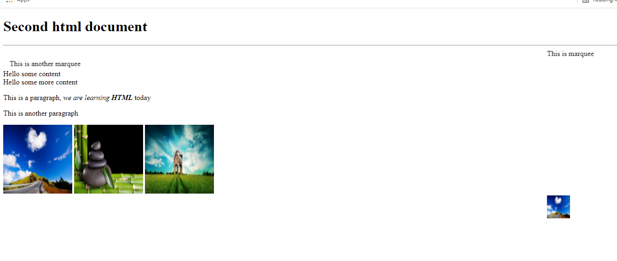

<marquee scrollamount = “10”> increases the speed, 10 is a number if you give greater numbers, the speed will be more

second.html

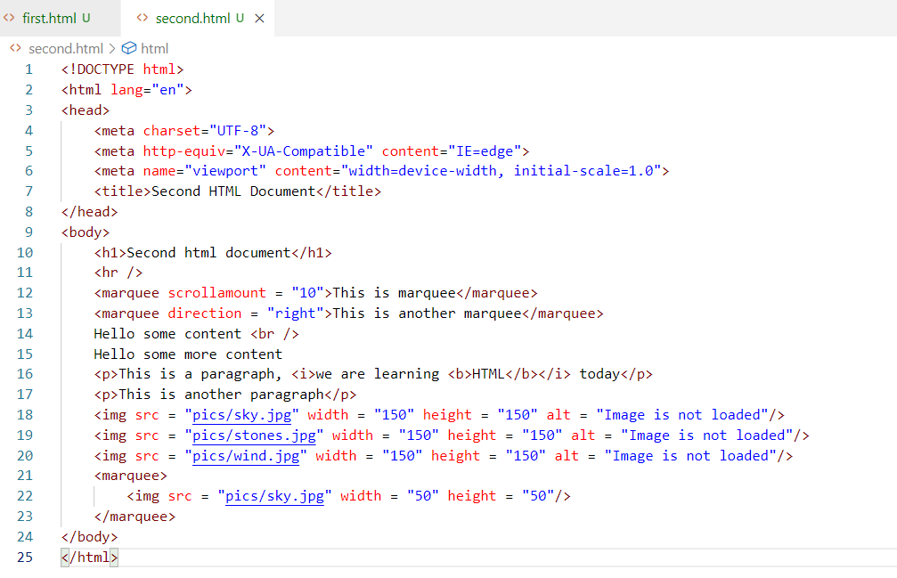

Output:

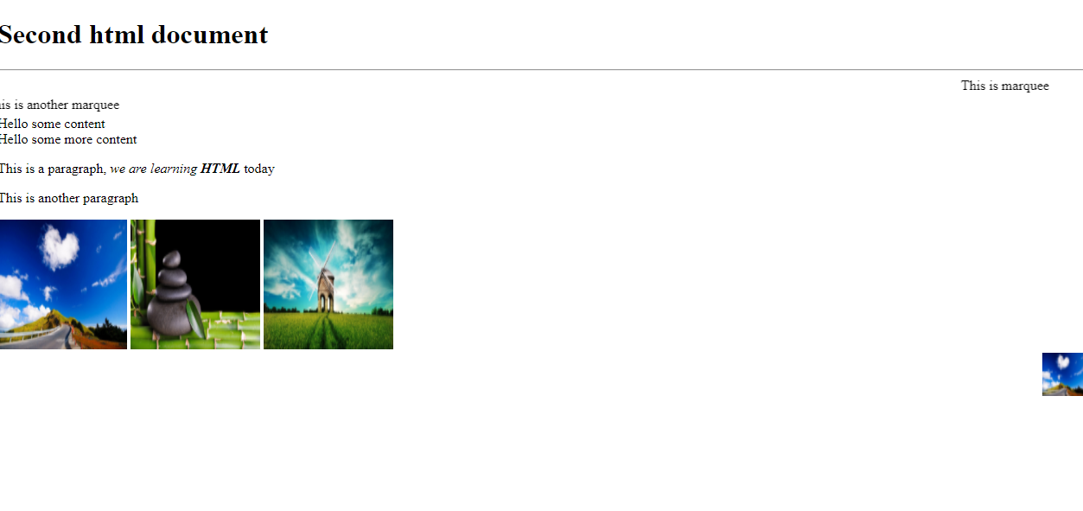

Ordering the items

We can create list of items using <ol> and <ul> both will use <li> to list the items.

third.html

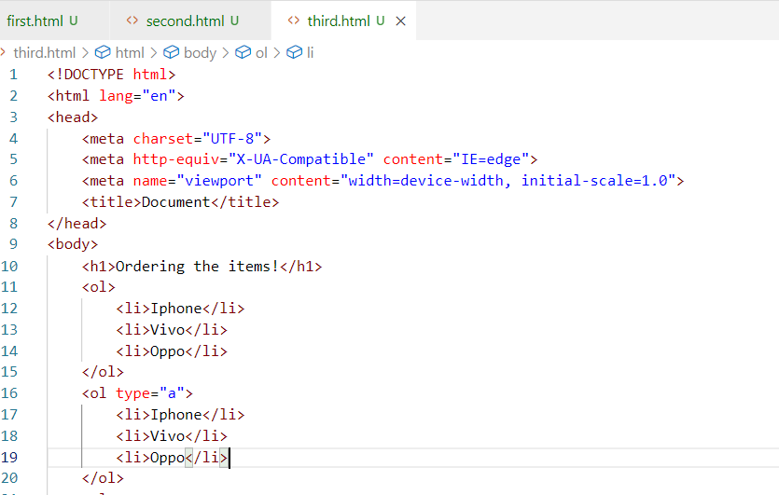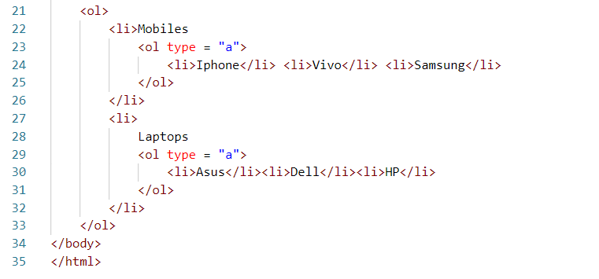

Output:

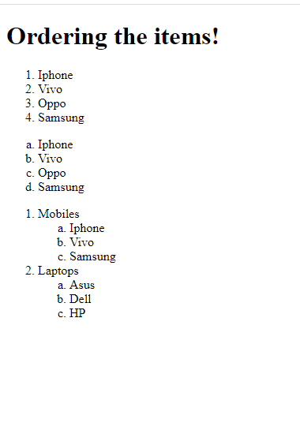

Unordered items: They will use bullets instead of numbers or alphabets

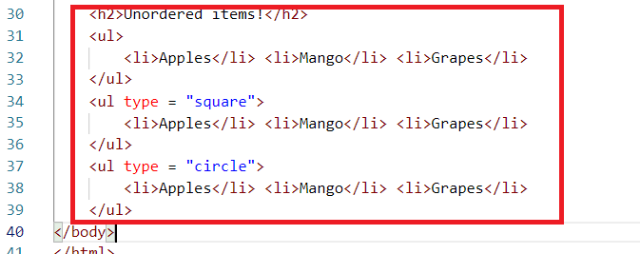

Output:

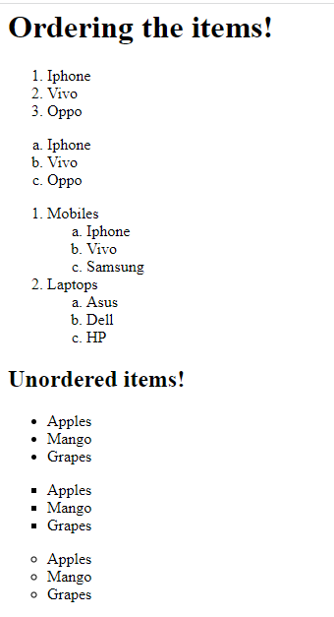

Entities in HTML

These are some special characters that you want to show to the user, like registered symbol ®, copyright symbol ©, ™ trade mark, Rupee symbol, greater than, less than and so on.

To create entities you must start with &entityName; that displays the entity on the browser

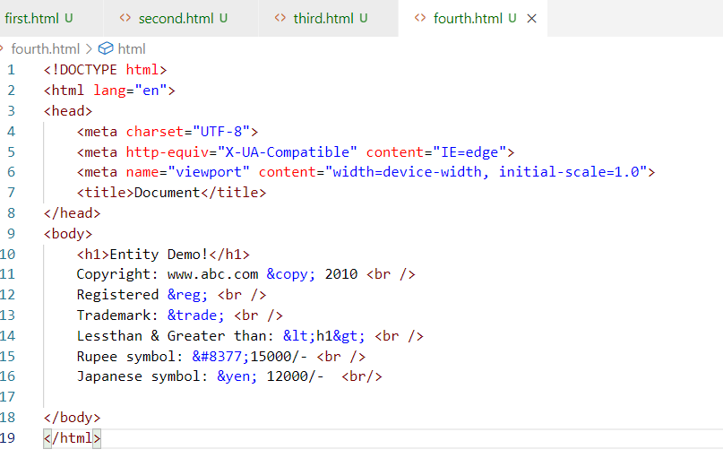

Output:

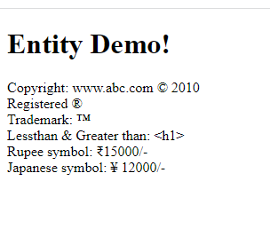

Some more entities:

&quot; For quotation

&amp; For &

&nbsp; For a space

Super script & Sub script

These are used to show the content in a different position beside the normal position.

Suppose you want to show a chemical formula or mathematical formulas, these super script & subscript would be helpful.

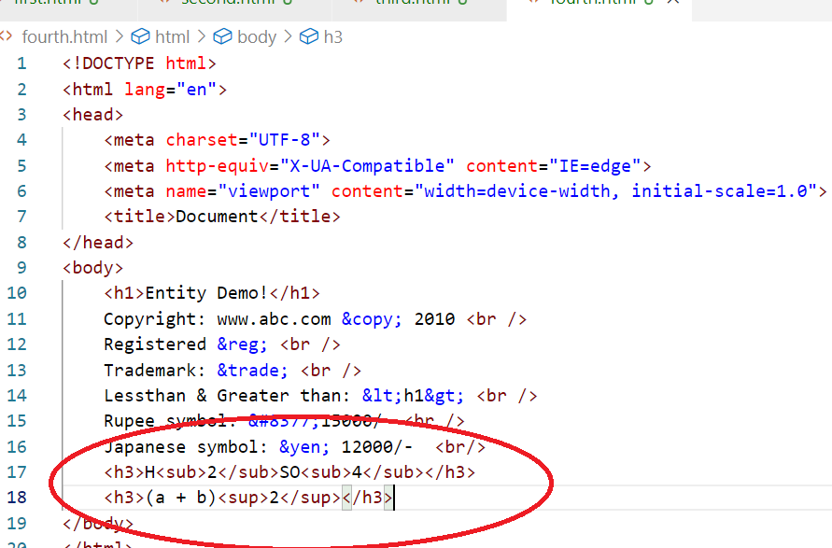

Output:

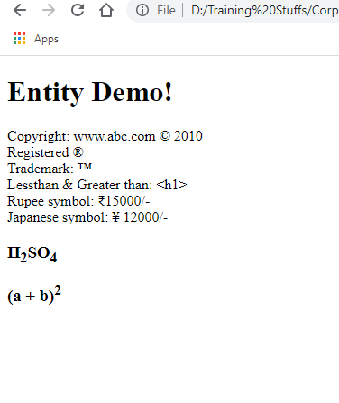

<pre>

It is used to show the contents in a way you specify in the HTML document

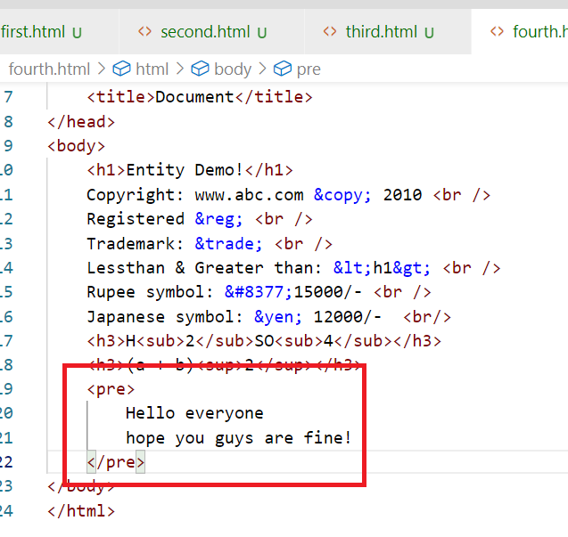

Output:

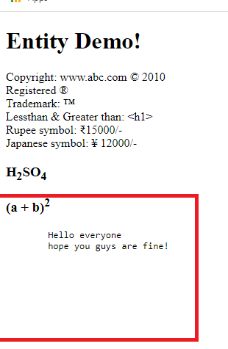

Data list

It is used to create some content with some brief description

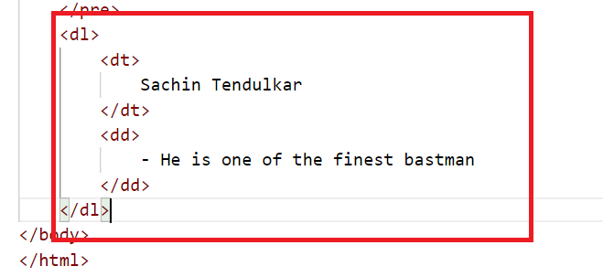

Output:

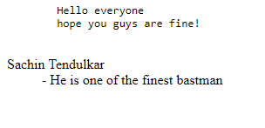

<a>anchor tag:

It is used to hyperlinks to different websites or server side resources

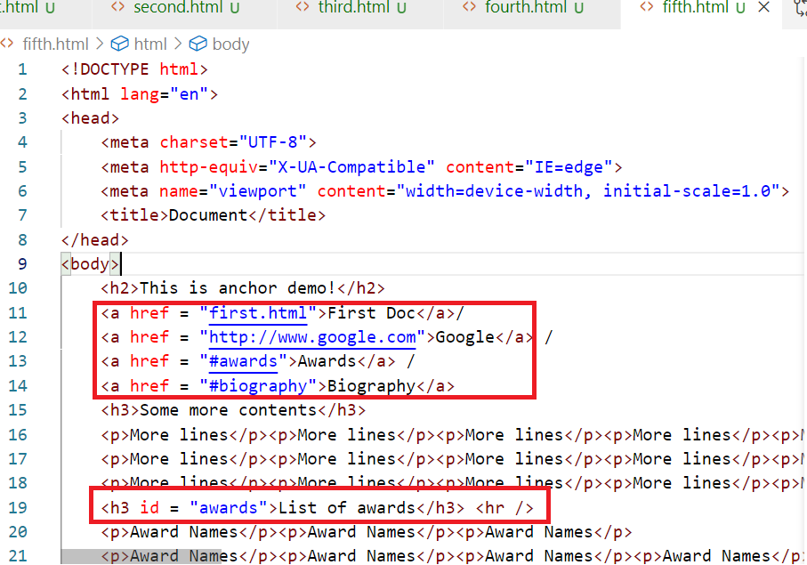

Here <a href = “#awards”> refers to the resource in the same page, the resource must have the id attribute i.e., <h3 id = “awards”> similarly you can have another <h3 id = “biography”> and refer it by <a href = “#biography”>

<video> & <audio>

You can have media tags in the HTML to render video’s are audio’s

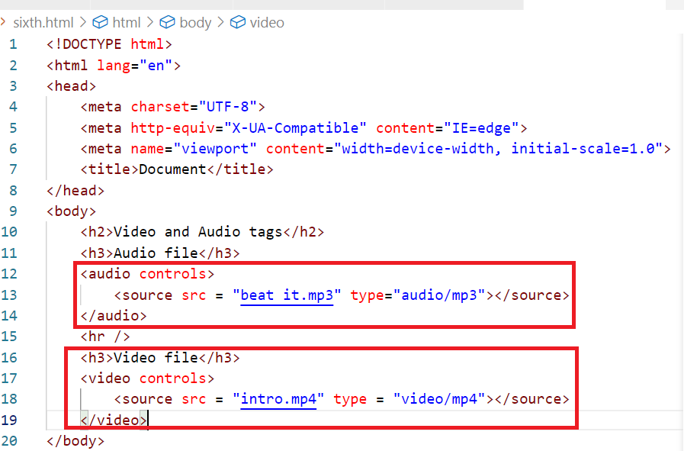

Output:

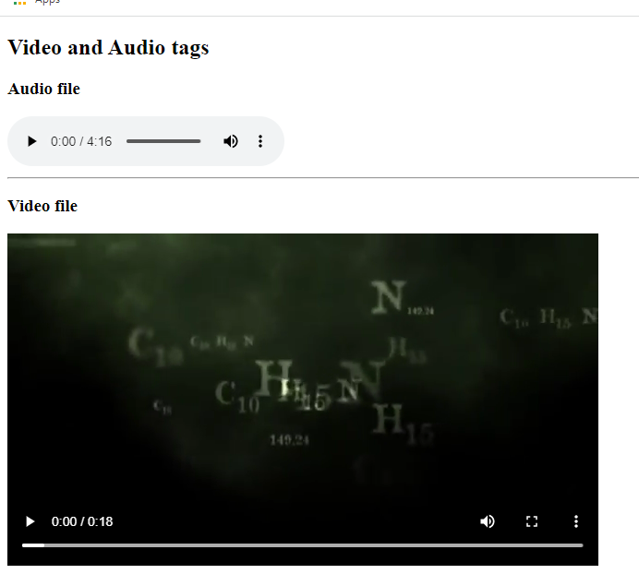

Note: You can also add links of different videos like youtube videos

table:

It allows you to create tables with rows & columns, a table must have heading which specifies how many columns it can have and body that will have content of the table.

seventh.html

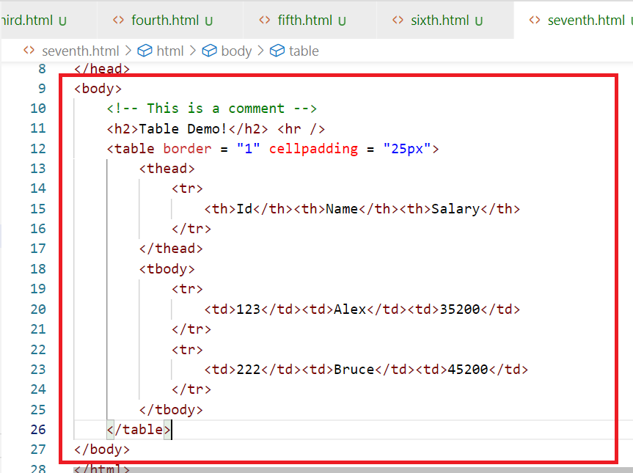

Output:

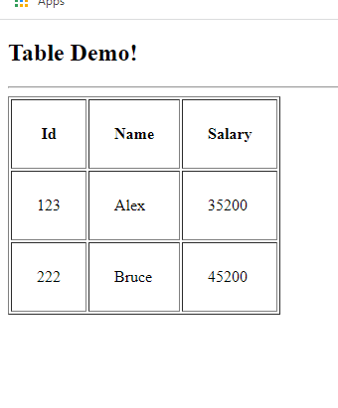

Activity:

1. Solve all the above examples discussed (this you don’t have to push to the git)
2. Fork the repository : <https://github.com/Kishor-C/rigved-students-activity.git>
3. Clone the rigved-students-activity repository created in your account
4. Create a folder like html-handson or html-examples and keep all the html related assignments in this folder,
5. Similarly for other technologies you will create separate folders, ex: for javascript, you will create javascript folder, for angular you will create angular folder and so on

Activity 1:

Create a table that will have product and its information, it must look as below:

|  |  |  |  |
| --- | --- | --- | --- |
| Product Id | Name | Price | |
| Rs | Ps |
| 1122 | Laptops | 23500 | 35 |
| 3311 | Mobile | 10200 | 50 |
| 4422 | Watch | 5200 | 20 |
|  |  |  |  |

container tags

These tags can include other html elements, by default html gives you body tags which is a container tag, along with that HTML gives you <div> tag that can include other html elements.

Till HTML4 we had only <div> but HTML5 onwards more container tags were released which can be used to provide in a specific layout, like <header>, <footer>, <article>, <nav>, <section>, <aside>, all these have the same behaviour of <div> but they can categorise the HTML document to create a layout.

Note: These tags would create a layout only when you apply CSS, else they all would be in a default position where you keep in the HTML document.

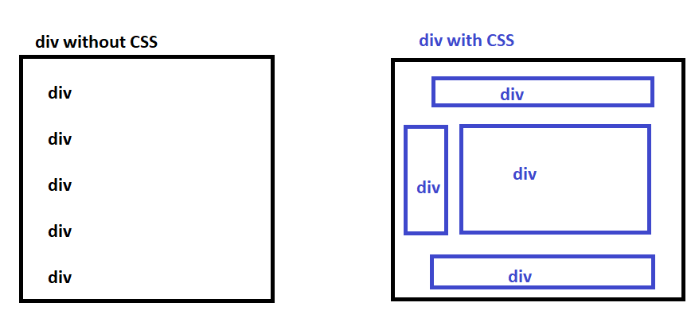

Since <div> doesn’t categorise the layout in the HTML document, HTML5 has released container tags that can be used to layout the document, but they will not have any default position until you apply css

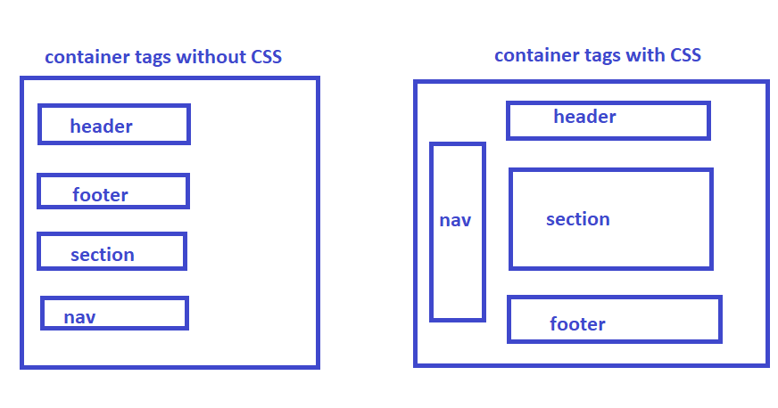

If you apply css to the container tags you can position it wherever you want, HTML doesn’t give any error for it, but you must follow the standard rule that header means it will be always at the top, footer means it will be always at the bottom,

Since <div> was the only tag earlier we had it doesn’t give any meaning to the users/developers, but header, footer, nav, aside, article, section, gives the meaning to the developers where they should appear.

day4/ex1.html

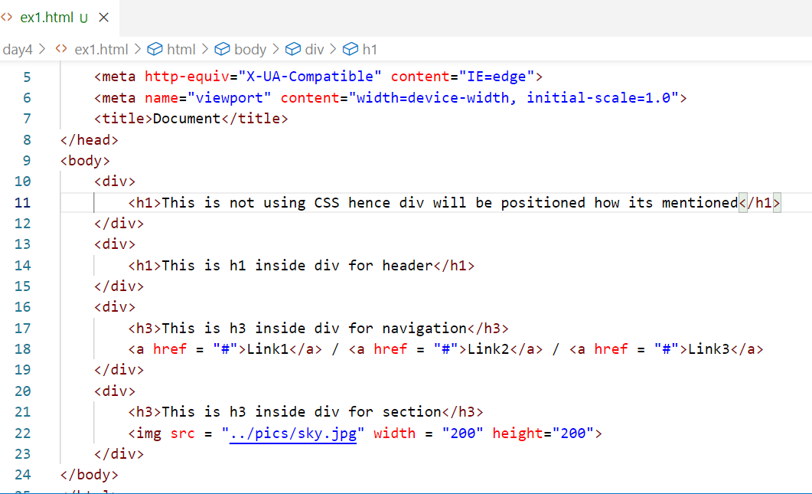

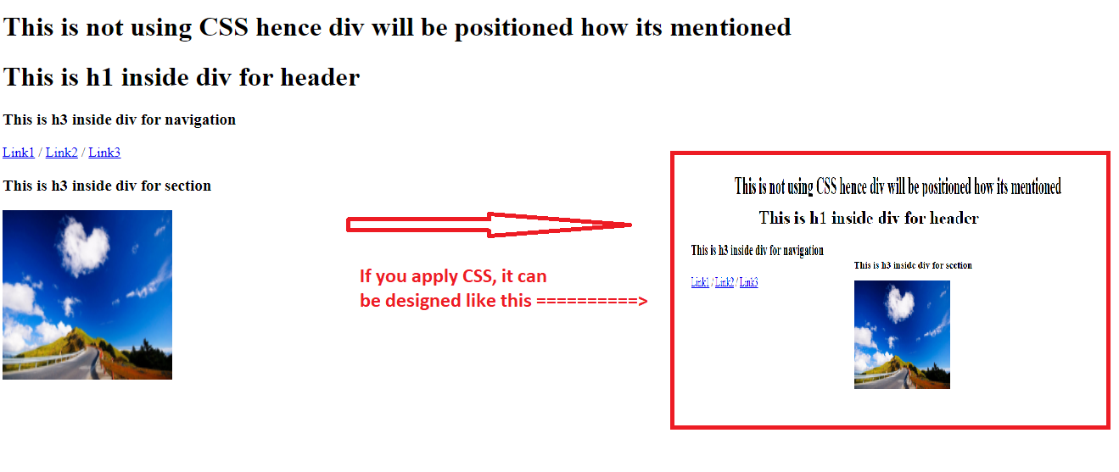

Same code can also use <header>, <footer>, <nav>, <section>, <article>, <aside> but these tags must also use CSS to form a layout so that they can be positioned at the right place.

day4/ex2.html

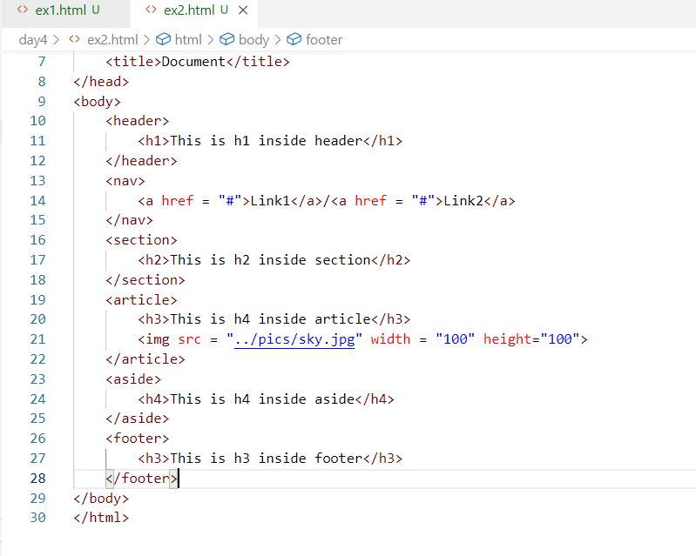

Output:

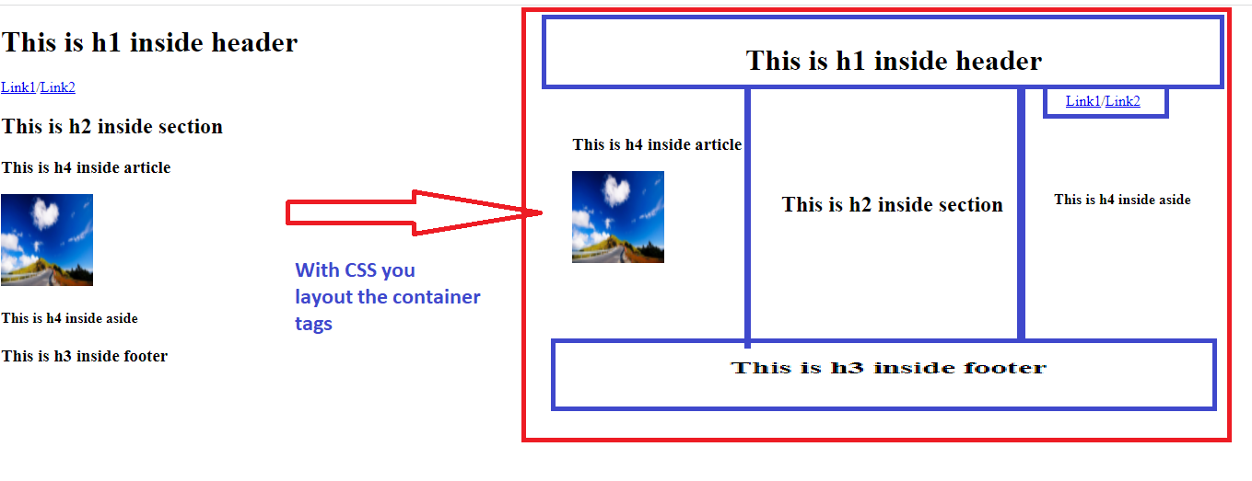

form tags

These are used to create input controls, where user can enter data, you can create input box, password box, radio button, check box, drop down, text area, file upload, buttons,

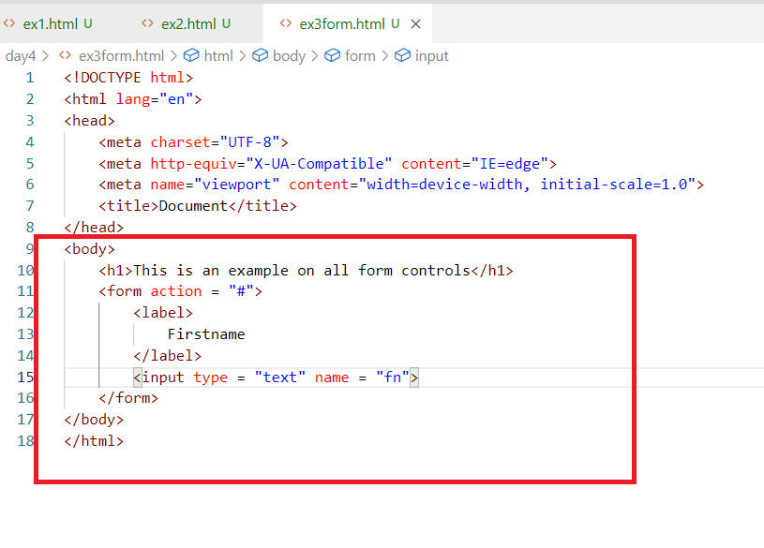

Here fn is a temporary variable that stores the value you enter in the input box

Output:

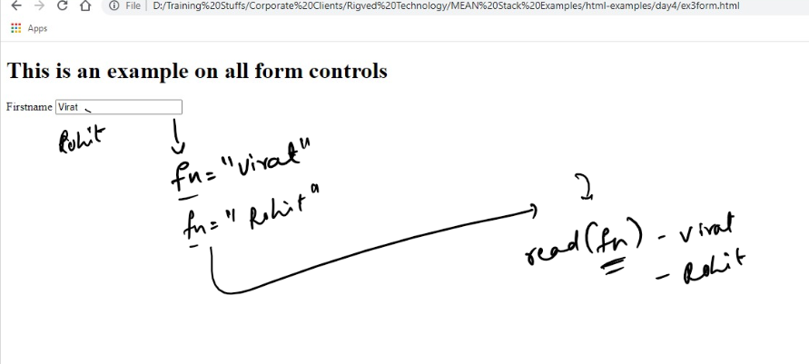

The below form shows the history of input you have entered, which might hide the elements below the input like below

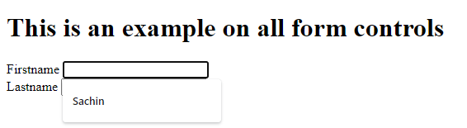

The above input shows some history of input you have entered, which would hide the below elements, to avoid that we can use autocomplete=”off”

ex3form.html

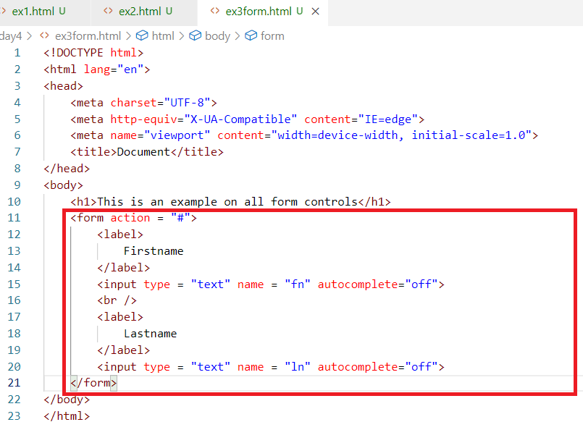

Output:

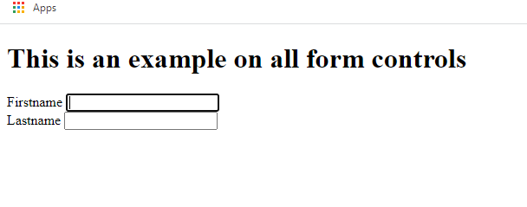

Since these input can’t be submitted, we can create buttons like submit, reset that can control the form input

ex3form.html

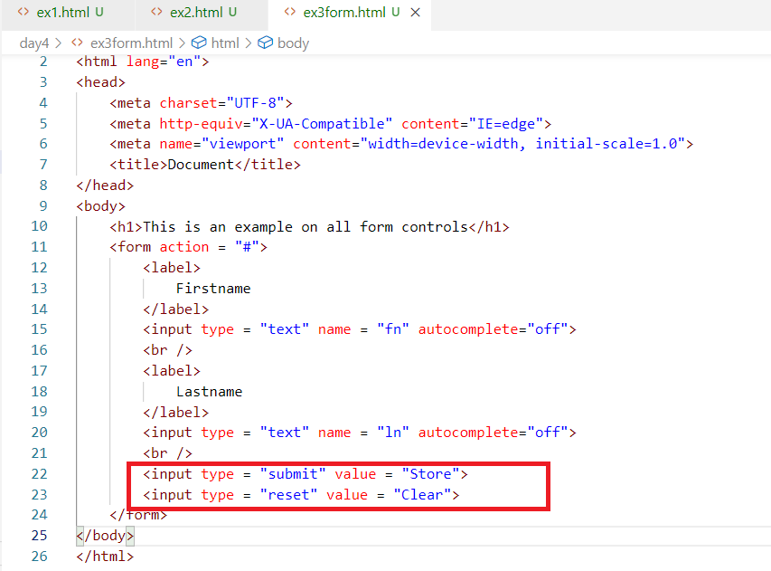

Output:

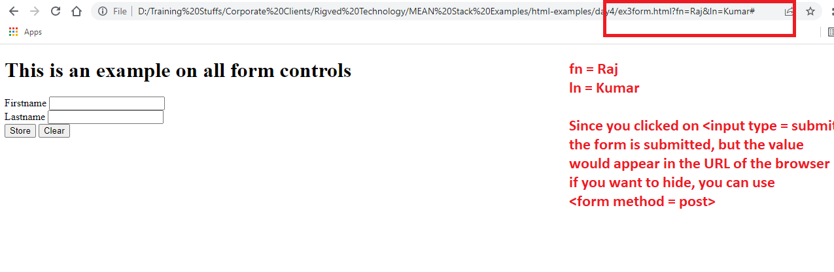

Most of the times form data must not be visible, hence you must use one attribute called method which can take values like GET & POST.

GET: This is the default behaviour of the form submission, which sends the data in the url

POST: This if used in the method, then the form data submitted, would be sent in the body of the document, not in the url, which wouldn’t be visible.

ex3form.html

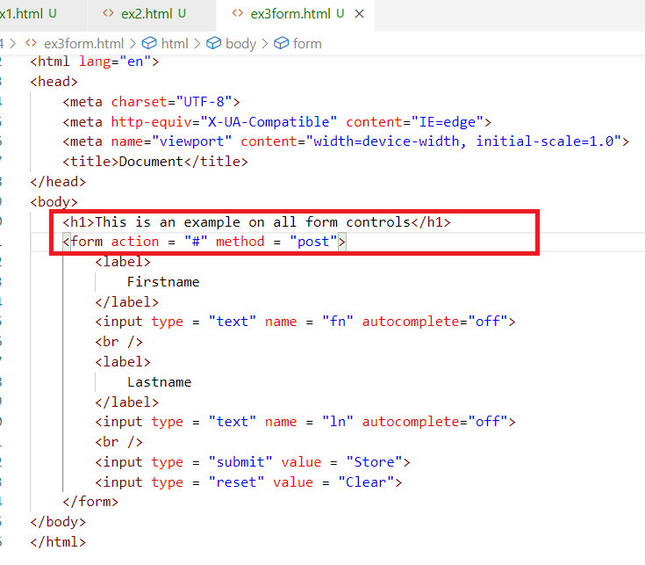

Output:

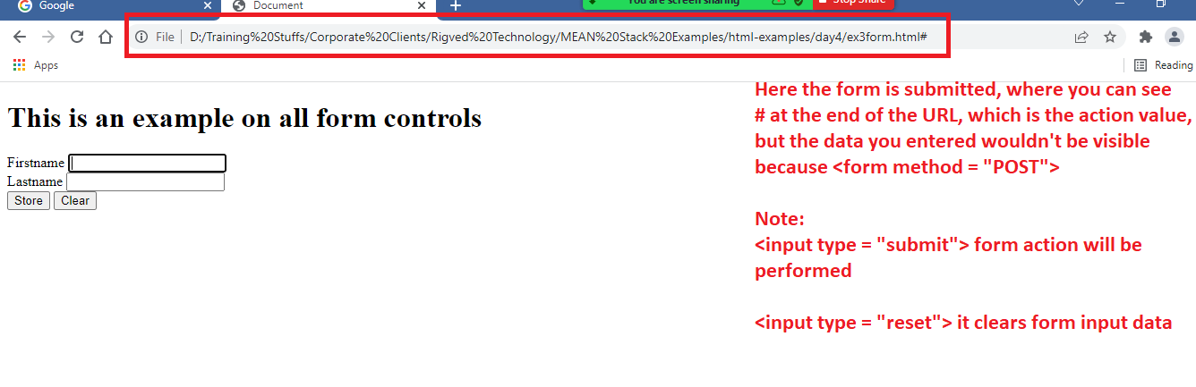

The input attribute type can accept lot of keywords like text, submit, reset, it can use below list of keywords:

1. password
2. button
3. radio
4. checkbox
5. file
6. number
7. date
8. email
9. range

Note: Usually when the form submitted, a request is send to the server resource mentioned in the <form action = “url-pattern”>.

A request will be of two parts

1. header: will have information’s like url & other properties of request like size of data, length of data, type of data
2. body: will have the data

Difference between GET and POST

|  |  |
| --- | --- |
| GET | POST |
| This is the default method of <form> | This must be mentioned explicitly in the method of <form> |
| The data <form> submits appear in the URL, because the data is sent in the header part of the request | The data <form> submits doesn’t appear in the URL, but data will be sent in the body of the request |
| Maximum characters you can enter in the URL is 256 | No limits in the number of characters |
| Not Secure | Secured |
| Faster | Slower compare to GET, certain milliseconds or nanoseconds delay |

Creating other form controls like password, radio, checkbox, drop down, file upload and etc.

ex4regform.html

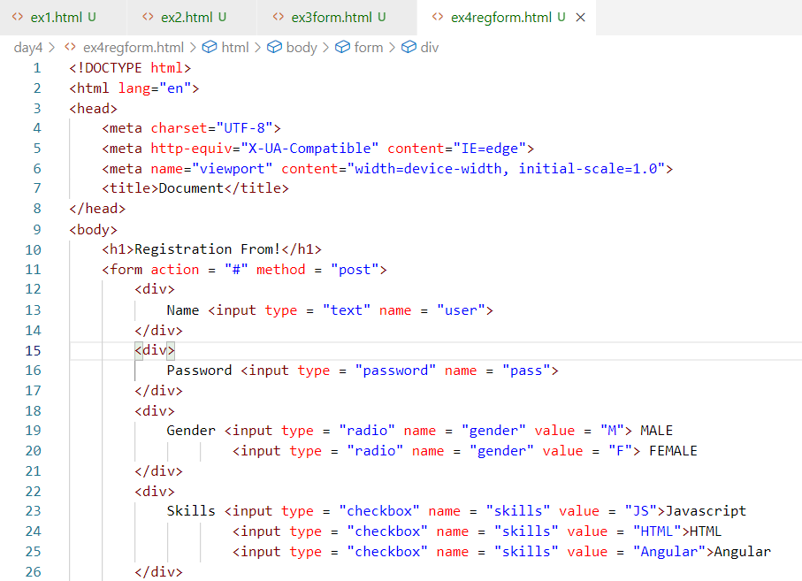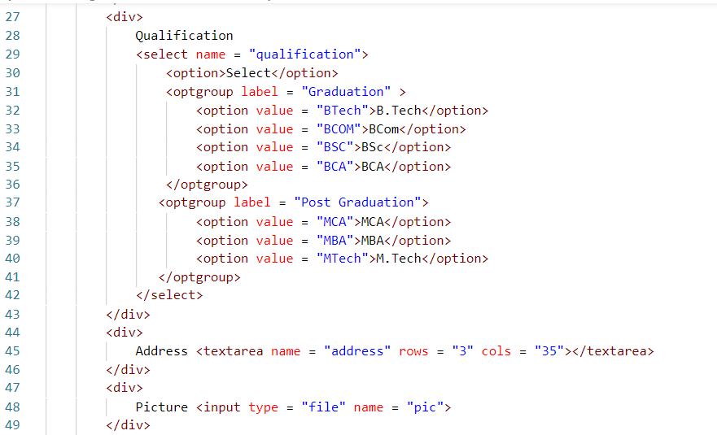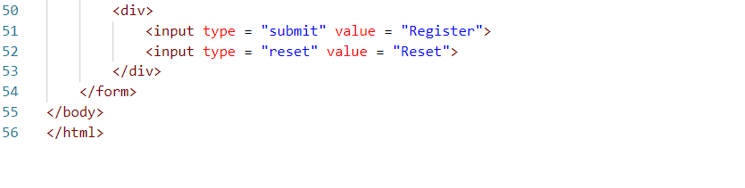

Output:

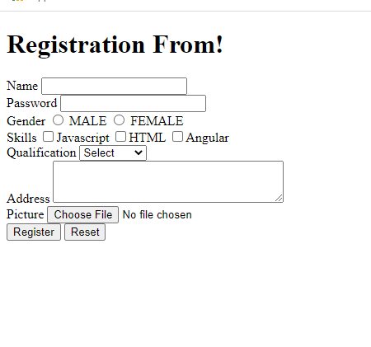

Other types of input controls: email, date, number, range, progress, placeholder - these were introduced in HTML5

day4/ex5form.html

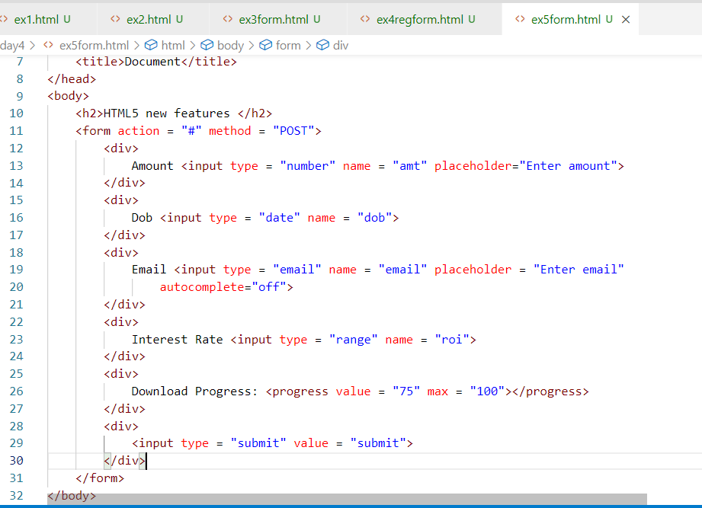

The progress value / range value can be dynamically updated through Javascript

Output:

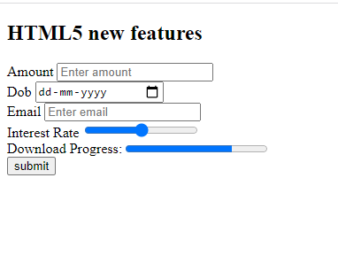

Actvity2:

1. Try all the above exercises discussed today
2. Create the same registration form with proper alignment using <table> tag

CSS: CSS stands for Cascading Style Sheet, it is mainly used to style the HTML document.

There are 3 types of CSS

* Inline CSS
* Internal CSS
* External CSS

CSS Syntax  
selector { property : value; property: value }

selector means it could be an element or group of element or a particular element id

Inline CSS: Styling the particular element using style attribute

ex: <p style = “color:red; font-family:arial”>SOME TEXT</p>

Internal CSS: You will have styles common to the entire HTML document, it is written using <style> tag inside <head>

ex:   
<style>   
 h1 { color : green; background-color : yellow }  
 .c1 { color : blue } /* this is for multiple elements using class name c1*/  
 #a { color : red } /* this for a particular element having unique id “a” */  
</style>

<h2 class = ‘c1’>SOME TEXT</h2>  
<h3 class = ‘c1’>SOME TEXT</h3>  
<b class = ‘c1’>SOME TEXT</b>  
<h1>SOME TEXT</h1>  
<h1>SOME TEXT</h1>

<h3 id = “a”>SOME TEXT</h3>

External CSS: It is an external css file that is linked to one or more HTML document, so that multiple HTML documents can have the styles written in that external CSS file

You need to use <link> tag to link the external css with html file.

day4/ex5inlinecss.html

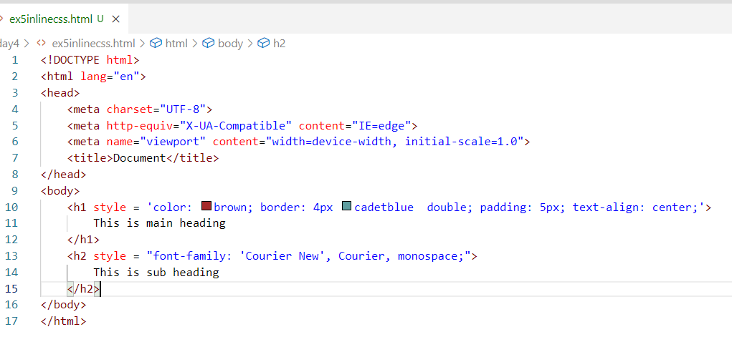

Output:

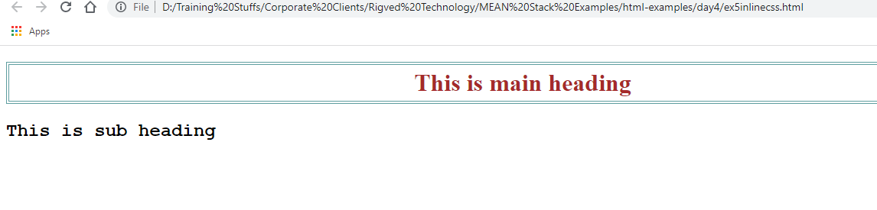

internalcss.html

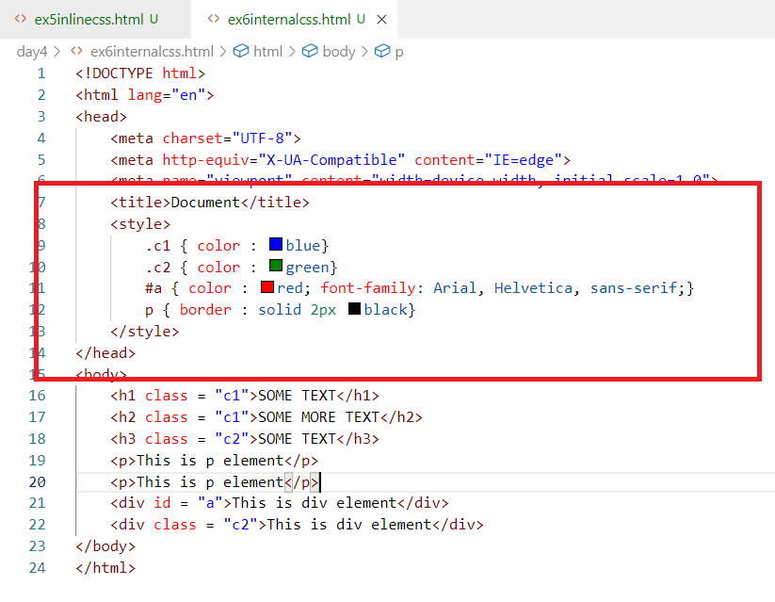

day4/mystyles.css

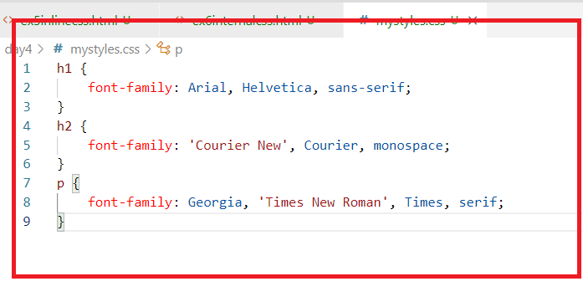

ex7externalcss.html

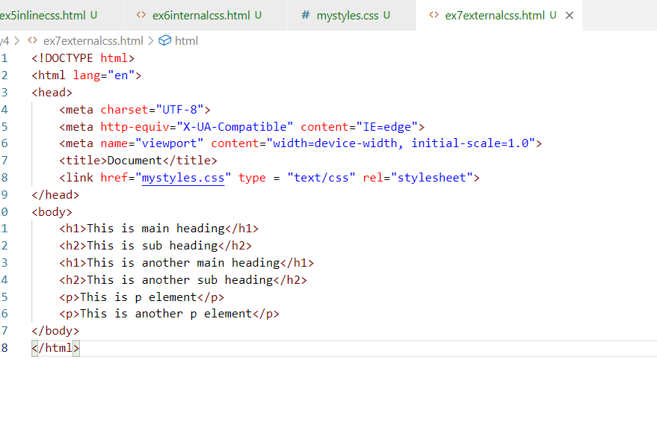

Output:

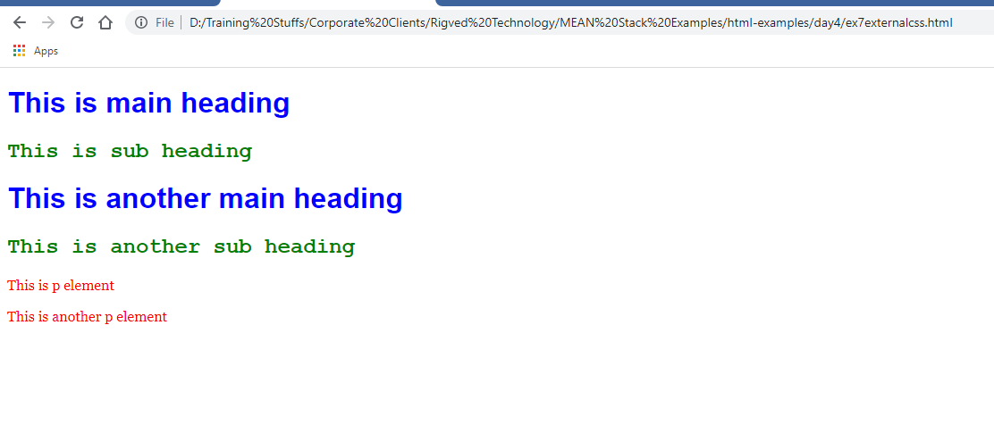

Keeping all the container tags in the same line

You can use a css property called display:inline, that doesn’t give line break to the container tags.

day4/ex8block.html

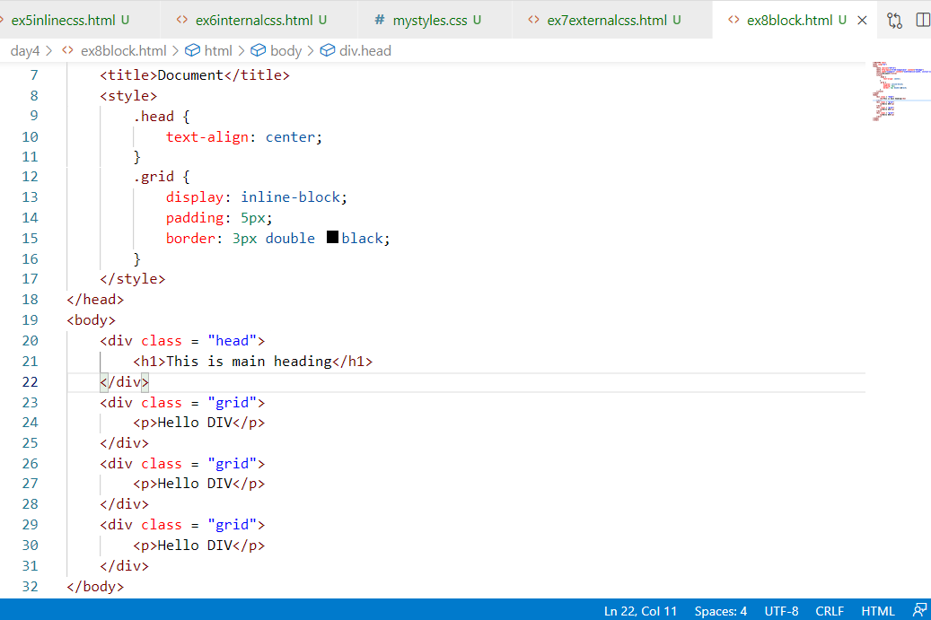

Output:

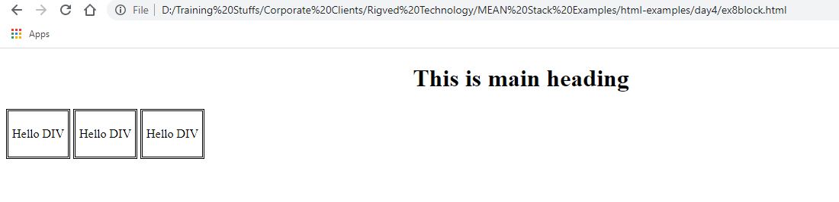

Activity:

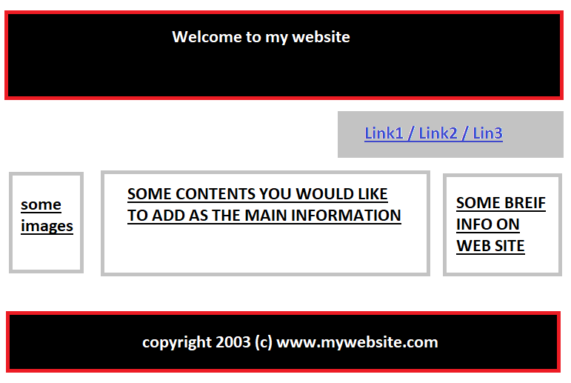

day5/template.css

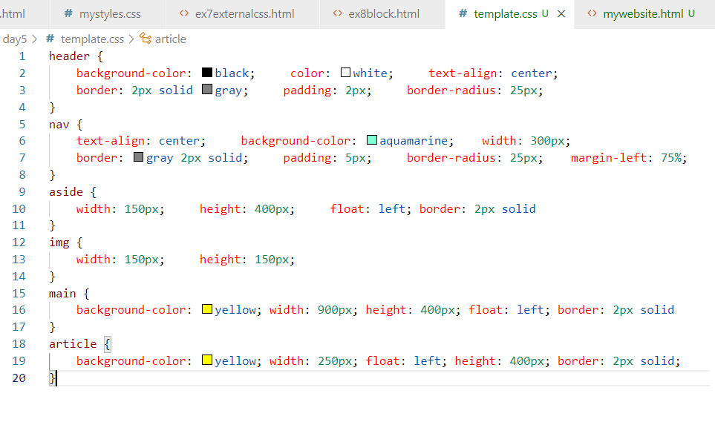

day5/mywebsite.html

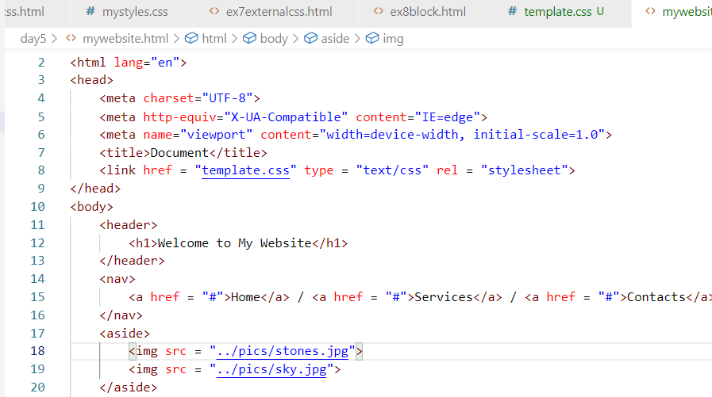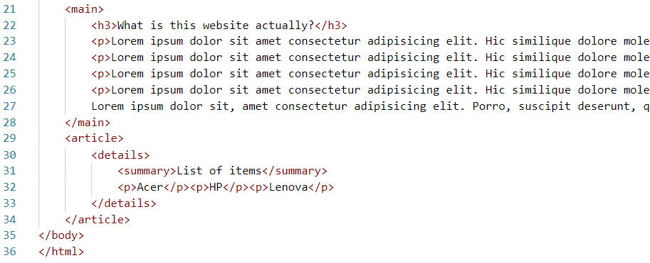

Output:

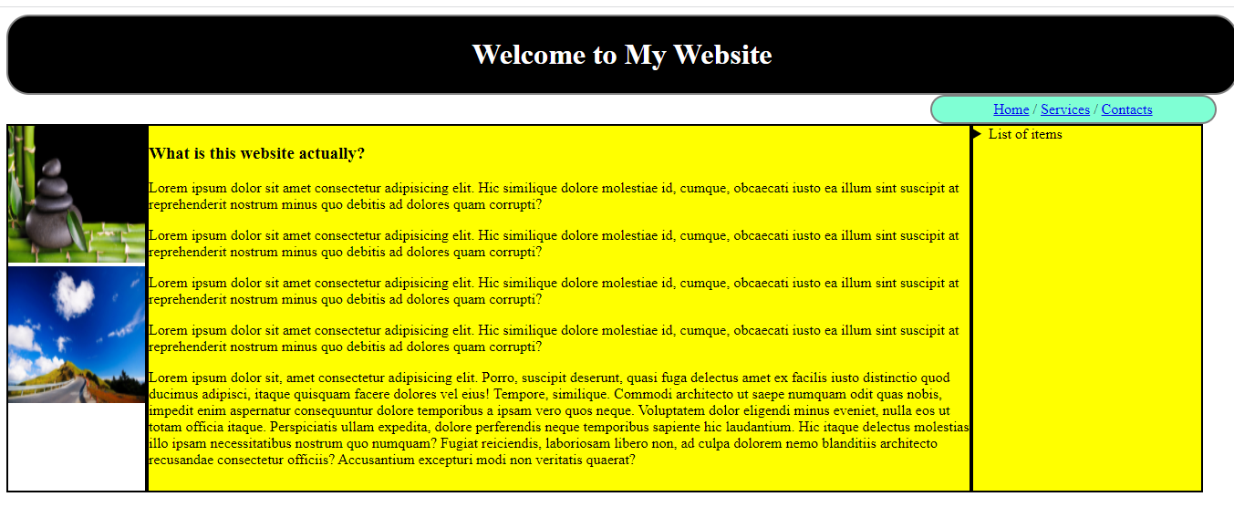

HTML 5 has provided some validation features

1. required
2. max, min
3. pattern
4. search type, tel type, number type and so on

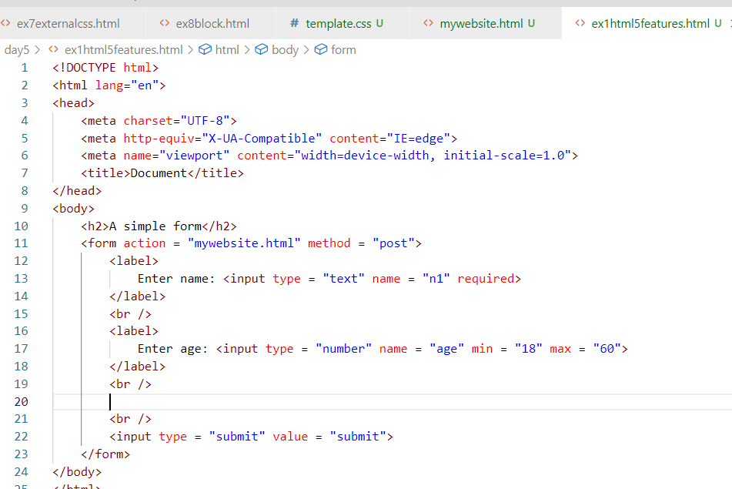

Output:

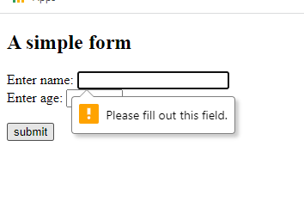

Pattern: This is an attribute which tests whether the input matches to the given regular expression

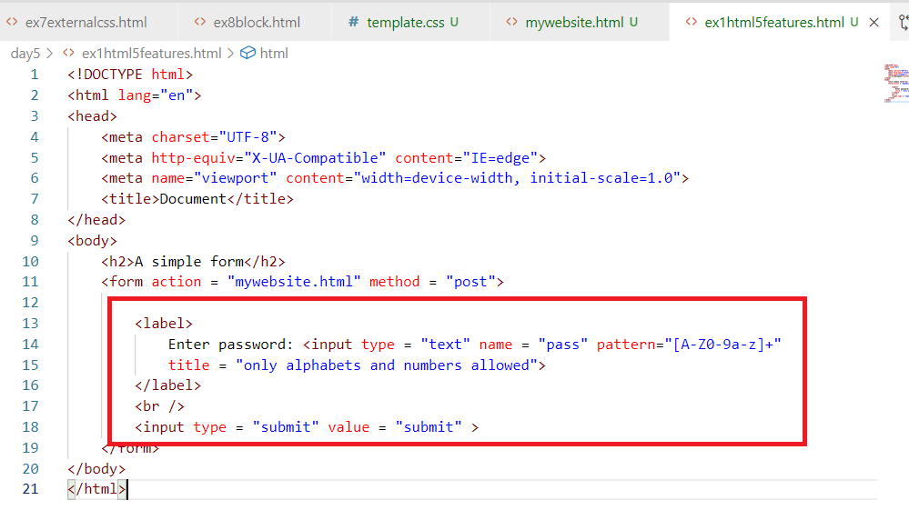

Output:

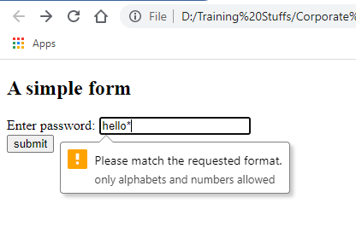

CSS3 Features

* Rounded corners
* Media Queries
* Transitions
* Transformations
* Animations
* Inheritance: Inheriting the other css properties in a css file

Animations:

It gives extra effect to the HTML elements, it is done using @keyframes to apply the animation rules that can specify the effects the HTML element must take within some duration.

animie.css

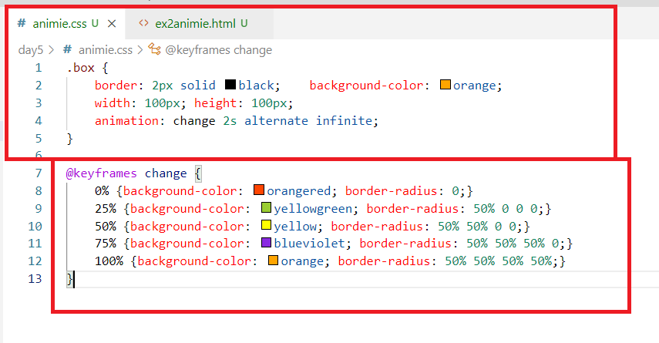

day5/animie.html

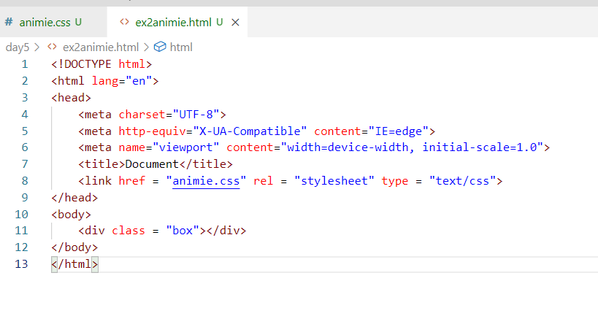

Output:

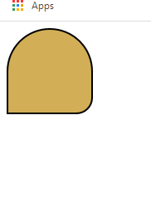

Transformation:

This is used to add extra properties to the animated element, where you can transform the HTML element direction like rotating in different axis

Ex: rotate(360deg), rotateX(360deg), rotateY(180deg)

transforming.css

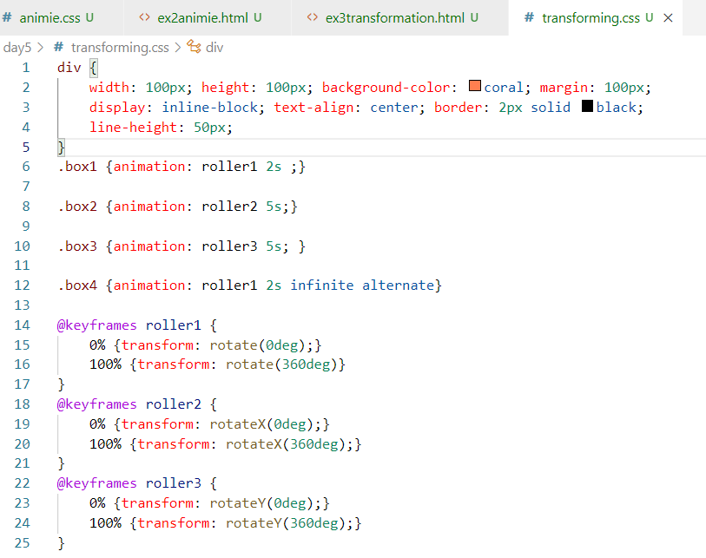

ex3transformation.html

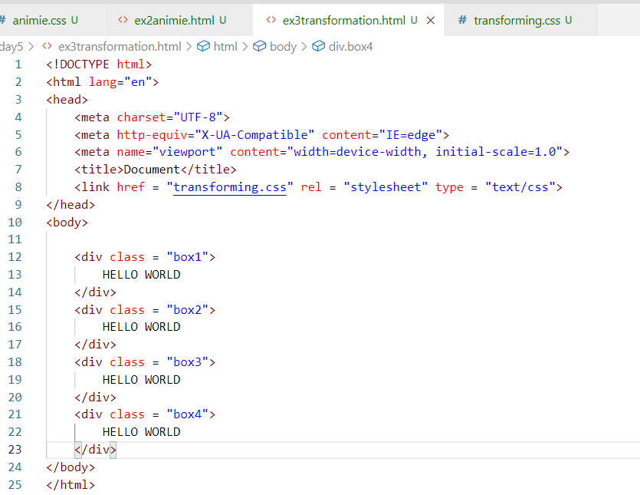

Output:

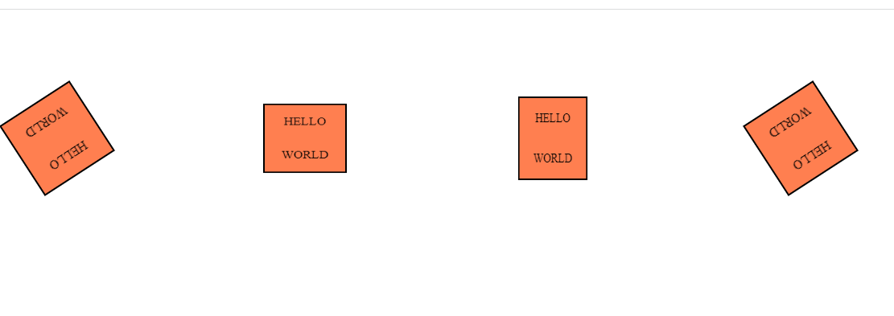

Moving the elements

moving.css

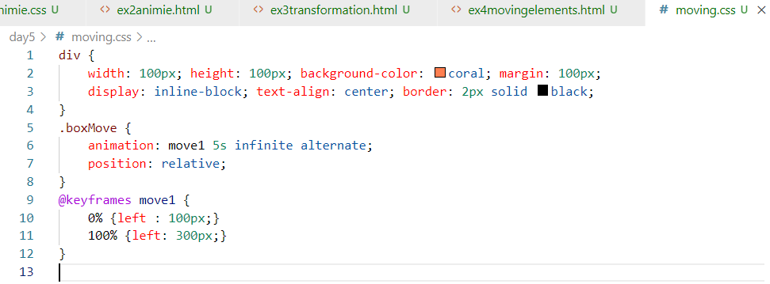

ex4movingelements.html

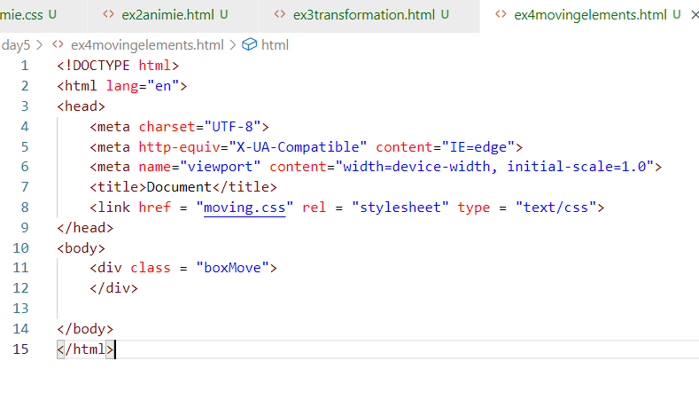

Output:

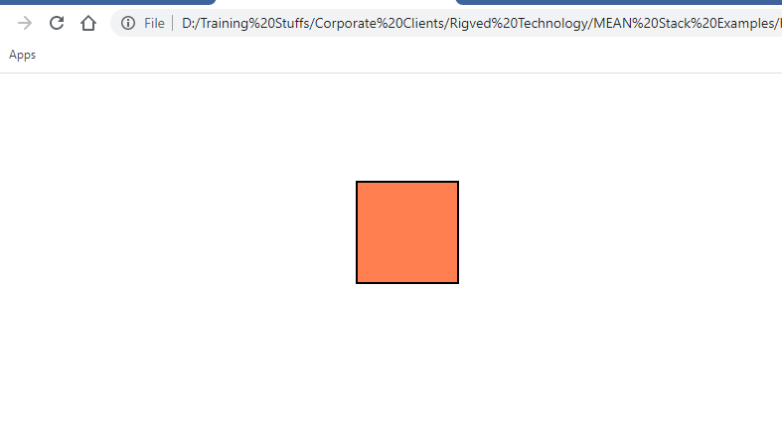

HTML 5 Features

1. Canvas element: This is to create 2d drawings, but we need to have Javascript knowledge
2. Drag & Drop feature
3. Web Storage: Where you can store the user data in the browser storage area, there are two types of web storage 1. Session Storage 2. Local Storage, here we need to use Javascript
4. Video & Audio tags
5. Different input types number, range, progress, placeholder, pattern, required, etc.
6. Details, Summary, datalist, output, header, footer, aside, main, nav, article, section, mark

Activity

1. Try the above exercises on html & css - animations, transformations, transitions
2. Work in a team to create a website that will have CSS features like animations, transformations, transitions, below is the activity result you must get

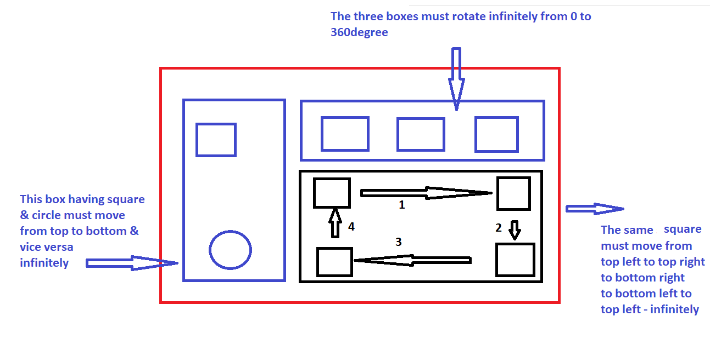

Here team must divide this task and create an external CSS and apply style to the single

HTML document, it means all the members work in a single HTML document, use GIT to take care of merging other person work

RWD: Responsive Web Design

RWD makes your web page fit to all the types of devices could be desktop, mobiles, printing devices, tablets etc.

Since earlier web designer designed the web pages for desktops, the screen was fitting to the desktop screen, but when people started using mobiles, tablets the browser had to scale the web page to fit the device size, this was just a quick fix but not a permanent fix,

To fix this issue, HTML5 introduced a method to control the users visible area which is called as view port

The html:5 template in vs code will have <meta> tag with view port access.

ex1rwd.html

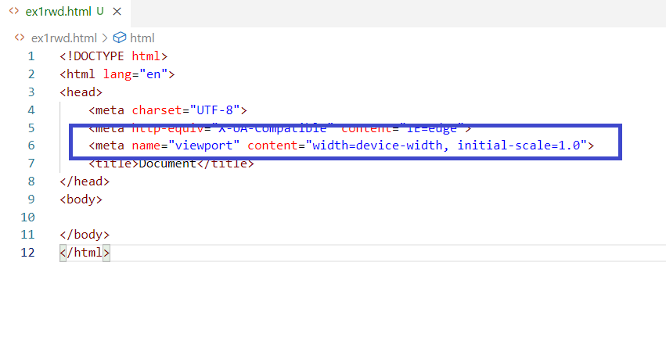

Here the <meta> sets the width of the page to the device width, the content would fit to the device width and the initial-scale is the zooming size is 1.0, now any content you have in the HTML would be rendered to any kind of devices without any manual scaling of the web pages in the browser.

Media Query:

It is a CSS technique to apply the block of CSS properties when some condition is true.

It is used by @media with some rules this will have CSS properties.

media-styles.css

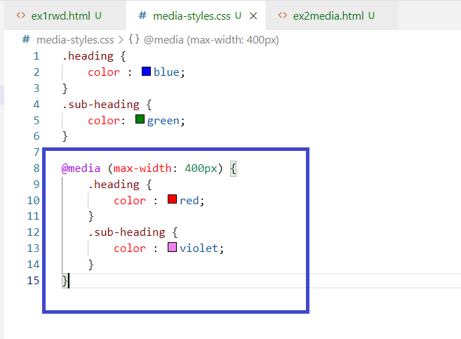

Once the width of any device is <= 400px then the .heading & .sub-heading color would change.

ex2media.html

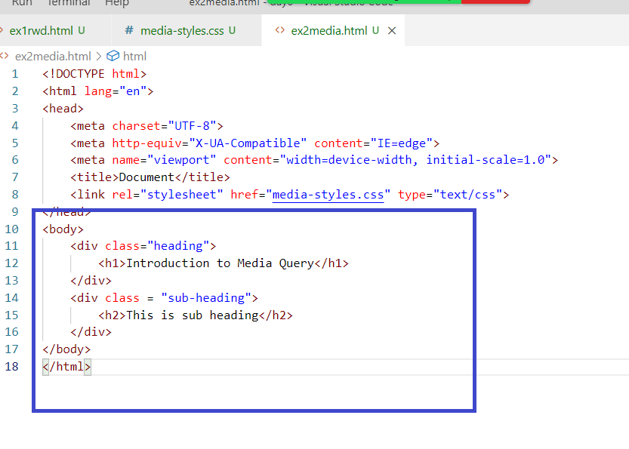

Output:

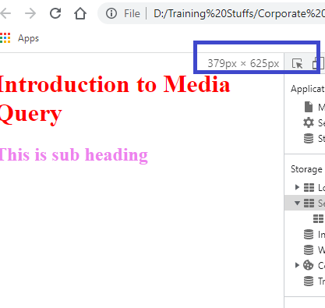

If the width is above 400px

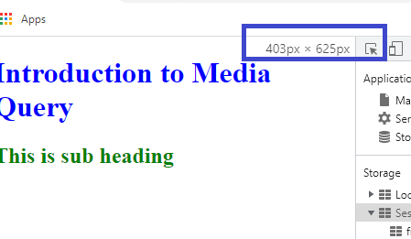

Suppose you want to change the style while taking the print you can use the @media for print devices

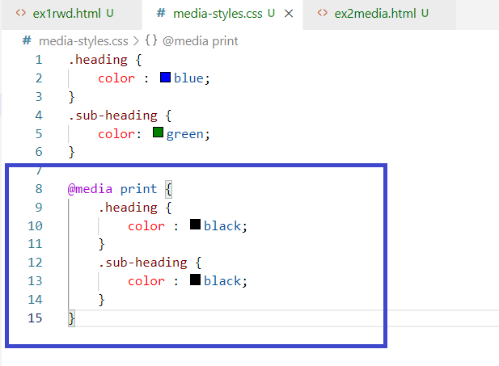

Output:

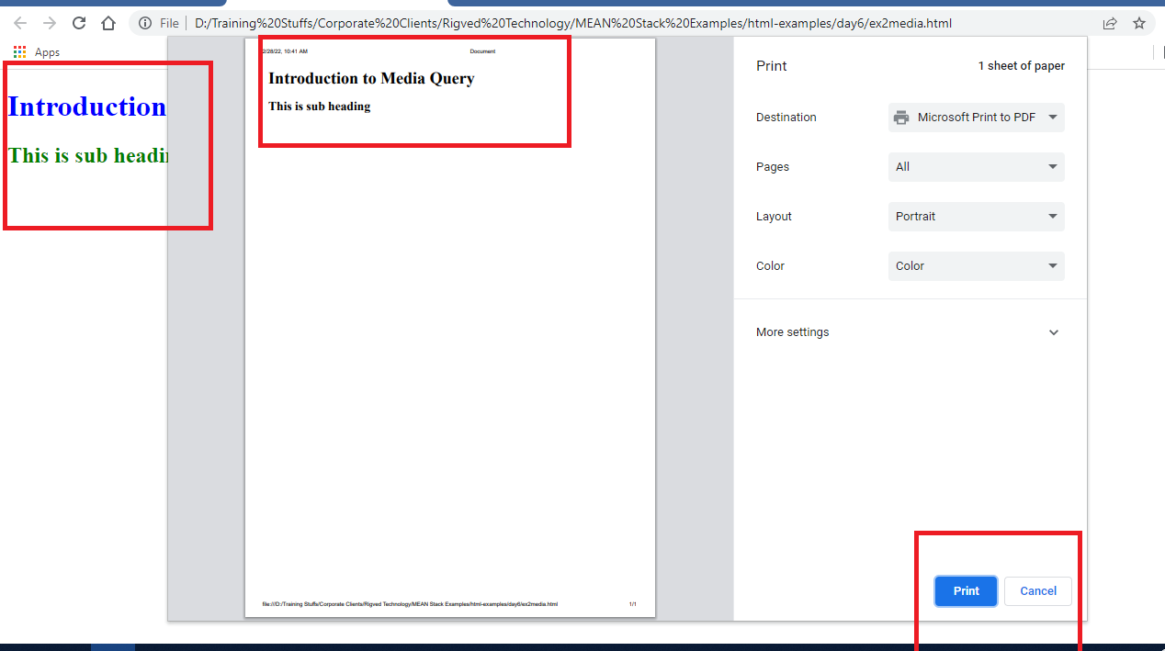

Applying the media rules for screen between some size.

media-styles.css

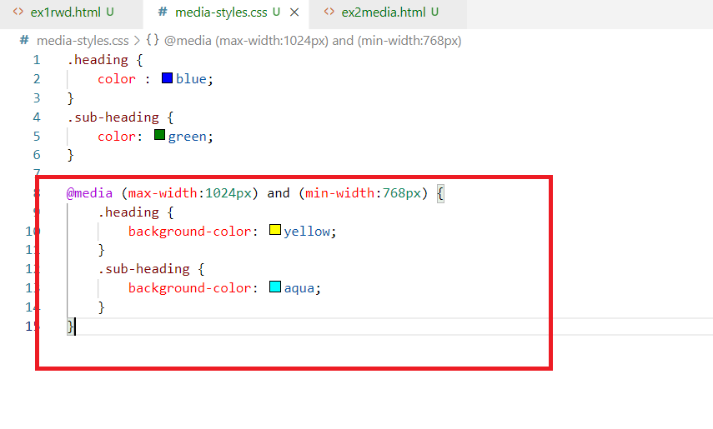

Output: Screen having 768px to 1024px will have the background color

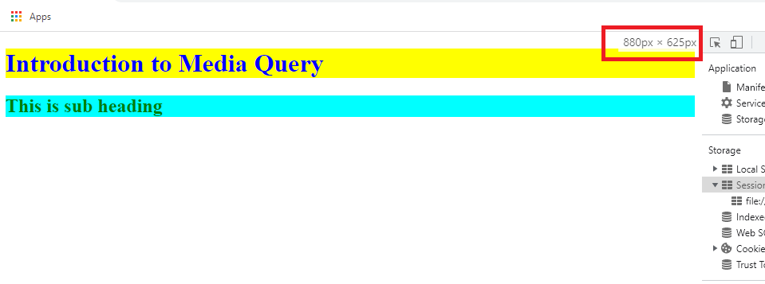

Flex box layout

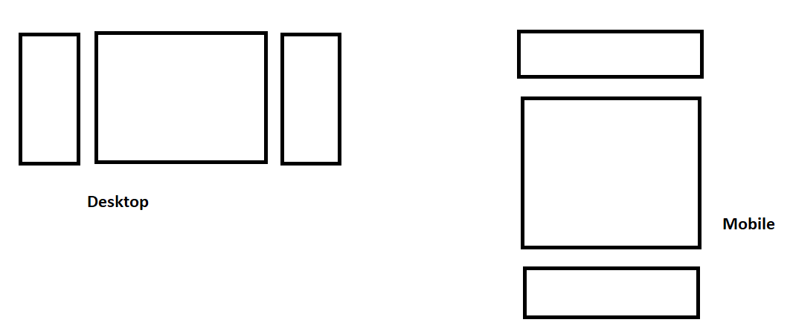

It provides an efficient way to layout, align, distribute space among items in the container, even when their size is unknown.

The main idea behind the flex box is to best fill the available space to accommodate all kind of devices & screen size.

A flex container can expand or shrink whenever need.

It is achieved using a property value called display:flex

flex-styles.css

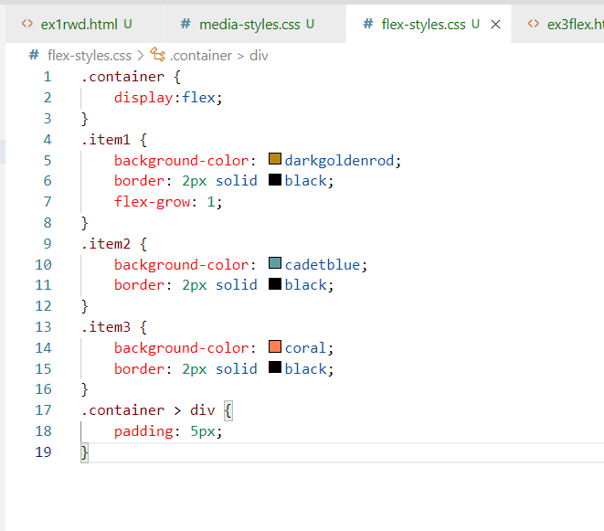

ex3flex.html

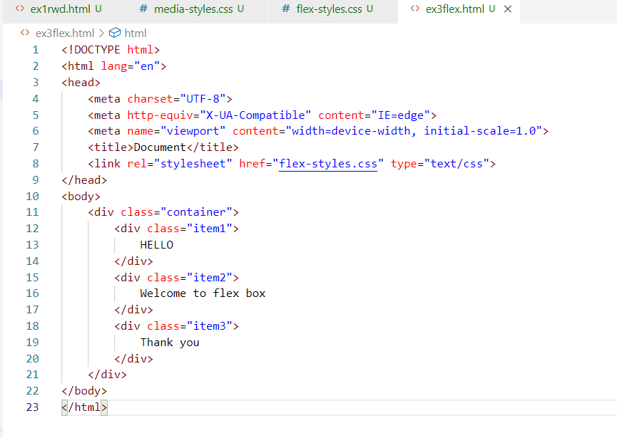

Output:



The contents would fit and the items would grow when the contents are more to accommodate the space.

ex4flex.html

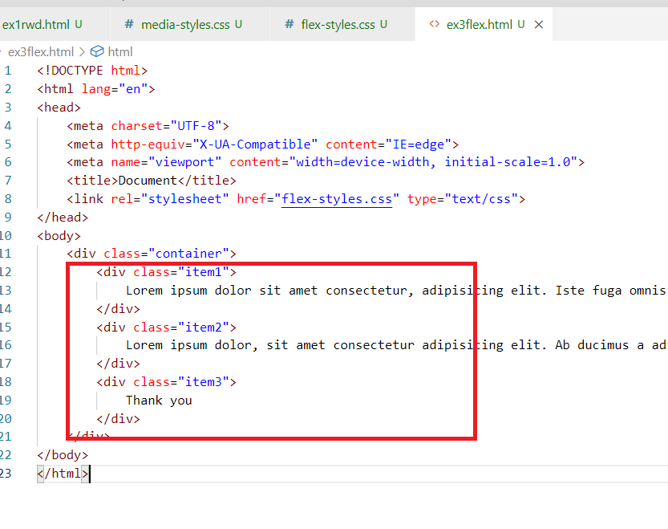

Output:

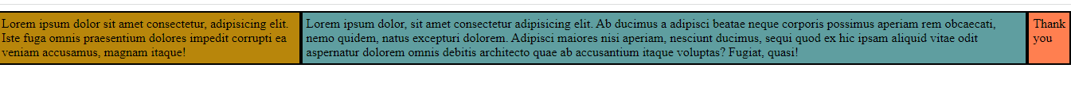

Output when you shrink the size

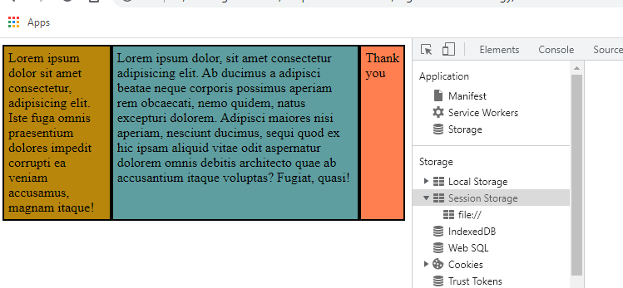

But you can use flex-direction to row or column to arrange the items to row or columns, usually when you want to arrange the items based on the device size if its less than 400px you can have items arranged vertically, if more than 400px you want items to appear horizontally, then you can use flex-direction.

flex-styles.css

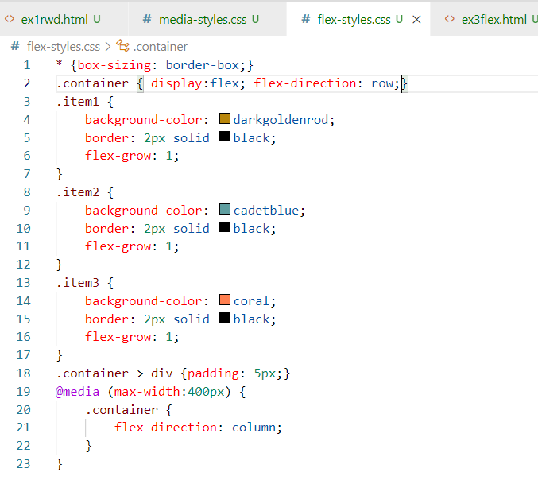

ex3flex.html

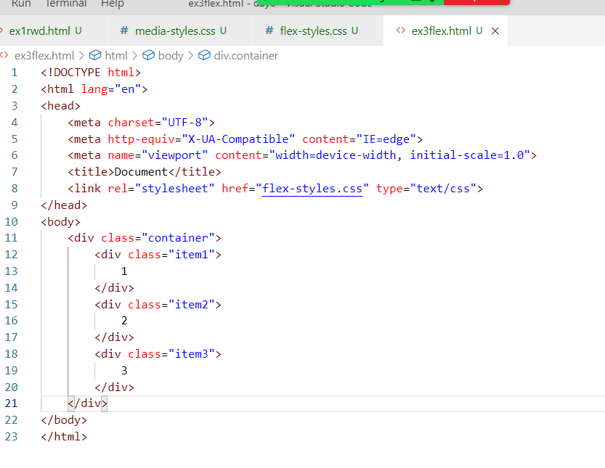

Output when screen size is > 400px:

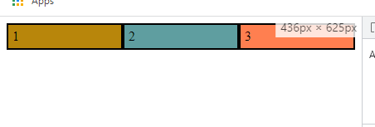

Output when screen size is <= 400px

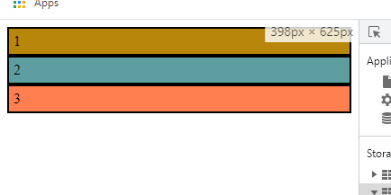

Bootstrap.js

It is a third party library which is used to style the websites, it has many inbuilt classes which are created keeping all kinds of devices & size in mind, you can use these classes in your project and they behave as per the device.

<https://getbootstrap.com/>

Above is the official website of bootstrap.js, this website provides the examples so that you can see the result of using their classes.

Adding bootstrap.js to the website

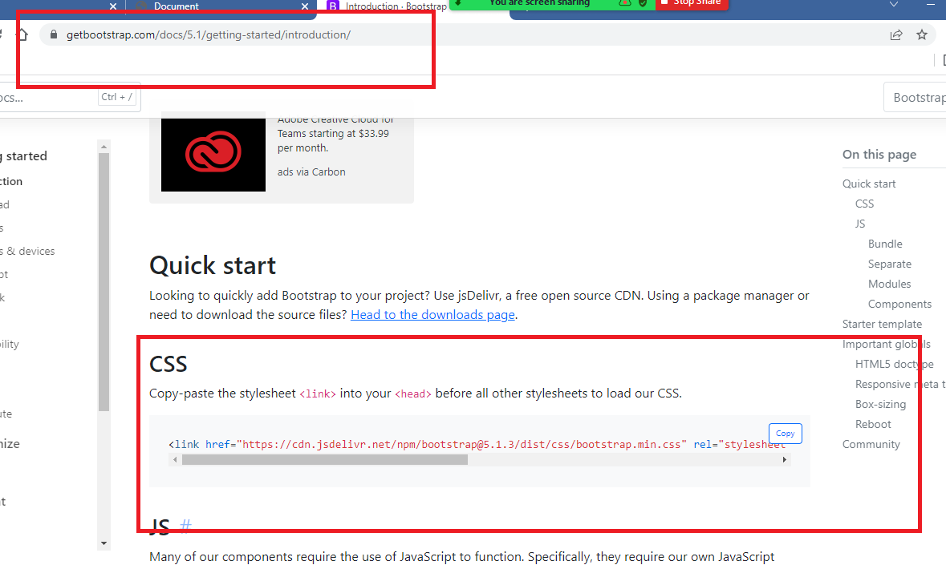

ex4bootstrap.html

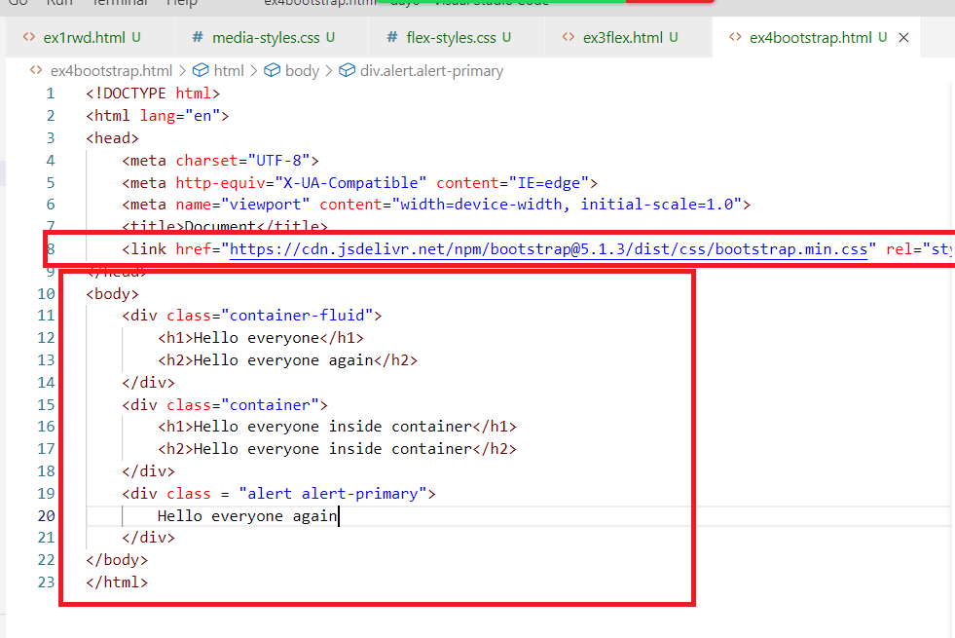

Output:

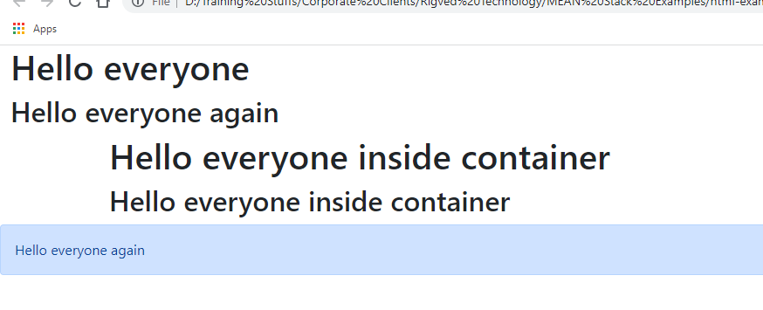

You can use different button classes

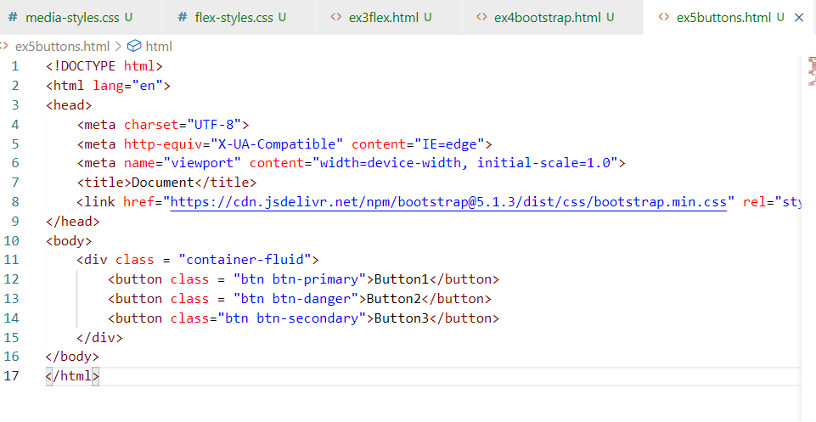

Output:

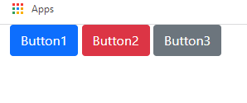

There are many types of classes like table, card, row & col and so on

table, table-striped

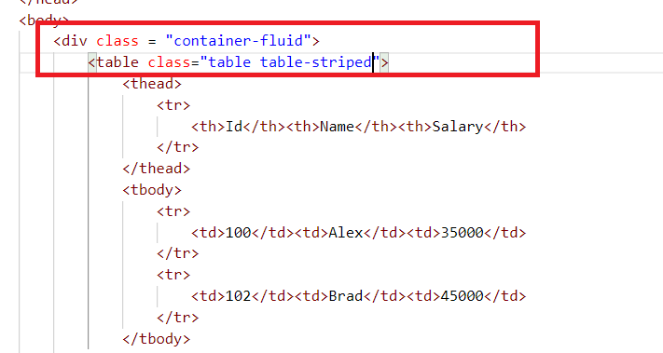

Output:

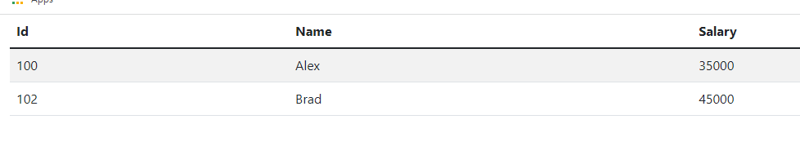

row & col classes

It is like a flex box, where you can have items in a row, but maximum 12 items you can have in a row, these items are created with class col, these col would occupy maximum 12 items space.

i.e.,

col-1 -> occupy 1 space

col-3 -> occupy 3 column space

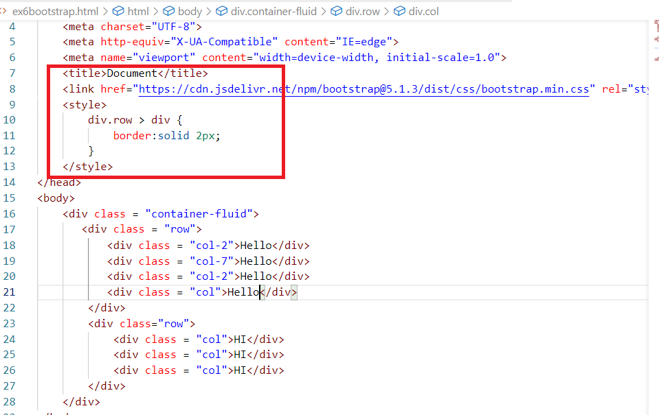

Note: You can see at 10th line div.row > div, which means selects the <div> inside <div class = “row”>

Output:

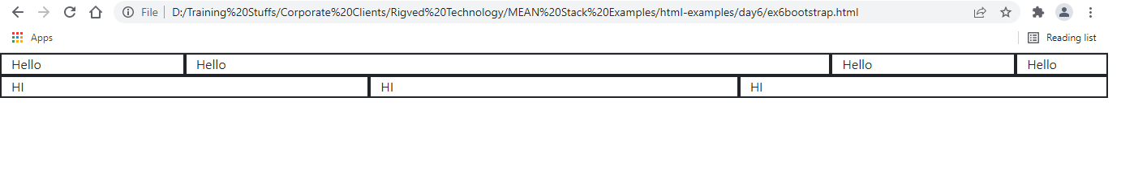

You can also apply lot of other classes like card, form-control and so on.

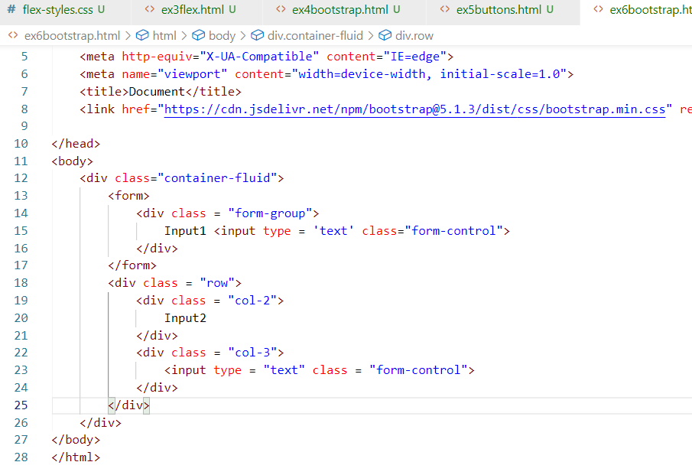

Output:

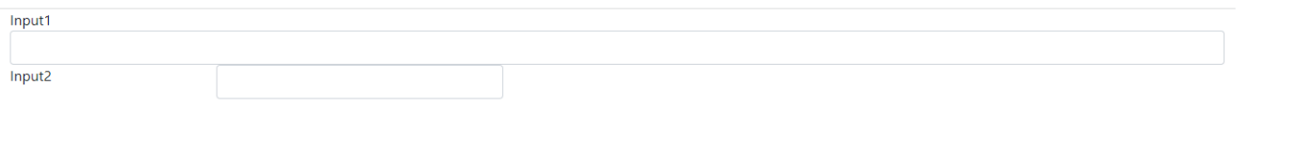

Activity:

1. Try today’s exercises like media query, flexbox, some bootstrap examples
2. Goto the bootstrap website <https://getbootstrap.com/docs/5.1/getting-started/introduction/>

Try out all the classes and observe the result, some important classes you had to try.

1. card
2. row & col
3. container, container-fluid
4. alert, alert-danger
5. navs & tab
6. navbar
7. spinners
8. toasts
9. pagination
10. progress

Along with the above classes, try other classes as well.

Day7:

Javascript

* It is a scripting language used to access HTML elements and
* can add dynamic behaviour to the web page,
* it can perform DOM (Document Object Model) manipulation - adding element, updating element, removing element and so on,
* it can add CSS at runtime,
* it can handle the events generated by HTML elements,
* it can perform client side validations,
* it can execute logics based on some user actions
* it can be used as a scripting language to write client & server side programs

Client: The browser can execute the javascript, client side scripts can work at the front-end to perform actions on the UI-side i.e.., browser or mobile

Server: Javascript is executed by backend environment like node.js, server side scripts can perform various business logics like interacting with the database, accessing filesystems, securing the applications and so on

We are going to learn Client side javascript, means it is executed by browser, but we are also going to learn Server side javascript which is executed by node.js later.

Either you write javascript for front-end or back-end the syntax or lexical structure is same.

Libraries, Frameworks or Tools in Javascript

* Ext.js
* Node.js
* Angular Framework
* React.js
* Vue.js
* Backbone.js
* jQuery

All the above lists are Javascript libraries & frameworks which simplifies writing javascript code, to understand them we must know Javascript first.

You can use <script> tag to add javascript to the HTML document, you can add Javascript directly to the HTML or create a script file and include in the HTML, means there are two types of Javascript

1. Internal Javascript
2. External Javascript

Where to write <script> tag in the HTML

You can write <script> either in <head> or <body> or both

<script> inside <head> loads when the head of the document is loaded, but before body, if there are more scripts then the document takes time to load the content

<script> inside <body> loads when the body of the document is loaded, if you write <script> after all the contents then the script is loaded after all the contents are loaded.

Whether you write script in body or head they are loaded in two ways

1. Scripts that are executed as soon as they load
2. Scripts that are executed only when some actions are performed

How many <script> tags can be written in the HTML

You can write any number of <script> but they are executed in the order they appear

Fundamentals / Lexical Structure of Javascript

* Datatypes
* Comments
* Keywords
* Variables
* Functions/Methods
* Loops
* Conditions
* Operators
* Classes & Objects

Inbuilt objects in Javascript

Javascript provides lot of inbuilt objects which every browser understands like

* window
* document
* console
* Math
* String
* Date

Note: Javascript is case sensitive

window: It is a global object, all the objects are part of window whether its document or console or Math or String etc, window is the main object of the browser, it appears at the root level

document: It is used to access browser DOM, using which you can manipulate DOM elements like accessing HTML element, removing HTML element, updating the content and etc

Object: It is a real world entity which will have 2 things

1. property / variable
2. behaviour/function

Property: Object properties like what object has

Behaviour: Object actions like what object does

Comments: These are ignored by browser or execution engine, in Javascript you can write two types of comments

1. single line comment: //
2. multi-line comments: /* */

day7/ex1helloworld.html

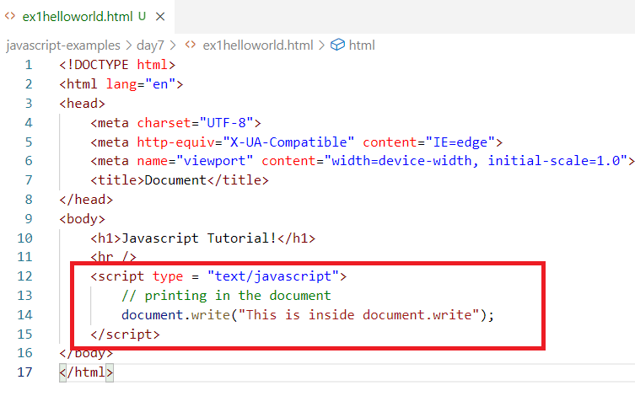

Output:

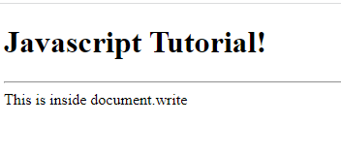

Scripts must be inside the <script> tag, since <script> tag supports other types of scripts you need to mention type = “text/javascript”, so that browser understands what type of script you are writing.

document.write(): It is used to write content to the document, write() is a function inside document object, it is case sensitive

Note: semicolon at the end of the statement is optional in Javascript as long as each statement is in separate lines, if you have multiple statements in the same line then each statement must be separated by semicolon.

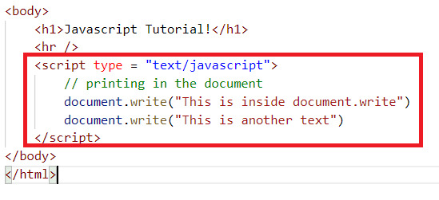

Output:

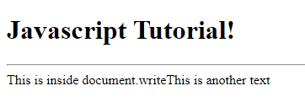

Since HTML doesn’t consider any extra space or line unless you use <br> tag, the contents appear in the same line

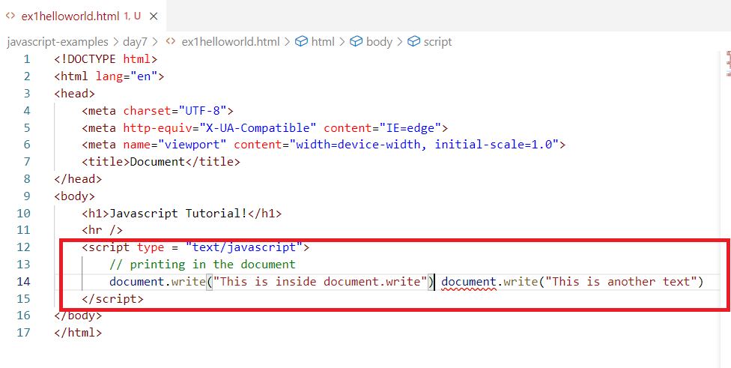

Here two statements are written in the same line without semicolon, but browser doesn’t show any error in the document, it shows error in the console (developer tools)

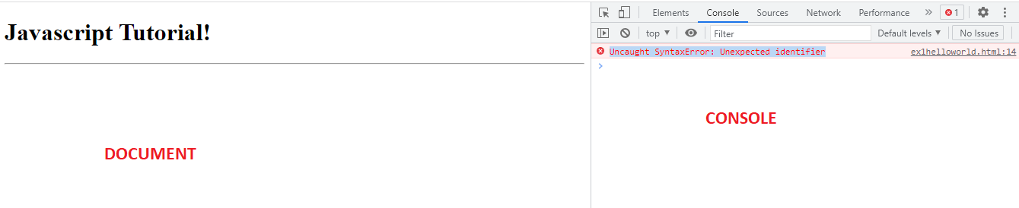

Here the document is not showing any error, if you are not getting the output as you expect check the console if there are any errors, try to understand the error and resolve it.

How to resolve this error

There are two ways

1. Write both the statements in separate line
2. If both are in the same line use ; (semicolon)

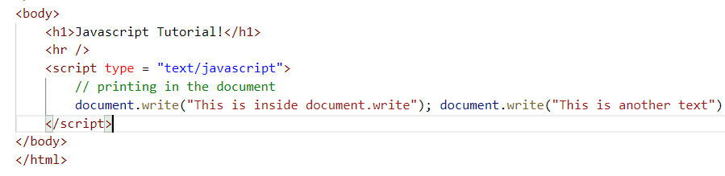

Output:

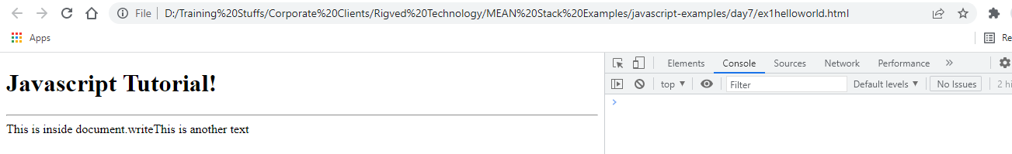

Note: Any new programmer can improve the logical skills when the errors in the program is resolved by himself.

Another mistake in document.write

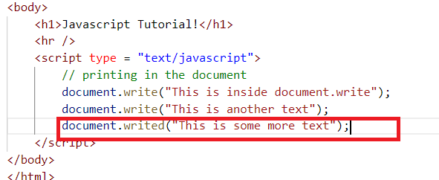

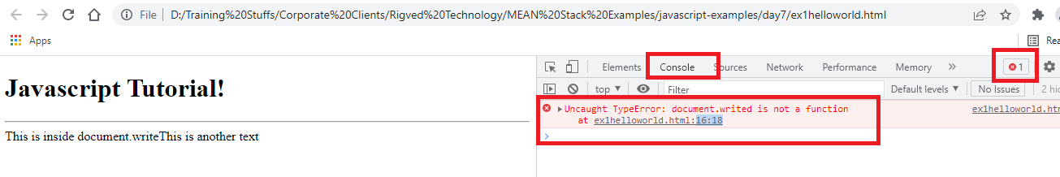

Declaring Variables:

Variables are memories to store the data, you can store any kind of data in a Javascript variable, to declare variable you can use a keyword ‘var’

var name = “Alex”;

var age = 35;

var salary = 35200.35;

var isMarried = true;

Variable names can have alphanumeric characters, means alphabets and numbers, but they must begin with letters followed by alphabets or numbers.

Valid Variable names

var num1; // valid

var num123; // valid

var num12abc; //valid

var first_name;// valid, you can use underscores

var num$xyz; // valid, but most of them don’t use $

var _; // valid, just an underscore is also valid

Invalid variable names

var 123abc; // invalid, can’t start with numbers

var 123; // invalid, can’t have just numbers

var abc-xyz; // invalid, can’t have hyphen, because treated as 2 variables need to subtracted

Literals: These are values the variables take, you can have strings, numbers, boolean, objects as literals

Note: A string can be in single or double quotes

var name = ‘Alex’; // valid

var name = “Alex”; // valid

var name = “Alex’; // invalid, because you are closing with single quote

ex2variables.html

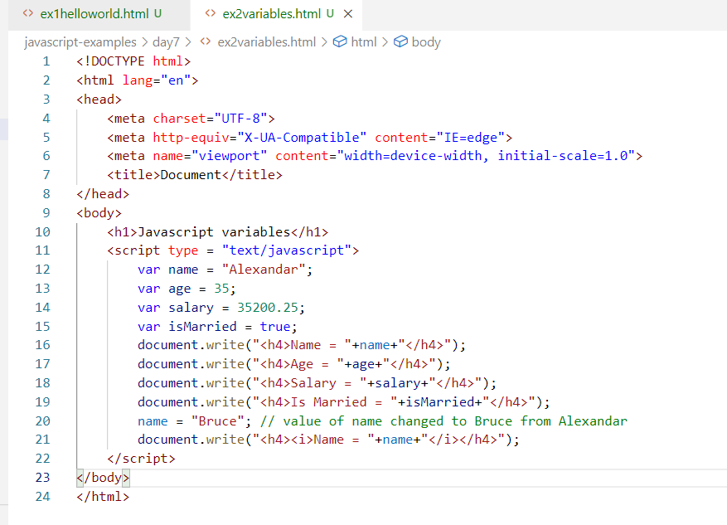

Output:

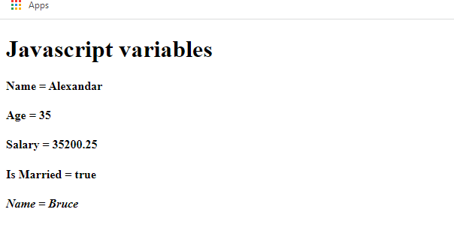

In Javascript you can create variables without using var keyword also

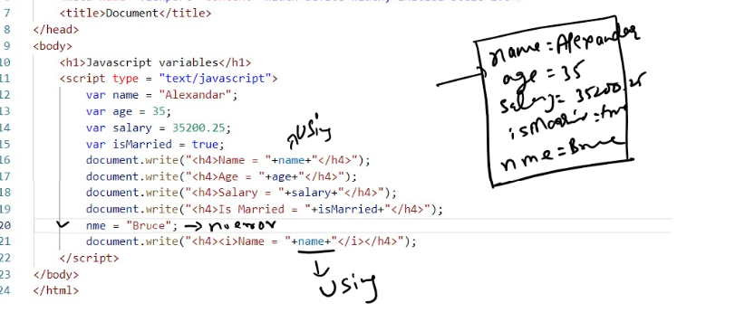

The above code at 20th line will create a new variable ‘nme’, hence you don’t get error.

Output:

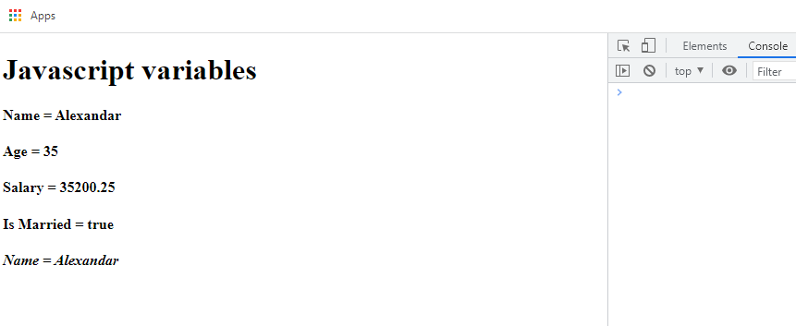

Note: When you are accessing the variable without declaring then only you will get undefined error.

var name = “Alex”;

document.write(name); // accessing name variable

fullname = “David” + name; // accessing name variable, we are concatenating name with David

fullname is the variable that is getting initialized, thought it is not using var fullname, it is still okay in javascript.

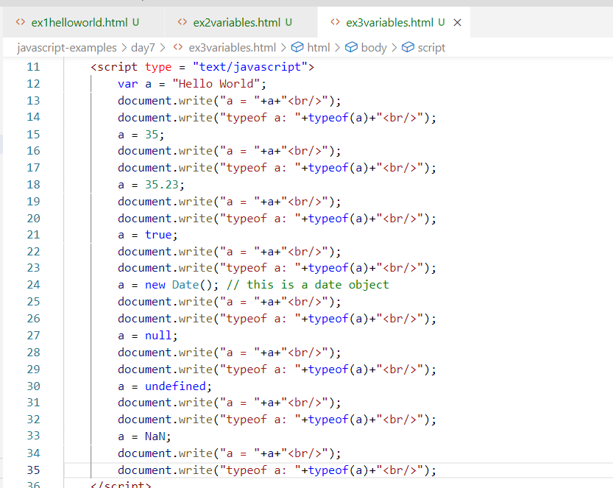

Output:

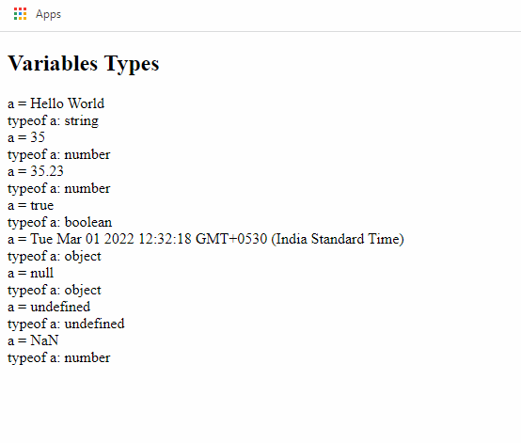

Note: NaN is also a number type which means Not A Number, undefined is also one type, null is an object type.

Pop up boxes

We can three types of popup box in javascript

alert(): creates an alert box

confirm(): creates a confirm with ok or cancel, returns true/false

prompt(): accepts an input from the user & returns to the program, the value returned by the prompt will always be string, which can be converted to other types using some inbuilt functions like parseInt(), parseFloat()

ex4popupbox.html

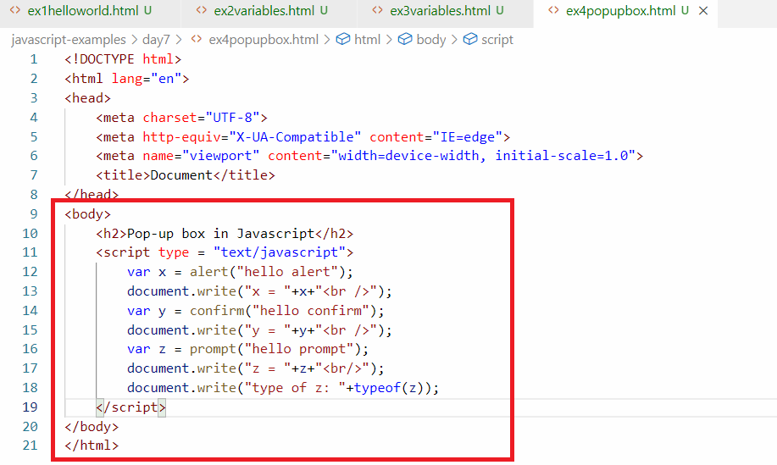

Output:

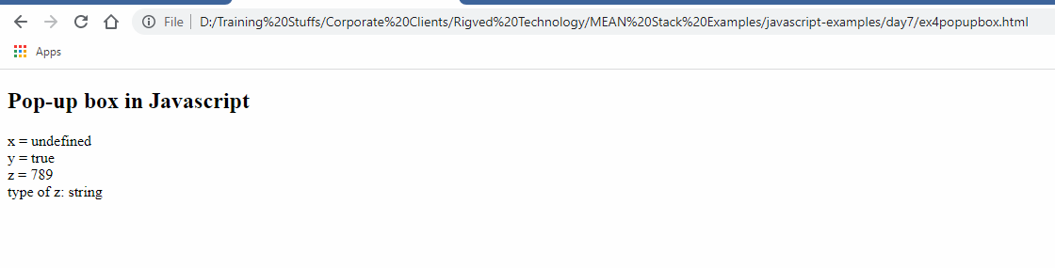

Operators in Javascript

We have arithmetic operators, logical operators, bitwise operators, comparison operators, conditional operators and so on

+, -, *, =, /, ++, --, <=, >=, <, >, !=, ==, ===, &&, ||, +=, -=, *=, /=, %, ^

ex4operators.html

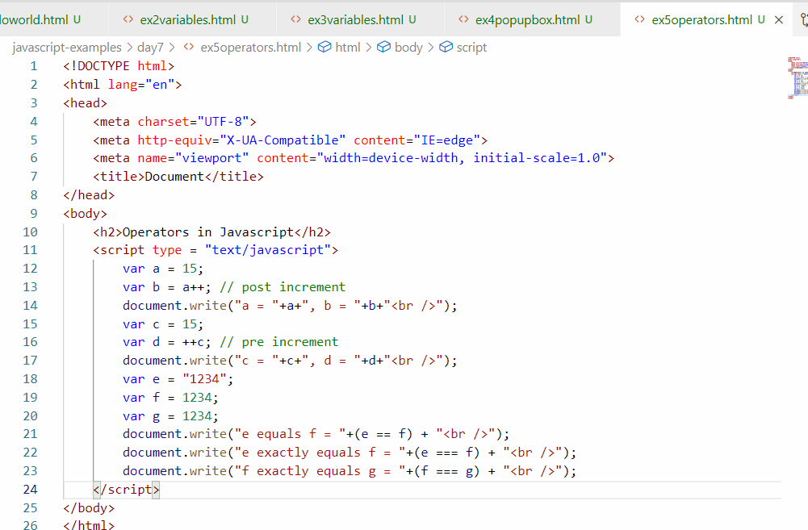

Output:

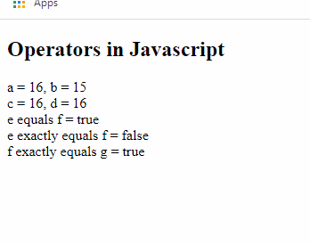

Datatypes: They are type of data a variable can store, there are two types of datatypes

1. primitive types: like string, number, boolean
2. non-primitive types: like arrays, objects

Arrays: It is a variable which can store more then one value

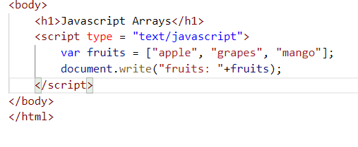

Output:

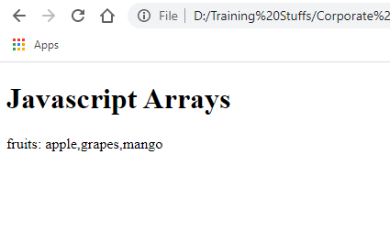

Loops

Executing same statements again and again repeatedly until some condition is met.

In Javascript there 3 types of loops

1. for
2. while
3. do while

Conditional branches

Executing some statements when some condition is met

In Javascript there are following conditional branches

1. if
2. if else
3. if else if else if … else
4. switch

ex7loopsconditions.html

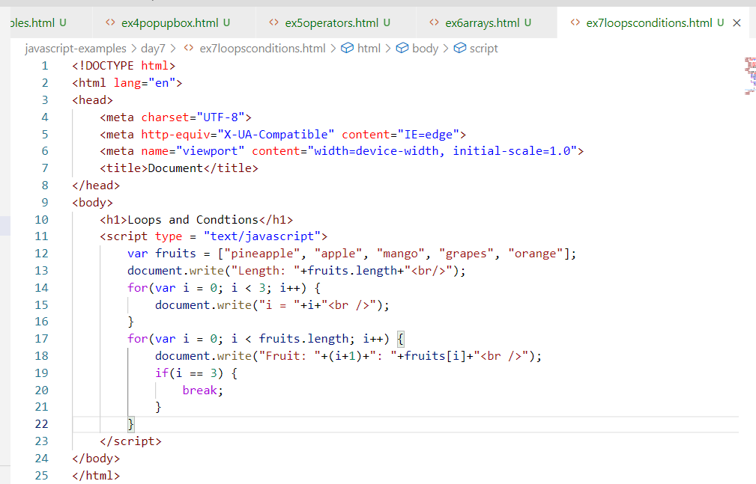

Output:

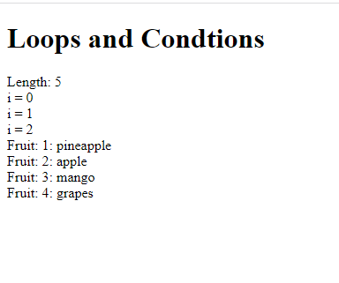

Nested loops:

A loop inside a loop is nested loop

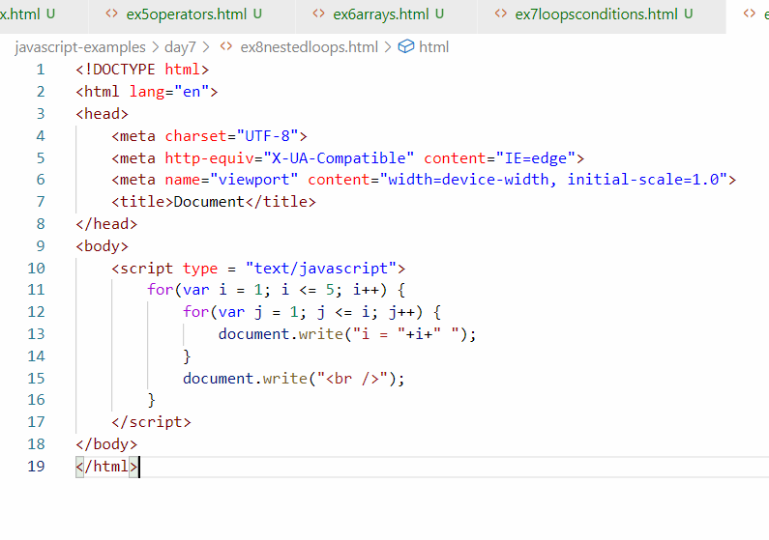

Output:

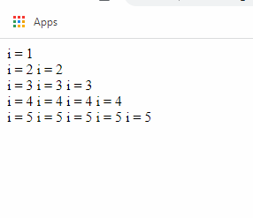

Activity

1. Try out all the above examples to understand variables, operators, loops & conditional branches
2. Using loops & conditional branches print only the odd numbers from 1 to 10
3. Using loops & conditional branches print only the even numbers from 1 to 10
4. In an array of elements [10, -3, 50, -2, 70, 40, 60], print the largest number & smallest number i.e., largest number must be 70, and smallest must be -3
5. Using loops & conditional branches create some patterns
6. Pyramid pattern

Output:

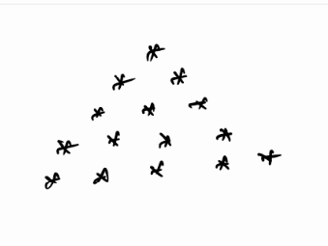

1. Diamond pattern

Output:



1. Reverse pyramid

Output:



There are two more loops you can write in Javascript

1. while loop
2. Do while loop

ex1loops.html  
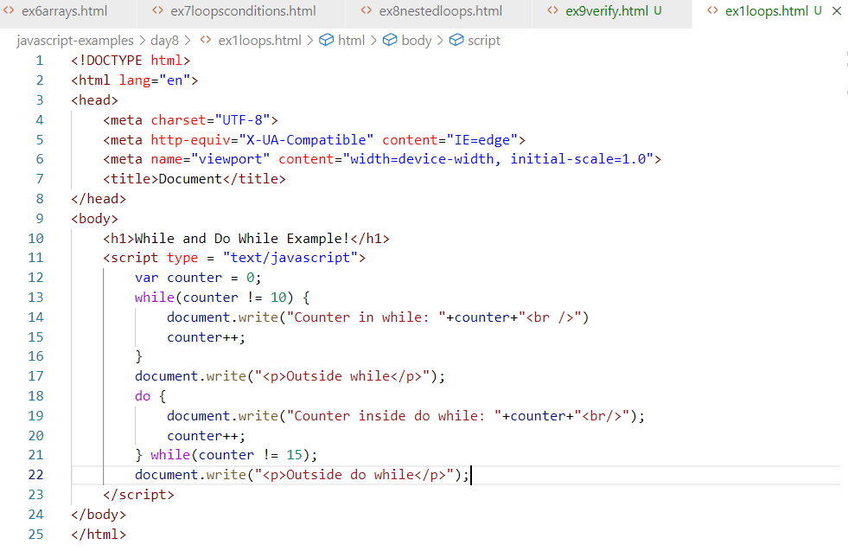

Output:

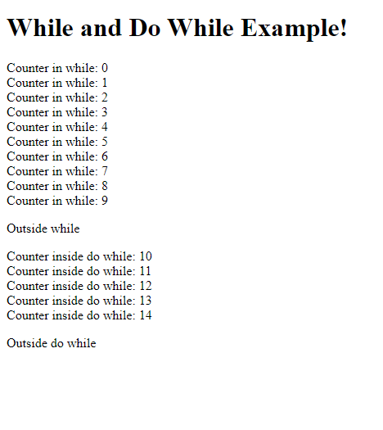

ex2numbers.html

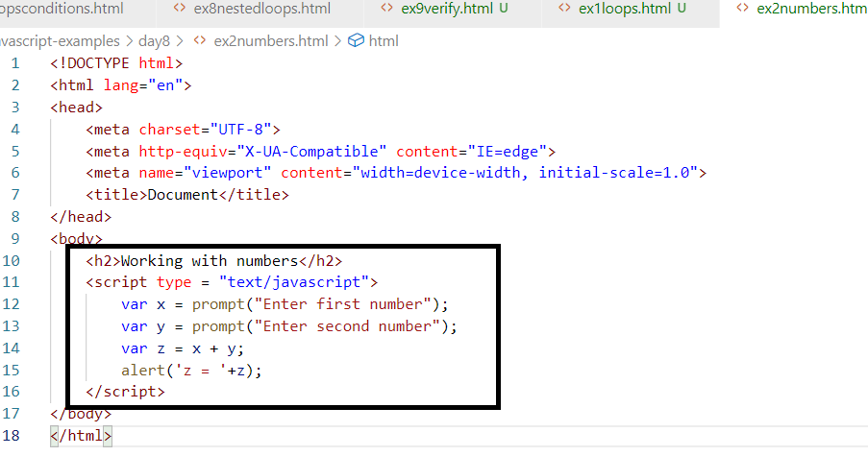

Since prompt returns the value always in string it concatenates x & y instead of adding x & y.

To convert string to number we have parseInt() and parseFloat() functions

parseInt(): Converts string to integer value ie.., whole numbers

parseFloat(): Converts string to floating point number i.e., considers fractional value as well.

parseInt(“3.2”): returns 3

parseFloat(“3.2”): returns 3.2

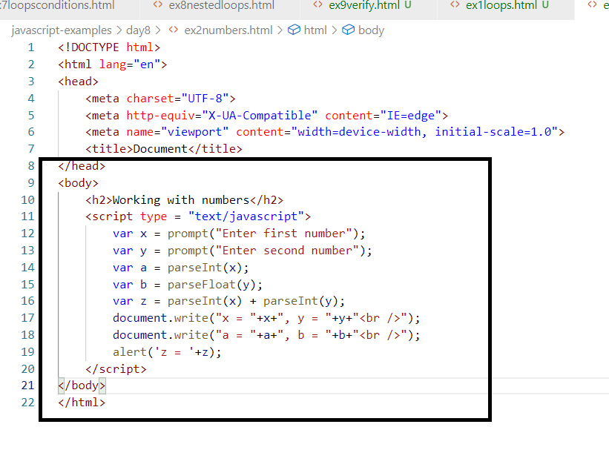

Output:

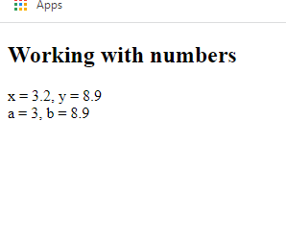

The above code uses parseInt() for 3.2 but the value will be 3 which is assigned to a, however 8.9 is passed to parseFloat() which is assigned to b, it doesn’t ignore the fractional points.

parseInt() & parseFloat() can’t convert string to number if the beginning characters are alphabets.

ex:

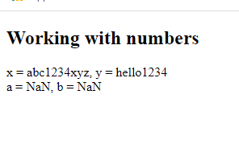

since abc1234xyz and hello1234 can’t be converted to number they return NaN.

However if the beginning characters of the string is numbers then parseInt() or parseFloat() can convert to number.

ex:

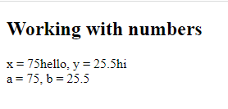

Understanding if, else, switch

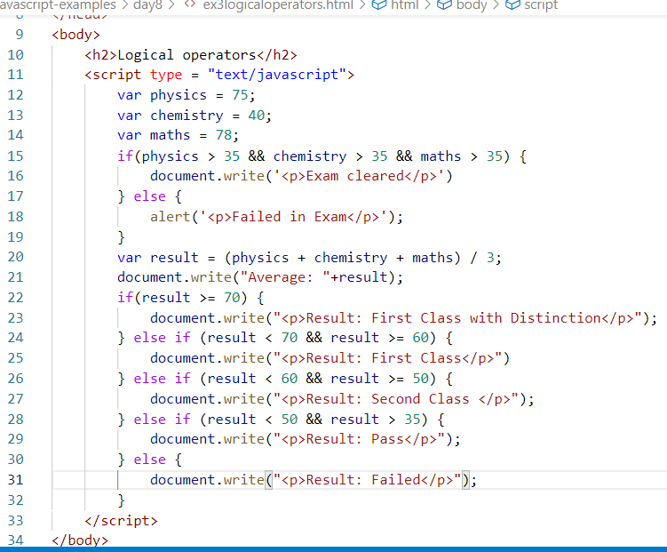

Output:

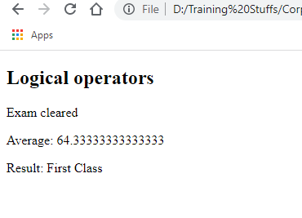

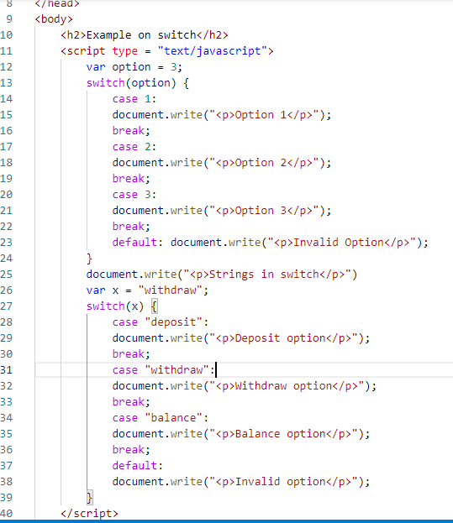

Output:

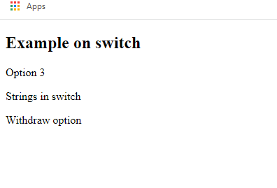

Note: Switch can accept numbers & strings, it is similar to if - else if - else, but it is mainly used when there is a single condition that could match the case.

Functions in Javascript

They can have statements which are reusable so that you can call whenever necessary, in Javascript function is created using function keyword followed by names.

The statements what you write in the functions are executed whenever you call, in Javascript you can write statements without functions also, these statements without functions were executed as soon as they load, but the statements in the function is executed only when you call.

How to call the statements inside the function

You can call the function by its name and passing arguments to it if it takes any parameter, in Javascript the functions are called whenever an event occurs.

Event: It is an object that is created when you perform any action on the HTML element, like click, submit, keyup, keydown, mouseover and so on.

There are many events the HTML element can generate based on the users’ action, some of them are

MouseEvent, KeyboardEvent, WindowEvent and so on.

These types of events are generated by either mouse or keyboard or by browser window.

When does mouse event occur?

When you perform some action via mouse, similarly other event occurs whenever you perform some action via keyboard or window.

The HTML element has attributes for every event like:

onclick, onmouseover, onmouseout, onsubmit, onload, ondbclick, onkeyup, onkeydown, onblur, onfocus and so on

ex5functions.html

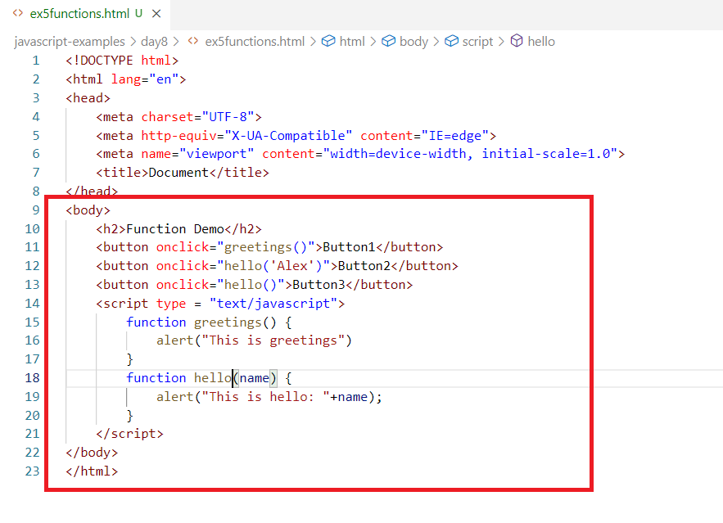

Output:

When you click on Button2, hello(‘Alex’) is called, so that it initializes name to Alex hence prints the name in the alert box

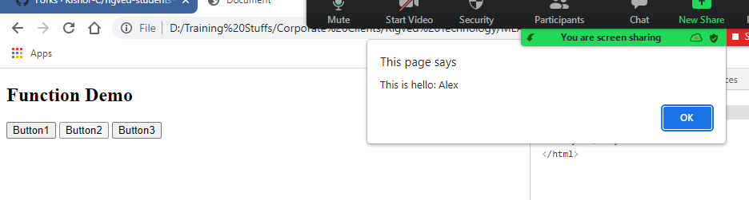

When you click on Button3, hello() is called without any parameter, so name will be initialized to undefined, hence the alert box prints undefined

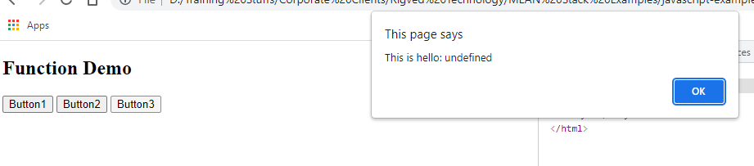

Creating functions outside the HTML

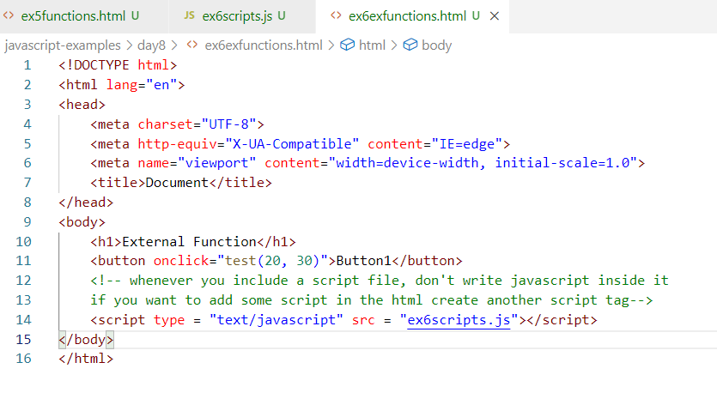

ex6scripts.js

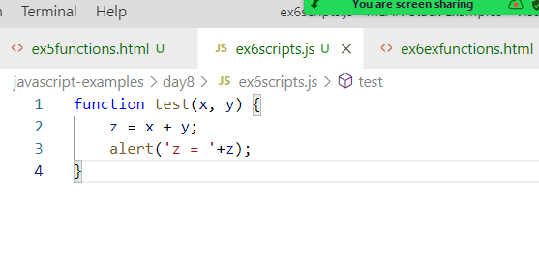

Output:

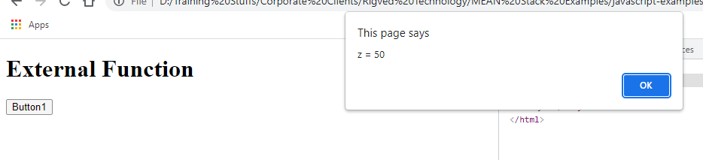

Other types of events that we can handle are:

onmouseover, onmouseout, onsubmit, onfocus, onblur, onchange and so on.

onmouseover & onmouseout: It occurs when you place mouse over an HTML element, onmouseout occurs when you move mouse out of the HTM element

onsubmit: It occurs when you submit the form and click on submit button

onfocus: When you focus on HTML element, i.e., when you focus on input element

onblur: It is opposite of onfocus.

onchange: It occurs when the drop down is selected

ex7events.html

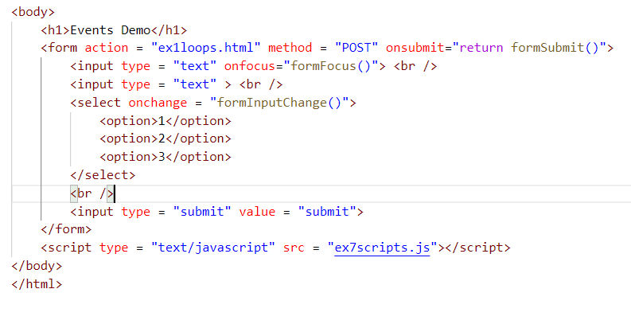

ex7scripts.js

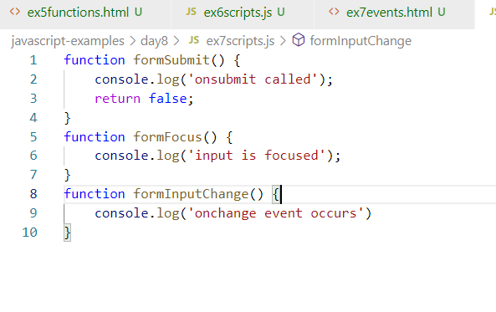

Output:

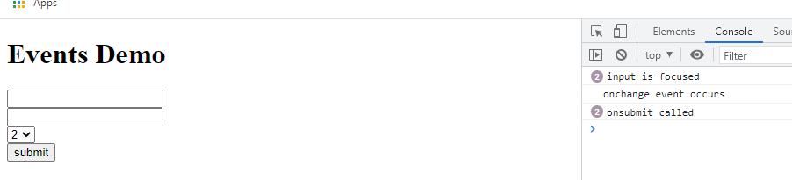

Detecting the events

You can pass an event keyword while calling the function when the event is generated so that you will know event is generated by which html element.

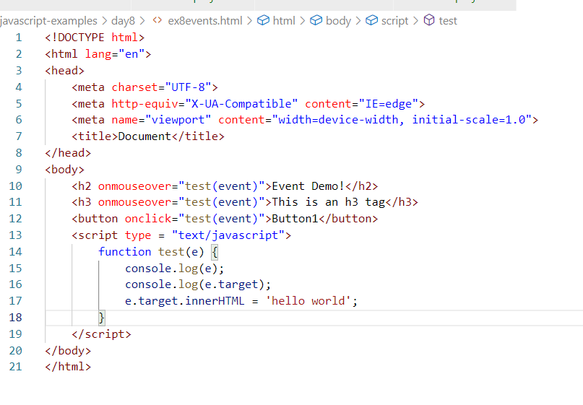

test(event) will pass the event object generated by the HTML element, the event.target gives the html element that generated the event, event.target.innerHTML is another property that changes the content of the HTML element that generated the event.

Note: target is the property of event object, since it is an HTML element, innerHTML you can access, as innerHTML is the property of DOM element

Output:

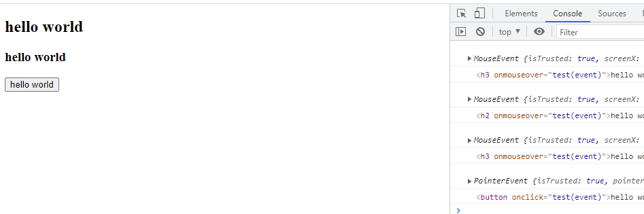

Reading value from the from

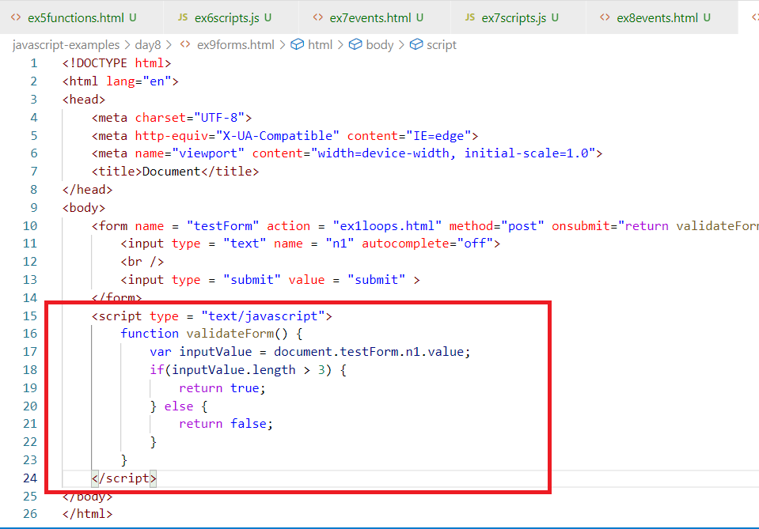

Output:

The form would be submitted only if the size of the input value is > 3

Activity:

1. Try all the above examples
2. Using Javascript validate the form that shows the alert box if there’s validation error.

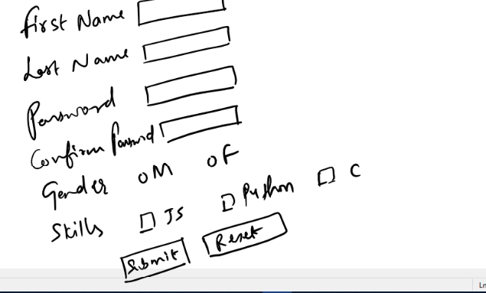

The above form must submit and show the next page only if following validation rules are met, if not display the alert box saying what is required

ex: if firstname characters < 3, then show the alert - firstname must be morethan 3 characters, similarly lastname must be > 1 character

* Password must be more than 3 characters, if not show the alert password must be more than 3 characters
* Password & confirm password must be same, if not then show the alert password & confirm password is not matching
* Gender must be selected, if not selected show the alert gender should be selected
* At-least one Skill must be selected, else show the alert any one skill must be selected.
* If any of the validation fails form must not show the next page, if all the validation succeeds then the form submission can show the next page

Solution for registration form validation

day9/ex1.html

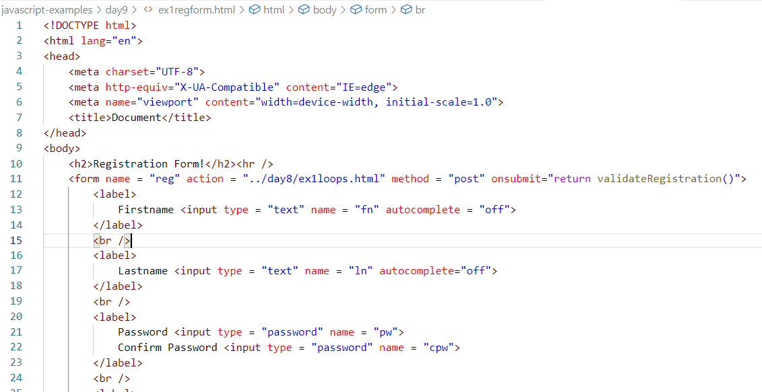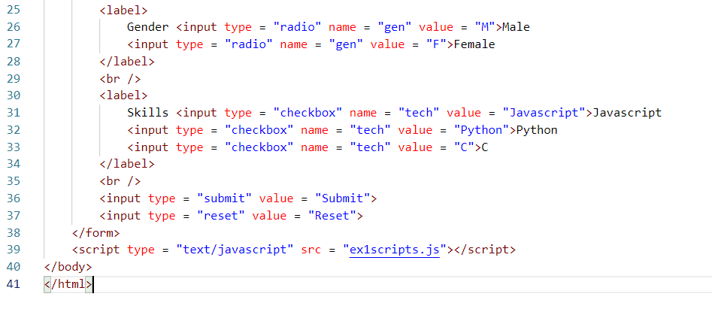

day9/ex1scripts.js

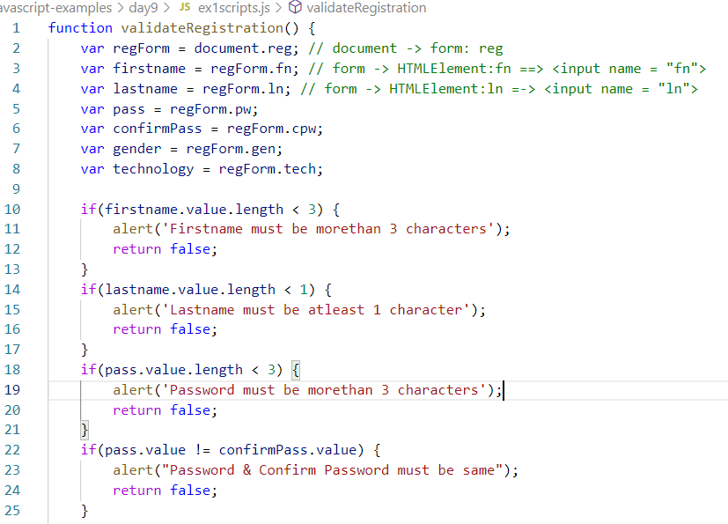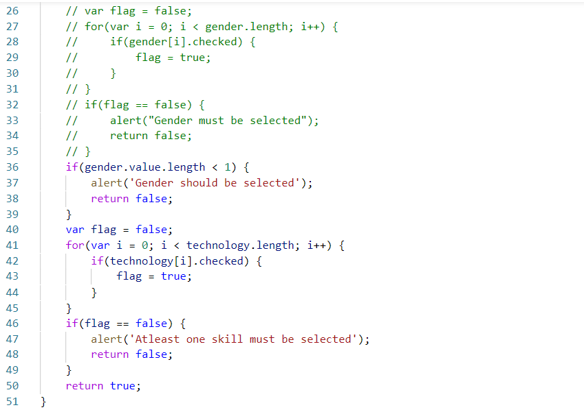

Output:

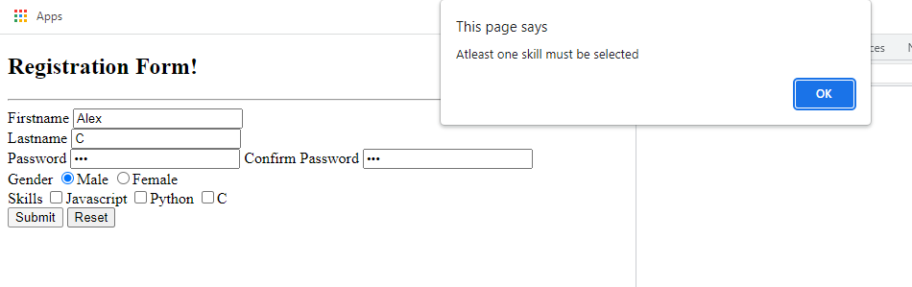

Inbuilt objects and their properties & behaviours

document: It refers to the DOM of the browser, it has methods like write(), getElementById()

Date: It gives you the date, it has methods like getYear(), getDate(), getMonth() and so on

Math: It gives you mathematical operations like round(), floor(), ceil(), random(), PI, E and so on

String: It is an object with functions like toUppercase(), toLowerCase(), indexOf(), lastIndexOf() and so on

ex2date.html

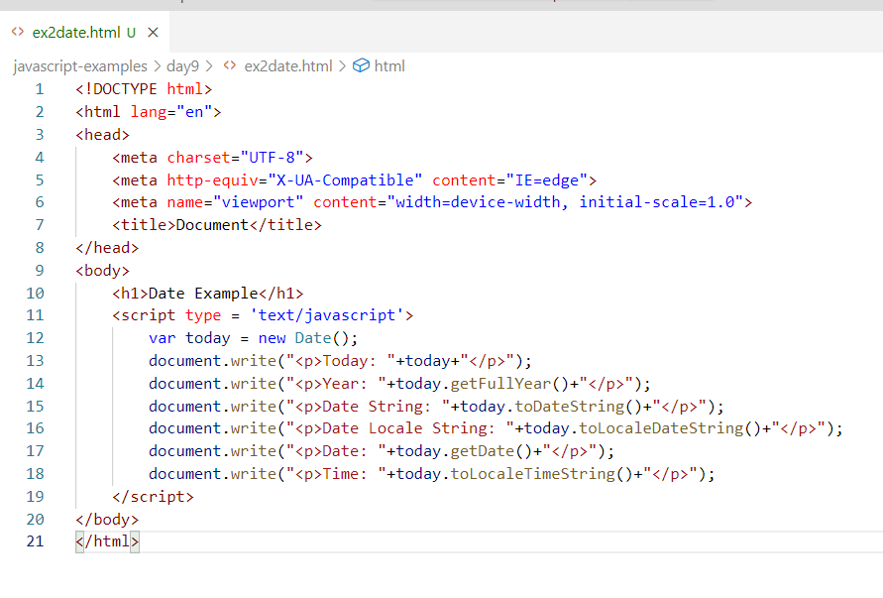

Output:

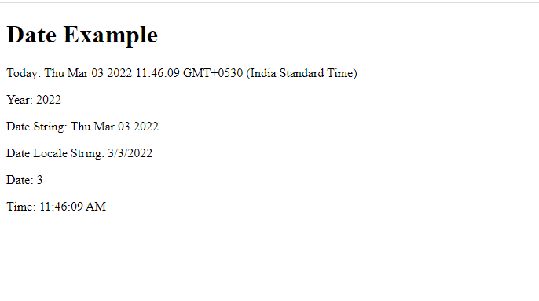

Note: new is a keyword used to create a memory for an object, the Date() is a constructor that initializes the object

Note: When you want to create object you will use the syntax with new keyword i.e.,

var d = new Date();

Working with Math functions

Since Math object is by default available you can use Math directly as

Math.PI, Math.ceil(), Math.floor() and so on

Since document object is by default available you can use document directly as

document.forms, document.write()

Math has two main properties like PI & E

PI: Gives PI value, which can be used in finding area

E: Gives exponential value

Math has many functions like

random(): to randomly generate numbers

round(): to roundup the numbers to whole numbers

ceil(): to roundup the numbers to the next whole number, i.e., Math.ceil(4.4): it will be 5.0

floor(): to roundup the numbers to previous whole number, i.e., Math.floor(4.4): it will be 4.0

pow(): to find power of a specific number

ex3math.html

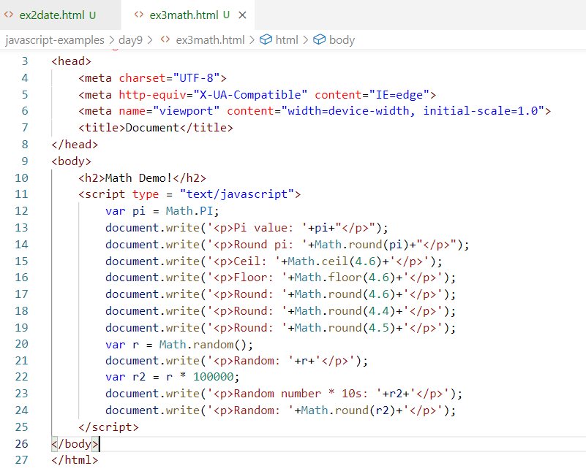

Output:

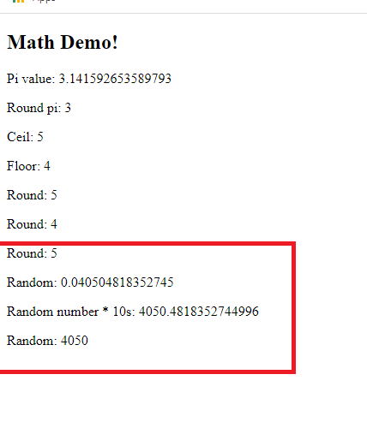

String functions:

String object is created when you create a string, it provides functions to work with string like concat(), toUpperCase(), toLowerCase(), charAt(), indexOf(), lastIndexOf(), split(), length()

concat: it is used to concatenate the strings

toUpperCase: converts strings to uppercase

toLowerCase: converts strings to lowercase

charAt: extracts the character from the given index

indexOf: returns the index of specific character

lastIndexOf: returns the index of specific character from the end of the string

length: returns the length of the string

split: it splits the strings into multiple strings based on the pattern, it returns an array of string having multiple strings.

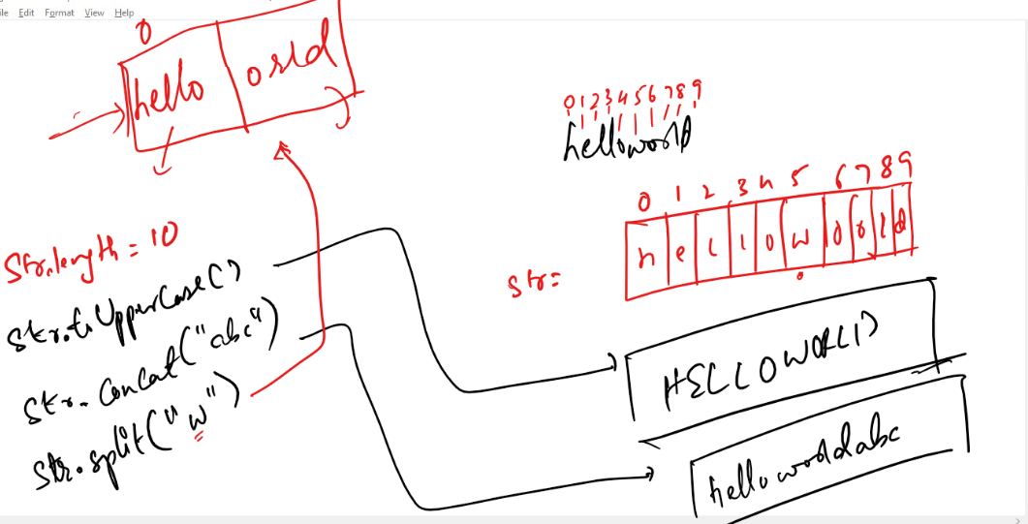

ex4string.html

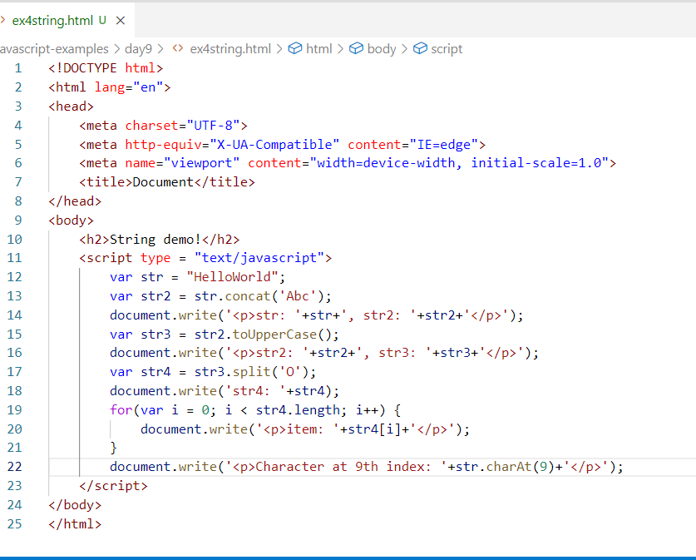

Output:

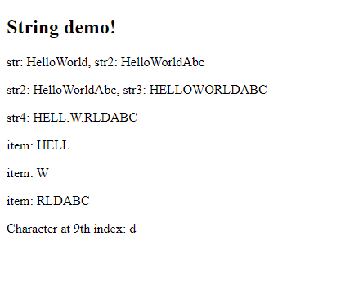

Creating our own objects

Object: An object is a real world entity with properties & behaviours, it will have constructor that initializes the object properties

How to create a constructor

You must use a function to create constructor whose name must start with uppercase.

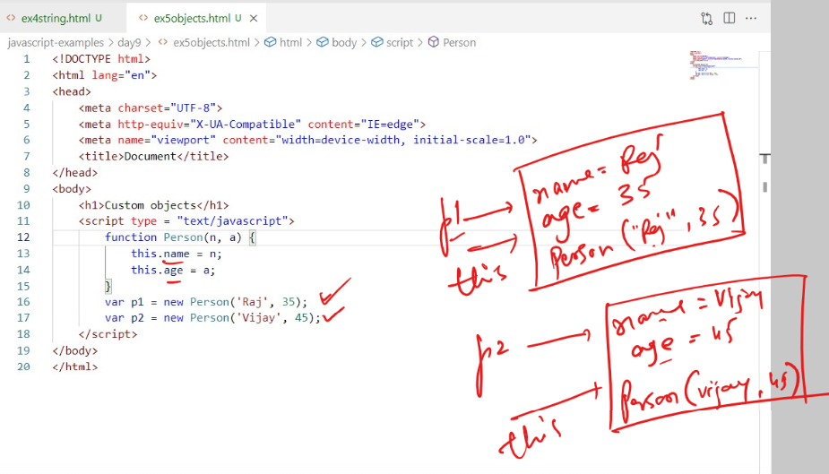

Note: this.name, this.age, creates the properties for the object, which you can access from the reference of the object i.e., p1.name, p2.age, p1.age, p2.name and so on.

ex5objects.html

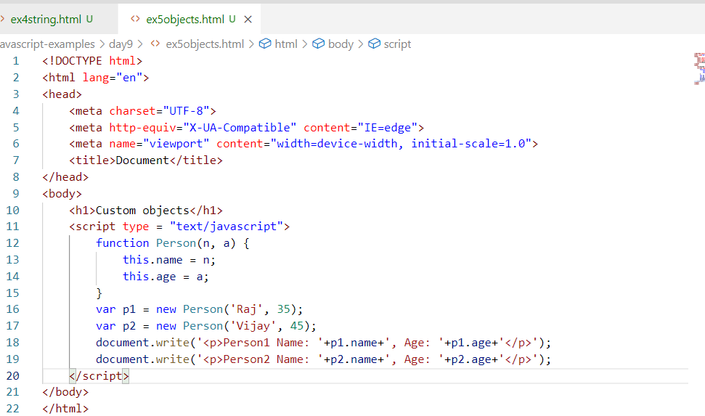

Output:

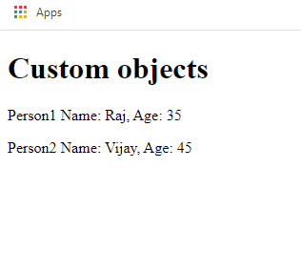

Activity:

1. Create 2 input box that takes numbers and shows the result in another input box when you click on buttons.

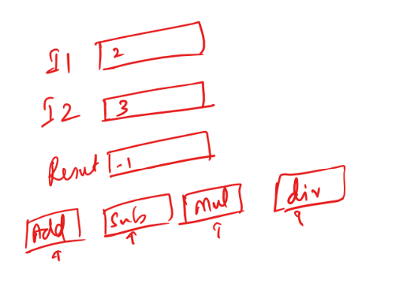

1. Show a prompt that accepts the number of digits the OTP should be accordingly generate the OTP, the number digits must be either 4 or 6 only, if you enter other digits like 1 or 2 or 3 or 5 or 7 or 8 or 9, alert with an error saying invalid digits to generate OTP

ex: If the prompt takes 4, then you must show 4 digits OTP

ex: If the prompt takes 6, then you must show 6 digits OTP

Prototype:

It is a feature in the object to add additional functions to it, so that you can access object properties either to read or update properties

Suppose you have a function to create an object of Person, like below:

function Person(name, age) {   
 this.name = name;  
 this.age = age;  
}

Here p1 = new Person(“Alex”, 35); is an object which has 2 properties name & age, these properties are initialized from the parameters name & age present within the parenthesis.

When you want to have some extra functions in an object you add through prototype, so that you can call those functions from the object reference.

Similar to the way you called inbuilt objects functions like Math, Date, String, document and so on, you can call functions from your custom object also.

i.e., var d = new Date(); you can write this statement because javascript has an object constructor for the Date, i.e., function Date() { },

From the reference i.e., ‘d’ variable you can access date object functions like getDay(), getFullYear() and so on, these are the methods allows you to read Date object properties like day, fullyear, months and so on, it is possible because they have these methods added in the Date object prototype.

These methods of Date are getters/accessors which are used to read the properties of date, like getYear(), getFullYear(), getMonth() and so on.

These are methods of Date which are setters/mutators which are used to modify the properties of date like setYear(), setMonth().

Mutators & Accessor or Setters & Getters:

These are used to modify the existing object properties as well as read the properties, these are access once object is created and you want to access a particular property either to modify or read.

To add the getters or setters you need to use object prototype.

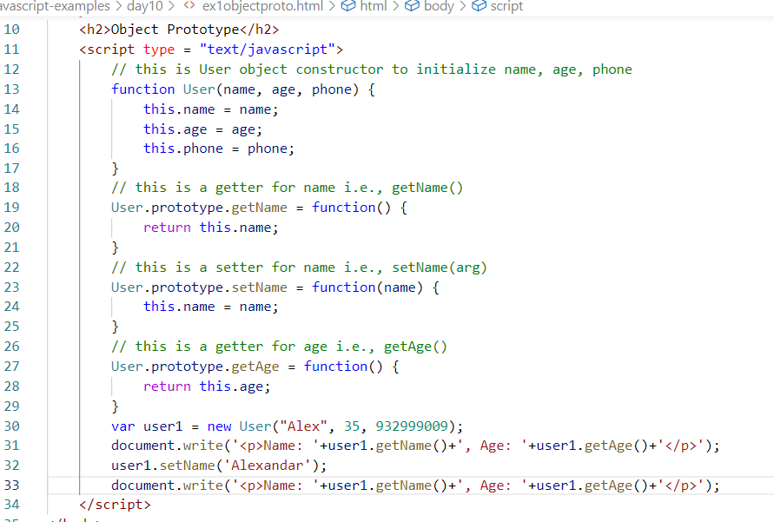

Output:

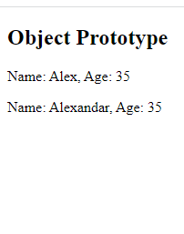

Inheritance:

Process of acquiring properties & behaviours of an object from another object is called inheritance, when you have multiple object with some common properties & behaviours then you can create an object with those common properties & behaviours so that other objects can inherit it so that common properties are inherited, however the new properties & behaviours specific to the object you can create in that object, here you are reusing other objects properties & behaviours without rewriting.

How to achieve inheritance in Javascript

* We can achieve inheritance using object prototype, but the new features of Javascript supports achieving inheritance through classes i.e., ES6 new features

ex:

function Person(name, age) { } // Person constructor for Person object

function Employee(id, name, age) { } // Employee constructor for Employee object

// achieving inheritance

Employee.prototype = Object.create(Person.prototype); // Person properties & behaviours copied to Employee

Now onwards you can access Person object properties & behaviours from the Employee object.

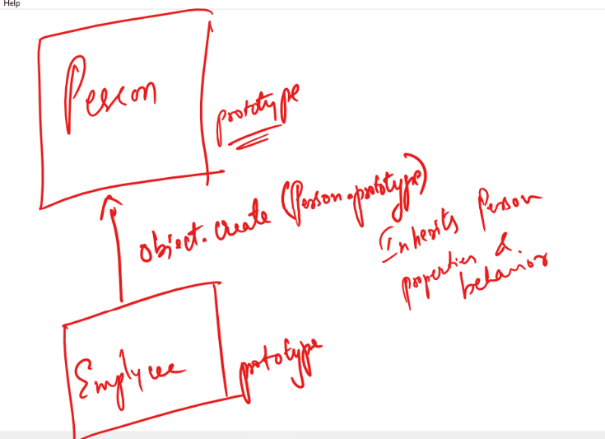

ex2inheritance.html

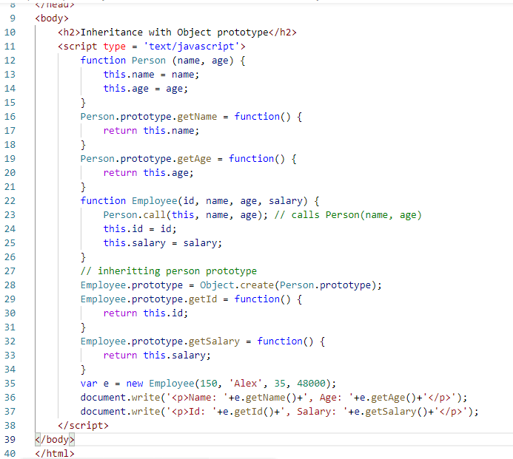

Output:

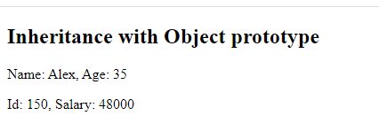

Creating object like a Record/Dictionary based syntax:

Record or Dictionary will have key & value, where key specifies the properties and value would the value to the property, you can also create functions in such type of objects

var e = {id : 100, name : “Alex”, salary: 35200}; // there the e is an object with 3 properties id, name, salary

var p = {name : “Raj”, age : 35, display : function() { } } // here the p is an object with 2 properties name & age and a function display

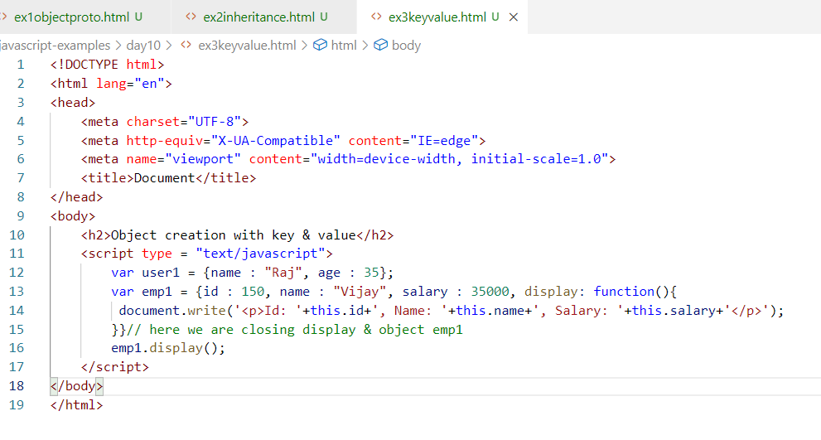

Output:

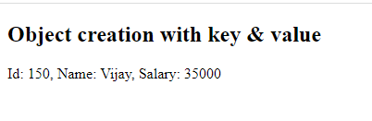

Arrays having objects

var emps = [{…}, {..}, {..}];

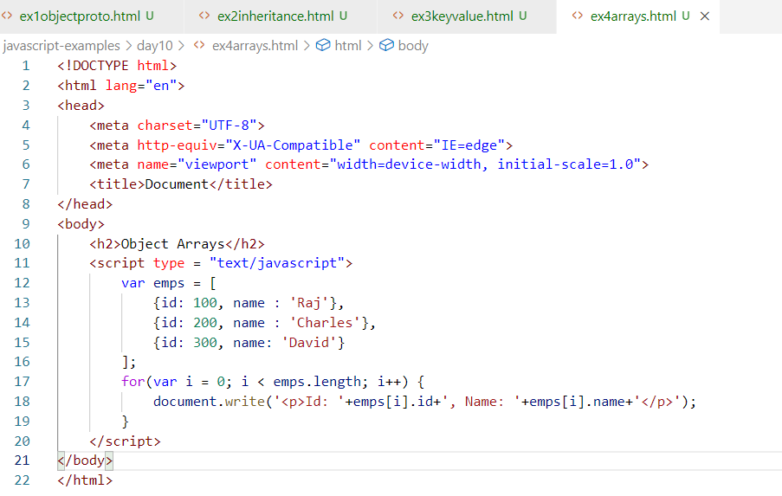

Output:

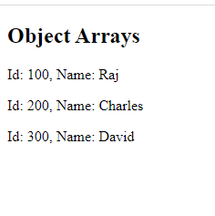

Activity:

1. Try out all the above exercises
2. Use the array having object with nested objects and display their values in a table, the array is below

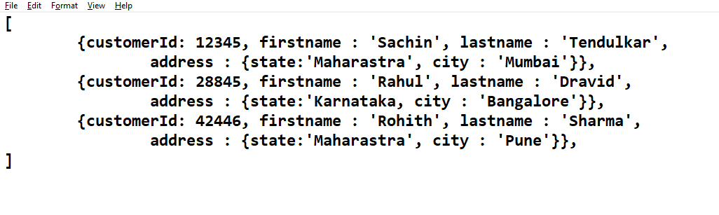

Expected output:

|  |  |  |  |
| --- | --- | --- | --- |
| Customer ID | Fullname | State | City |
| 12345 | Sachin Tendulkar | Maharastra | Mumbai |
| 28845 | Rahul Dravid | Karnataka | Bangalore |
| 42446 | Rohith Sharma | Maharastra | Pune |

Accessing HTML elements using DOM, i.e., document object

You can access the HTML element using id attribute, or class attribute, or by using the tag name, in document you have getter methods to access the element in different ways

getElementById(“idValue”): this will access a particular element having the id, you must have unique id for the element, duplicate id’s not allowed, it returns a node

getElementsByTagName(“tagName”): this will access all the elements having the tag name, it returns node list having all the nodes

getElementsByClassName(“className”): this will access all the elements having the class name, it returns node list having all the nodes.

Node: It is a javascript object that represent the HTML element, using which you can access many inbuilt properties & functions of the node.

Node List: It is an javascript arrays of object i.e., array of nodes,

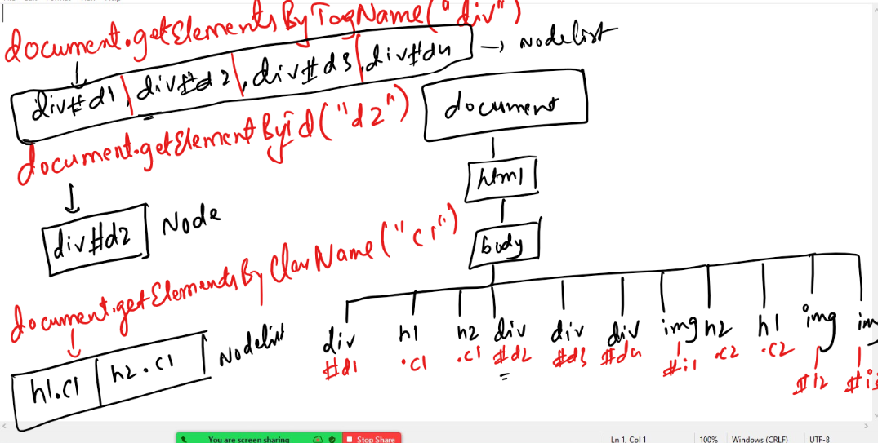

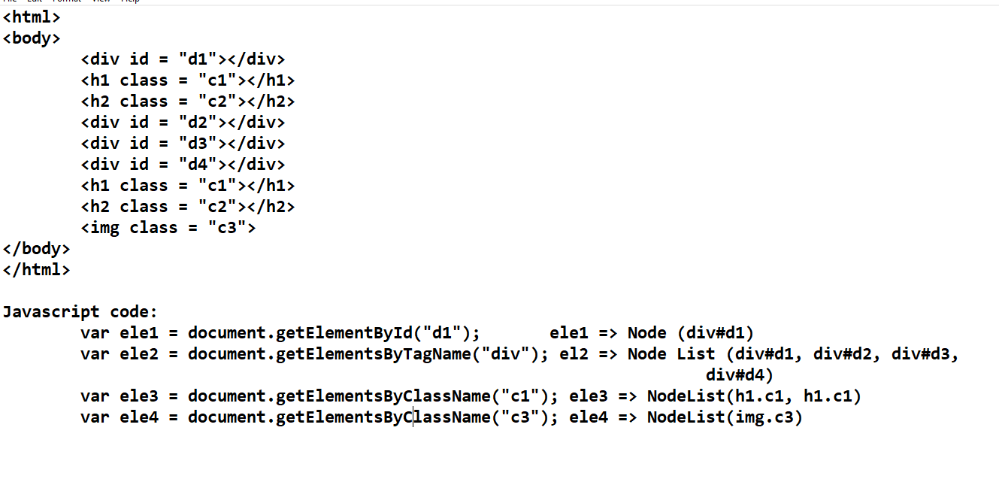

ex1nodes.html

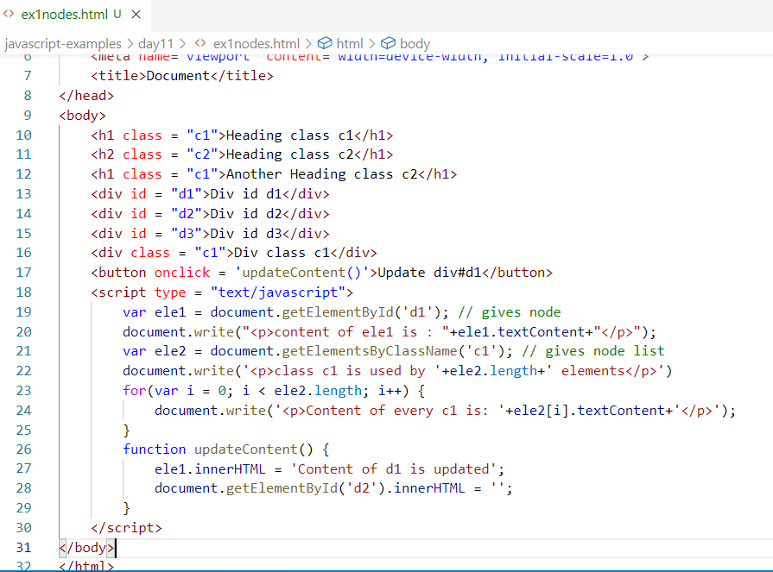

Note: 29th line removes the content of div#d2 and updates div#d1 content

Output:

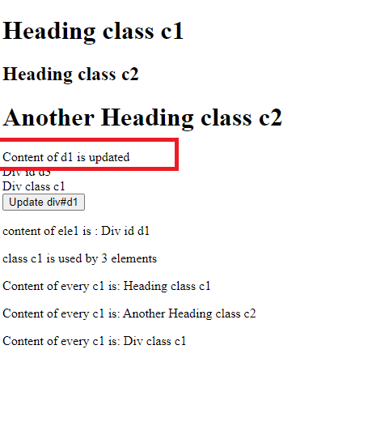

ex2gallery.html

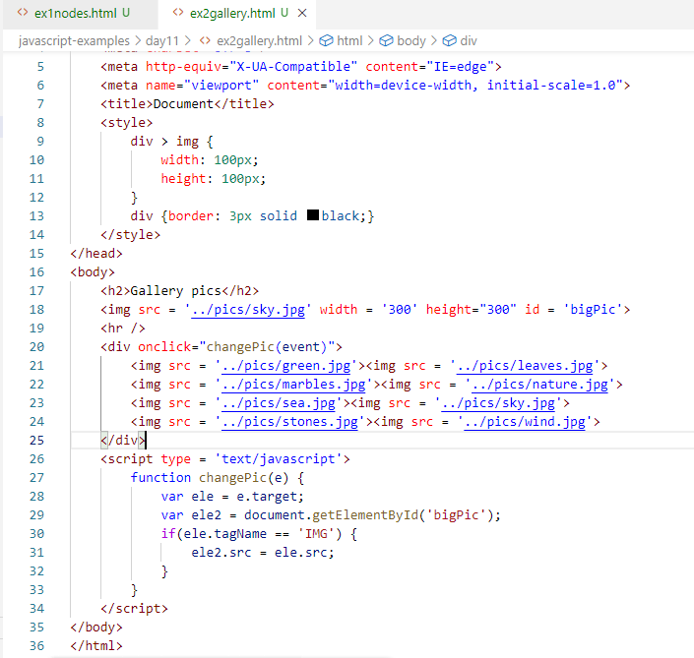

Since inside div there would be some extra space after all images are shown, there would be chance that user clicks on those space where images are not present, since we need to select the image src when you click on any of the image and assign to <img> with an id bigPic, we have written if condition that executes only if you click on the <img>. changePic() is executed only when you click on the <img> inside <div> that handles onclick.

Output:

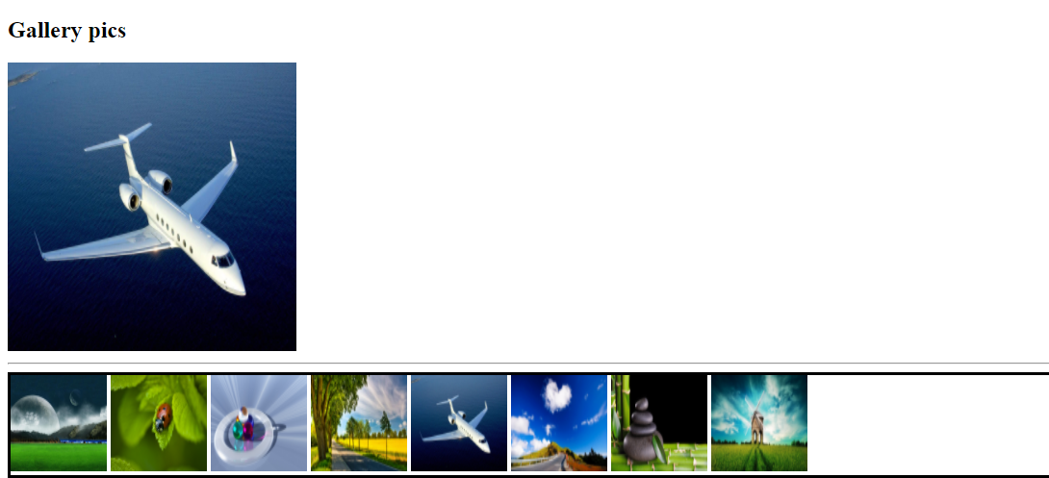

Adding CSS properties via Javascript at runtime

Whenever you access the node you can use the properties of the javascript object node to change the behaviour of the node at runtime, incase you want to add CSS properties then you must add style attribute in the element, to add style attribute through javascript you can use style property of the node element.

Syntax of CSS:

element { property : value }

Syntax of Javascript node

element.style.property = ‘value’;

|  |  |
| --- | --- |
| CSS properties | Javascript style property |
| background-color : yellow | backgroundColor = ‘yellow’ |
| font-size: 20pt | fontSize = ‘25pt’ |
| color : ‘red’ | color = ‘red’ |
| padding: 5px | padding = 5px |

ex3jsstyles.html

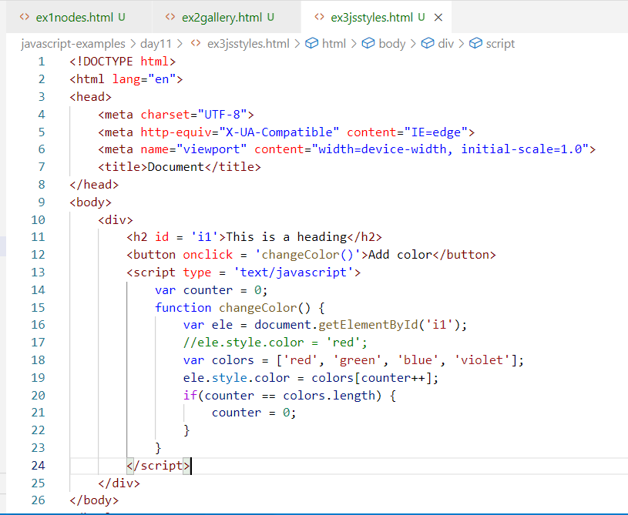

Output:

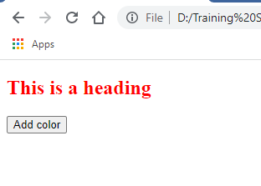

Activity:

1. Try the above examples
2. Create an element and 2 buttons below it, 1 button must increase the font size & another button must decrease the font size of the element

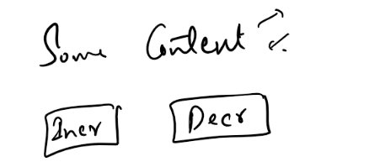

canvas:

It is an element used to create 2D shapes, it provides inbuilt functions & properties to create 2D drawings like lines, square, circle and so on.

Some of the methods are:

fillRect(x, y, w, h): It is to create square, where x & y are the axis, w & h are width & height of the sqare

arc(x, y, r, start, end, boolean): It is to create arcs & circles, where x & y are axis, r is radius, start & end are the degree like 0 to 360, boolean value is to tell the direction of the arc, whether clockwise or anti-clock wise.

We also have inbuilt properties like:

fillStyle: To mention the color of the filling

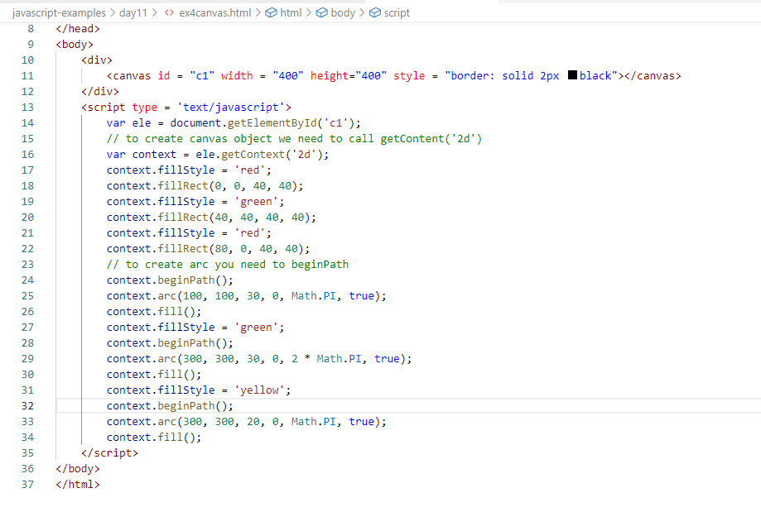

Output:

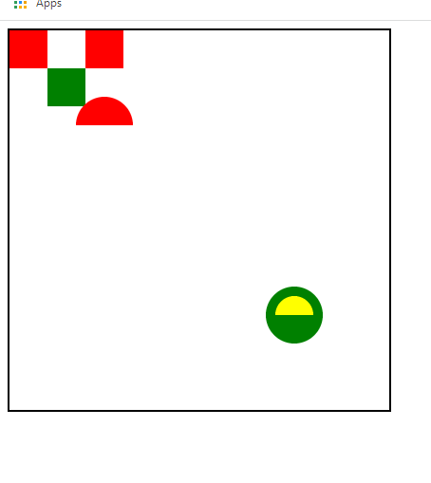

Activity:

Using functions to create square & arc, create 2 shapes

1. Chess board, where you will have white & black squares (8 * 8 = 64 squares)
2. Rainbow, where you will have VIBGYOR colors

Note: Don’t hard code the dimensions, instead use loops to create shapes & while iterating change the dimension

Solution:

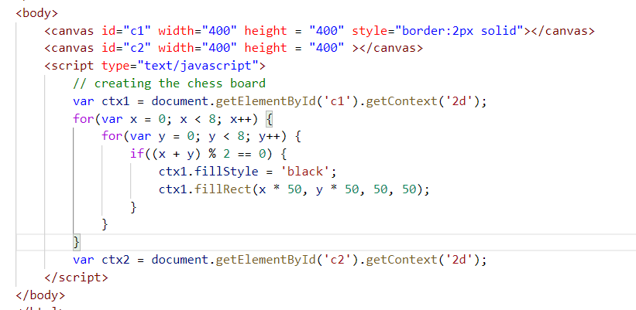

Output:



Rainbow solution

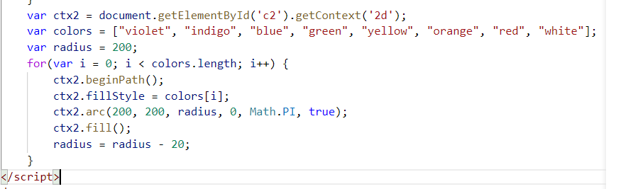

Output:

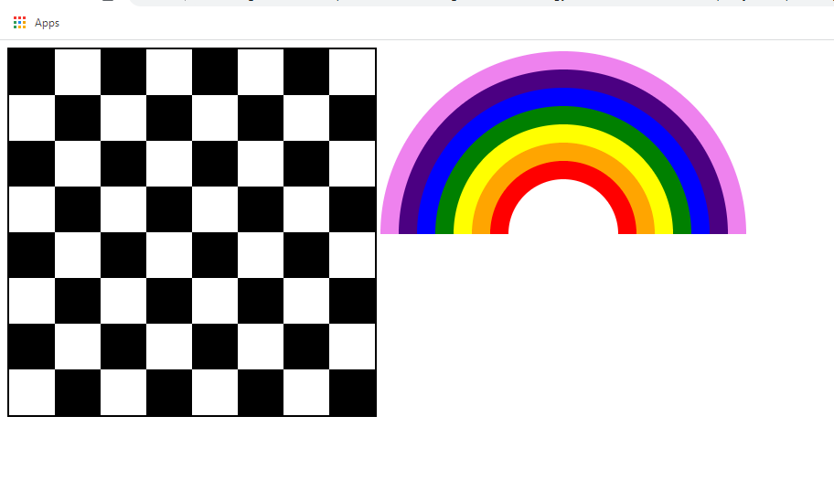

Web storage in HTML5

These are used to store the data in the web browser, there are two types of storage

1. sessionStorage: Data will be available till you close the browser
2. localStorage: Data will be available after closing the browser also until you programmatically delete it

Both the storage provides same types of methods to store, retrieve and delete the data from the storage.

* setItem(key, value): Store the data with a key
* getItem(key): Retrieves the data from the key
* removeItem(key): Removes the data based on the key
* clear(): Clears all the data

They are like cookies in browser

Cookies: It is a piece of text information stored in the client machine, the cookies are created by server, but it is a very old way of storing the data, now you can use either sessionStorage or localStorage

Why you must store the data in the browser/client machine

The data can be used later so that the server can recognize the user while responding.

ex2storage.html

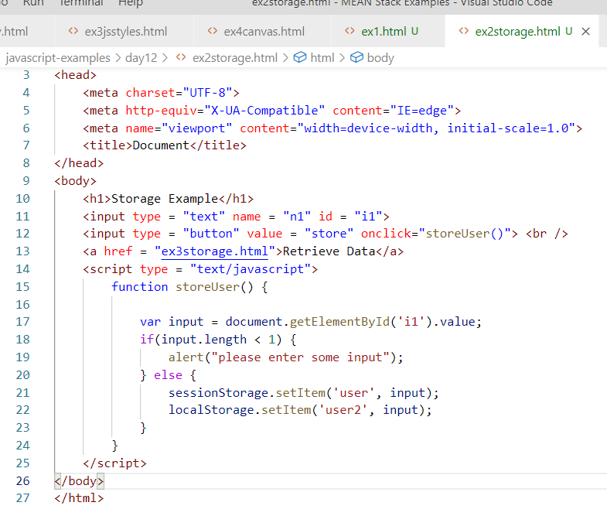

ex3storage.html

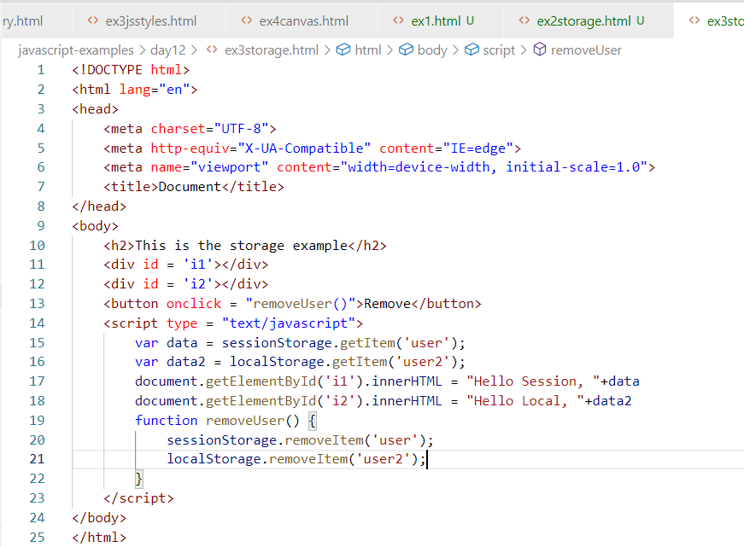

Output:

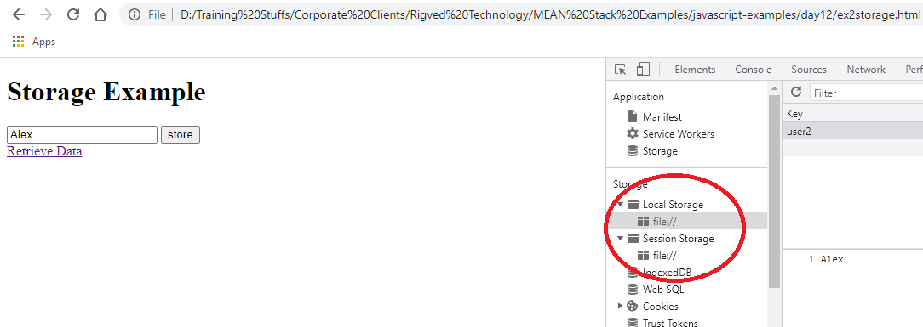

Note: Both can be deleted programmatically, however if you close the browser the session data will be automatically deleted, but local storage data will still be there which can be deleted through removeItem.

Regular Expression Object

It is an expression used to search the patterns in the string, so that you can match the pattern and perform different types of operations, like searching, updating, validating and etc.

Writing regular expression is complex as it involves lot of thinking about the occurrences of the characters, words, digits etc.

Simple regular expressions;

[a-z]: any character between a to z

[A-Z]: any character between A to Z

[a-zA-Z]: any character between a to z & A to Z

[0-9]: any digits from 0 to 9

[a-zA-Z]+: Atleast one or more characters from a to z & A to Z

[a-zA-Z]*: 0 or more occurrences

[a-z]?: 0 or 1 occurrences

(hello): matches hello

(hello){1, 3}: matches hello or hellohello or hellohellohello

ex4regex.html

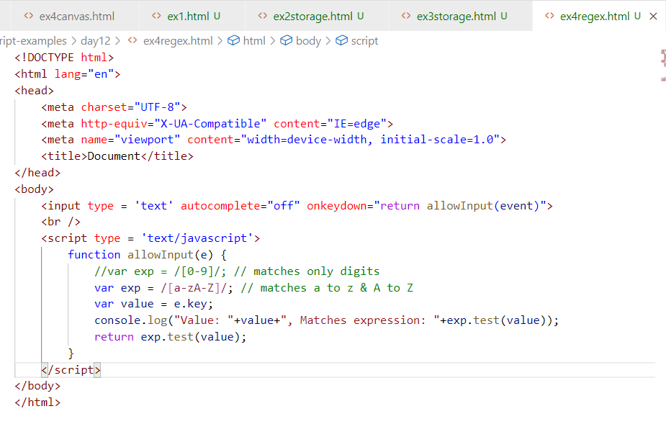

Output:

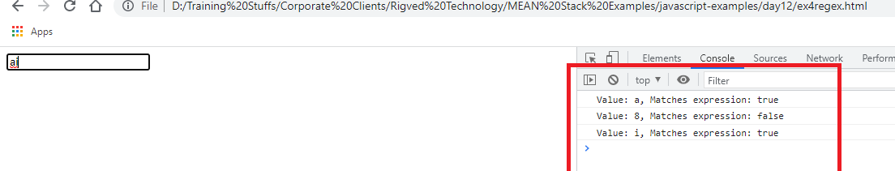

Collections:

These are datastructures which allows you to maintain the data, it is dynamic in nature, means you can increase its size at runtime, since you will be having different types of requirements to maintain the data we have collections in javascript to store the data in different ways.

1. Set: It stores only unique data
2. Map or Keyed Collection: It stores the data in key value pairs

Set: It allows you to store only unique data, not duplicates are allowed, it has a function add to store the data and remove to remove the data, size to identify the size of the Set

Keyed Collection or Map: It allows you to store the data in key value pairs, it has a function set() to store key & value, get() to retrieve the value, size to identify the size of the map

ex5collection.html

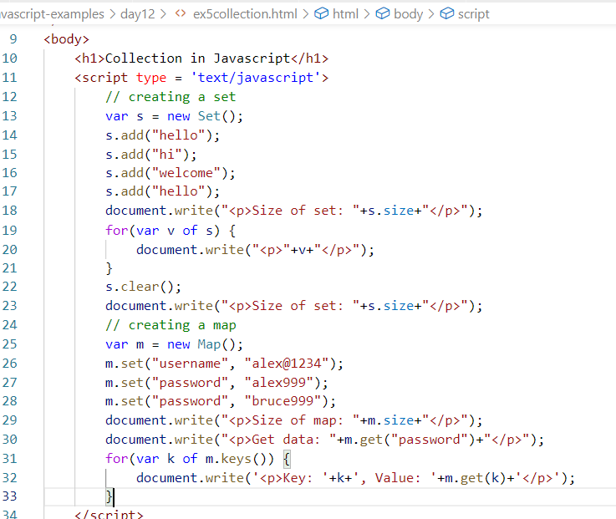

Output:

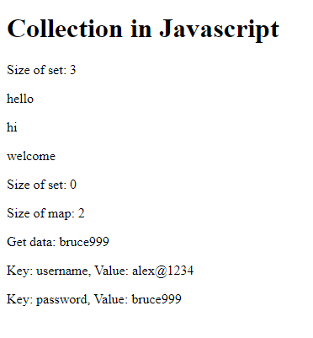

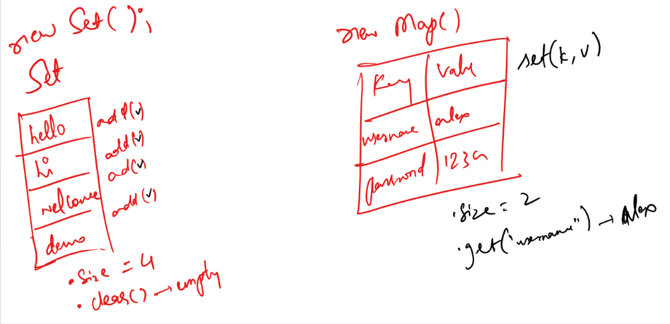

Closures / Nested functions

A function which can be called only by the closed functions so that they are not exposed outside the enclosing function

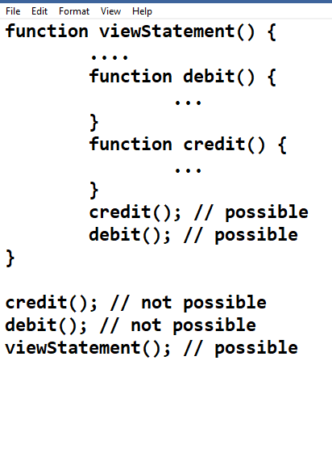

ex6closures.html

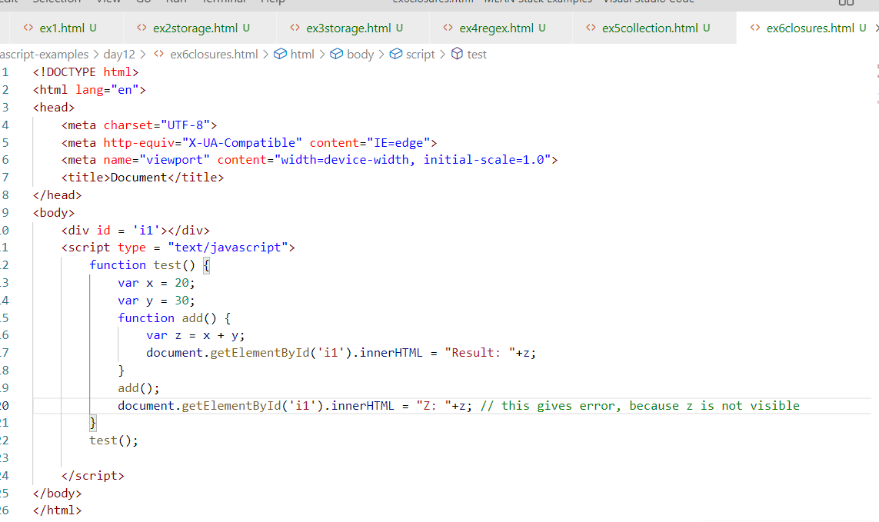

Output:

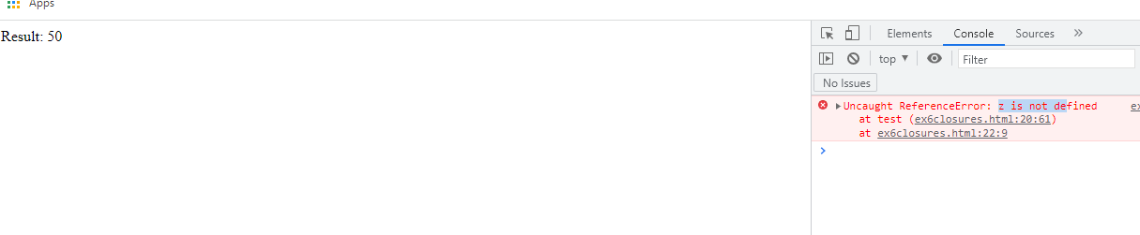

Note: You can’t call add() outside the test() function, but you can call add() only inside the test().

Error/Exception handling:

In Javascript if there’s any error then remaining part of the code wouldn’t be executed, but through handling these errors we can still execute remaining part of the code, in javascript there are some keywords that can be used in error handling

There are 4 keywords used in error handling

try, catch, finally, throw

try: Keep those codes which may generates errors, it is written with {} i.e., try { ….. }

catch: It is executed when the error occurs in the try block

finally: it is a block that is executed whether or not exceptions handled

throw: This is to manually generate error

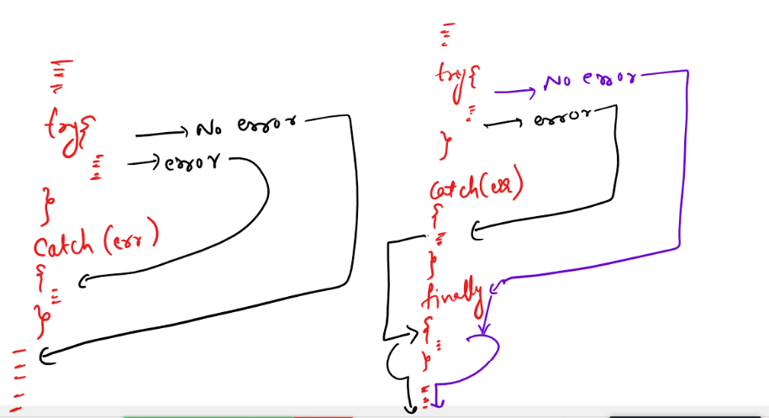

Finally is executed even when there’s no catch, but outside finally the codes are executed only if its normal flow without any error or if error is handled.

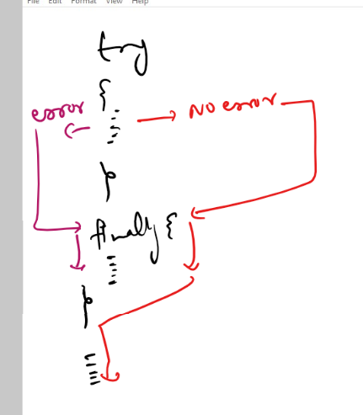

throw is used to generate the error manually whenever some condition is met.

i.e.,

try {   
 if(….) {

throw “some error message”;  
} }

catch(err) {  
 the error thrown can be handled here  
}

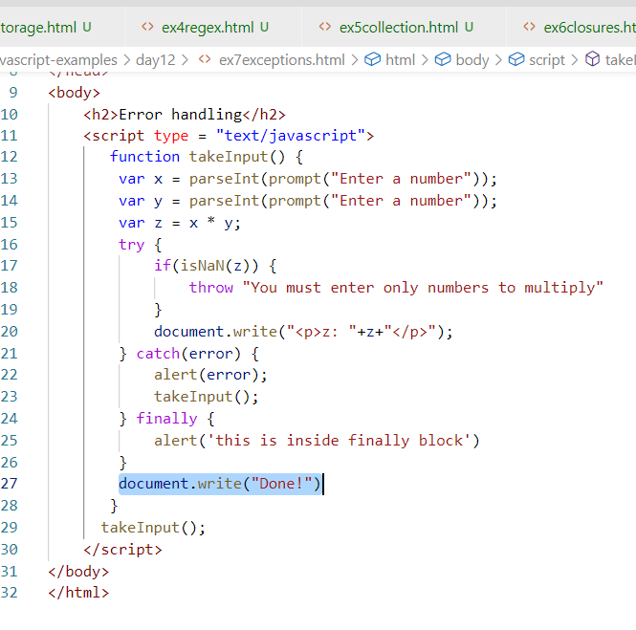

Output:

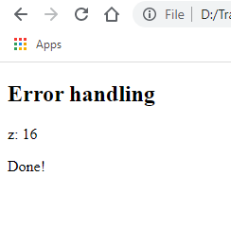

You get the result only if you enter numbers, if you enter alphabets, then the error will be generated and catch keeps asking you to enter the number.

Activity:

1. Try all the above examples
2. Create 3 html files first page takes input & second page shows the input you entered on the first page & the third page should edit an input which must be shown again in the second page

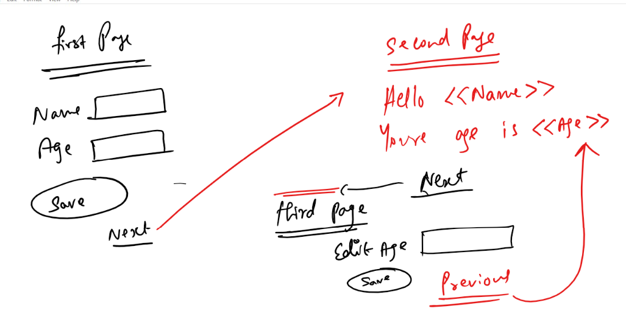

1. Create an employment form where you handle errors that are generated when you enter age

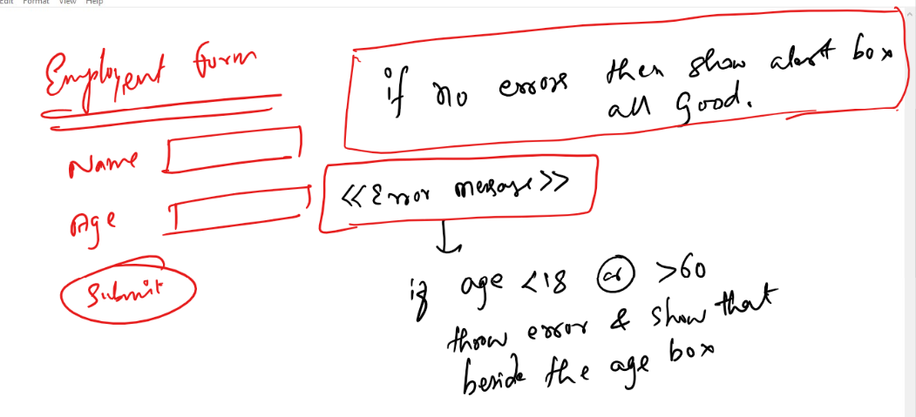

Day 13

Summary of Javascript

* Variables, Operators, Keywords, Inbuilt Objects, Functions
* Object function constructor
* Prototype - add members & achieve inheritance
* Regular expression
* Document(DOM) - access HTML elements
* CSS properties at runtime
* Canvas element - 2d shapes
* Validations - by accessing forms by name, by forms[index]
* Collections - Keyed collection (Map), Set - Array
* Webstorage - sessionStorage, localStorage
* Exception Handling - try, catch, finally, throw
* Closures - Nested functions

Callback functions:

These are special type of functions which are passed as an argument to another function, they are called after some time, it is mainly used to used to achieve asynchronous feature in the application, i.e., without waiting for the response you can do other tasks.

Ex:

setTimeout(callback, timerInSeconds)

The callback is an argument which accepts the function as an argument, the function is executed after some time mentioned in the second argument.

ex1timer.html

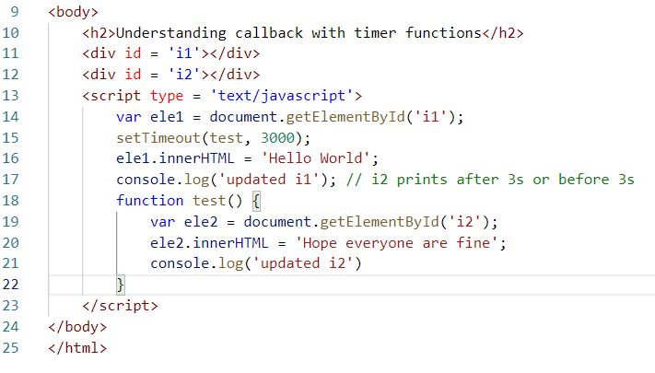

Here updated i2 would be printed after 3s, but updated i1 is printed first, because the browser keeps all the statements in the queue & pushes to callstack for execution

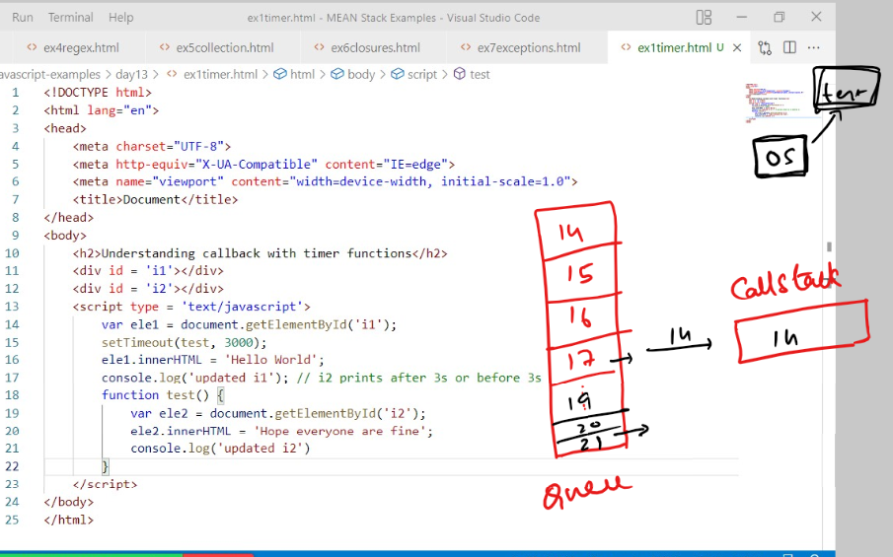

Here the 17th line goes first to the Queue which is pushed to the callstack for execution and 21st line goes to the Queue after 3s which is pushed to the callstack for execution, hence 21st line is printed later, though test is passed to the setTimeout before 17th line.

Output:

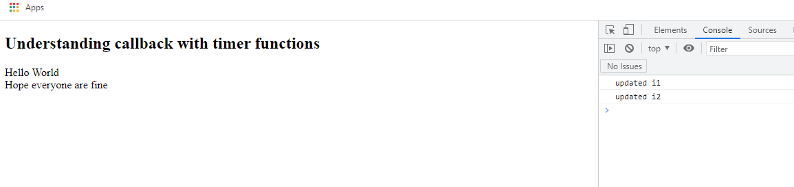

What happens if the function test() is created after setTimeout()

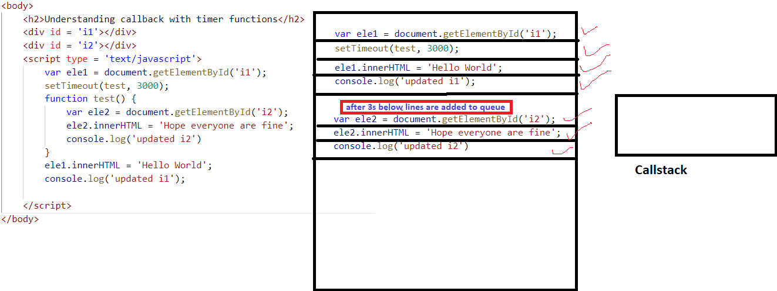

Even in this case also the Queue would add the statements in the test() after 3seconds, but if you directly call the test() the queue would look as below

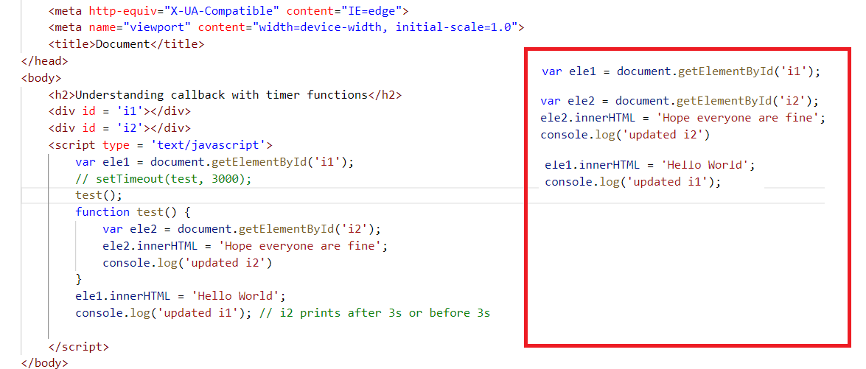

What happens if you don’t give any delay to execute test()

i.e., setTimeout(test, 0);

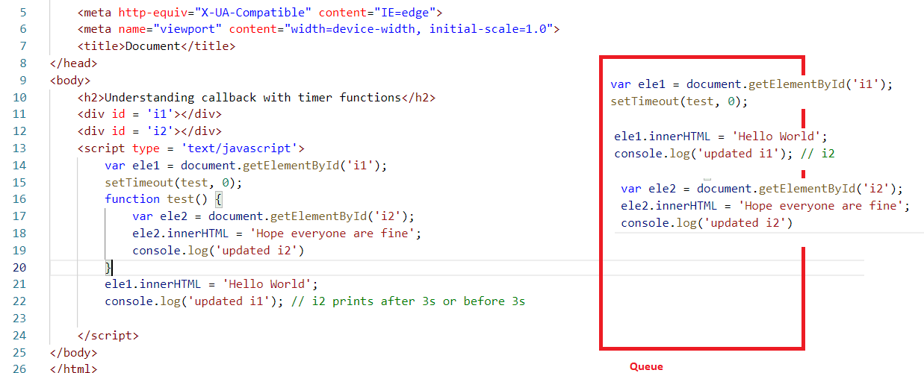

Though you have given 0 in the setTimeout, the test() function statements are added to the queue after 21st & 22nd line, which means after the 21st & 22nd line only 17th, 18th, 19th lines are executed.

Output:

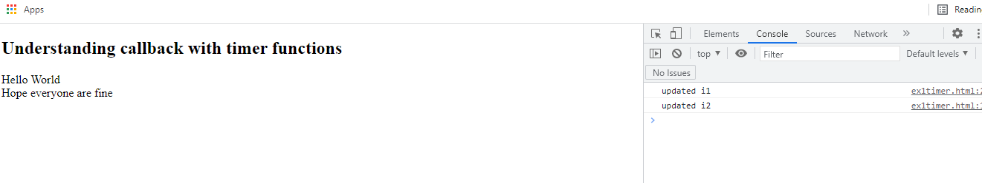

Here all the above setTimeout() code is asynchronous, means without waiting for the test() execution other statements are executed.

What would have been the problem if setTimeout was synchronous.

In that case the logics after setTimeout executes after particular time, in that case the front-end would not show any result till the time completes, you don’t getter better user experience.

Note: Here test is a callback function name, but you can pass the callbacks without explicitly creating that function

Another way to pass the callback function is

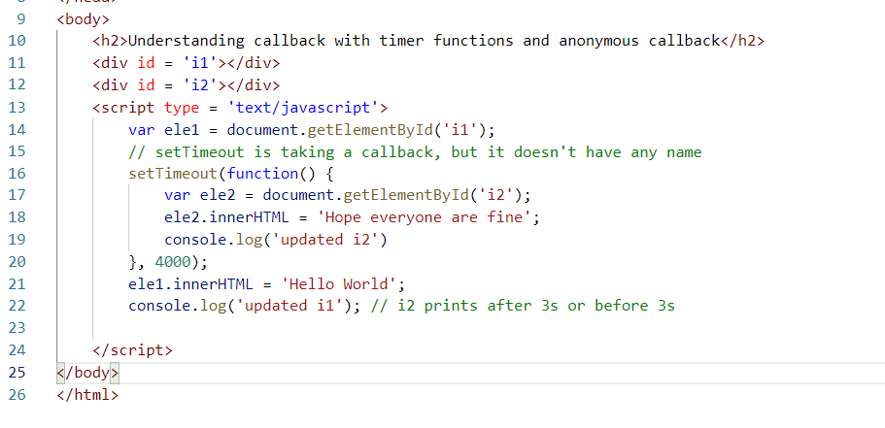

Output:

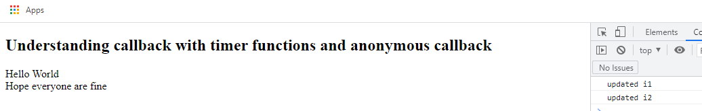

Callbacks are used in many places and also they increase the performance at the front-end as the front-end logics don’t wait for callback response to update the UI at the front-end.

Iterators functions in Javascript

We have some functions which can iterate over an array or collections, these iterators are functions which take callbacks as arguments to iterate the elements present in the collection or arrays.

They are:

forEach(callback): It is used to iterate the elements

map(callback): It is used to iterate the elements and generate another type of collection or array

For Each & map:

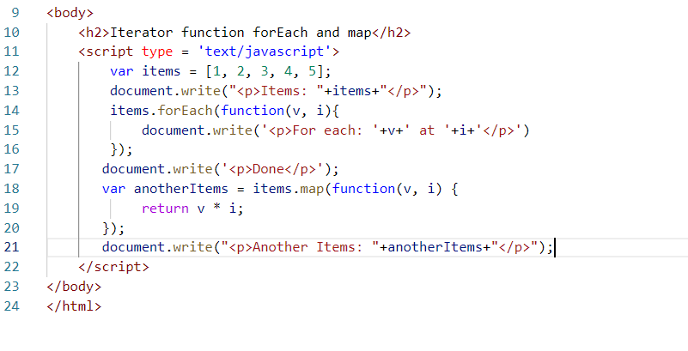

Here forEach() iterates each item present in the array and the callback is called by passing the iterated item in the 1st argument & index in the 2nd argument

Here map() iterates each items present in the array & the callback is called by passing the iterated item in the 1st argument & index in the 2nd argument, map can convert one item to another value and returns a new array.

Output:

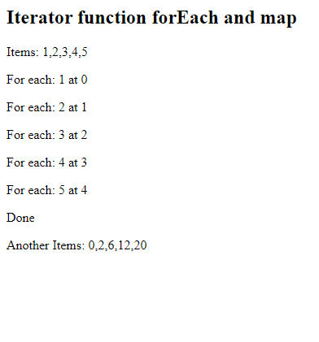

ECMAScript or ES:

It is a specification from where the Javascript is implemented, it gives all the set of rules so that Javascript, browser, Jscript and other implementations must follow

ECMAScript has provided lot of new features from the year 2015 which is termed as ES6 or ES2015, these new features simplifies syntax of javascript.

ES6 or the latest features in the years like 2015, 2016, 2017 and so on released lot of new features, they are:

New Features from ES6 onwards

* let, const, class, extends, super, constructor, static keywords
* Template literals
* Arrow functions
* Rest & Spread operators
* Object Destructuring
* Generators
* Exponential operator
* Optional chaining
* Default parameters
* Trailing commas
* New methods in Strings like padStart, padEnd
* New methods in Object like entries, values
* New Methods in Arrays like includes

Let & Const

These are two keywords which can be used now in javascript to create variables apart from var.

var: It creates global variable, even if you declare within a block, it can be accessed outside the block, i.e., for(…) { var x = 20; }, you can access x outside for loop also

let: It creates block scoped variable, if you declare in a block of code, it can’t be accessed outside the block, i.e., for(..) { let x = 20; }, you can access x only inside for loop, outside for loop if you try to access it gives error.

const: It is similar to let, which is block scoped, but const variables can’t be modified

ex4letconst.html

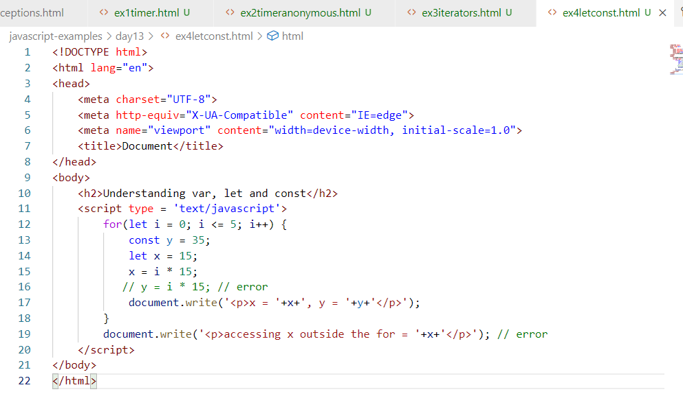

Output:

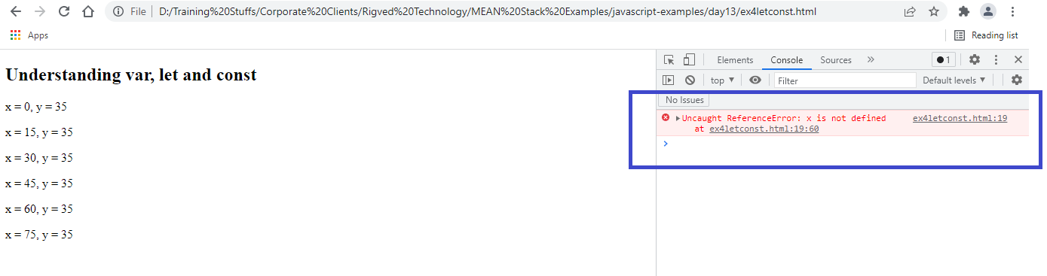

class, constructor, extends & super keywords

You can use class to create classes for the objects and the advantage is when you want some functions in the object you can create inside the class without using prototype, in a simple way you can create constructors & functions inside the object through classes.

ex5class.html

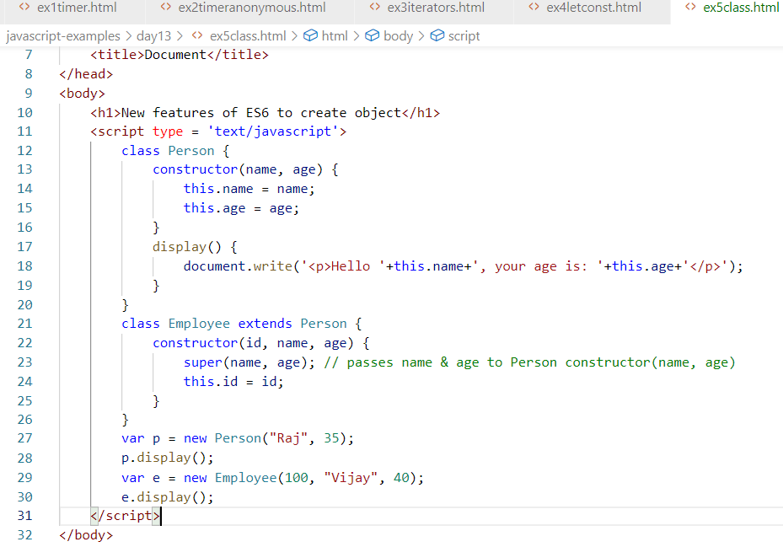

Output:

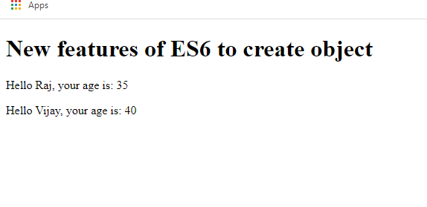

Rest & Spread Operators

These are introduced to avoid loss of data while calling the functions when the number parameters & arguments mismatch

Rest operator: It is a parameter used in the function to accept 0 or more arguments from the function call

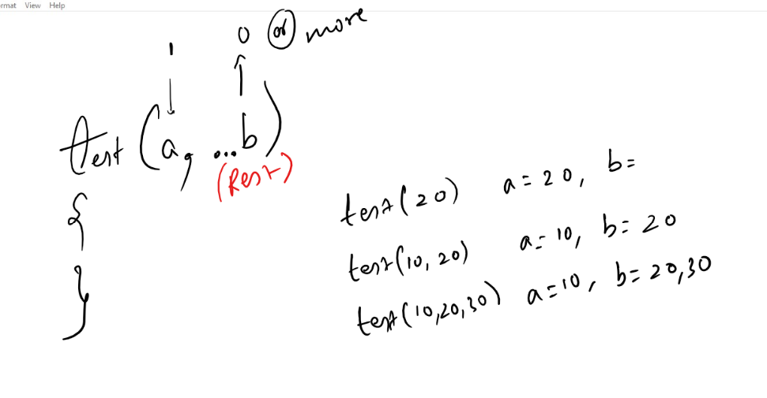

Rules on rest operator:

1. You must have maximum 1 Rest operator in a function
2. If you want rest operator in a function then it must be the last argument

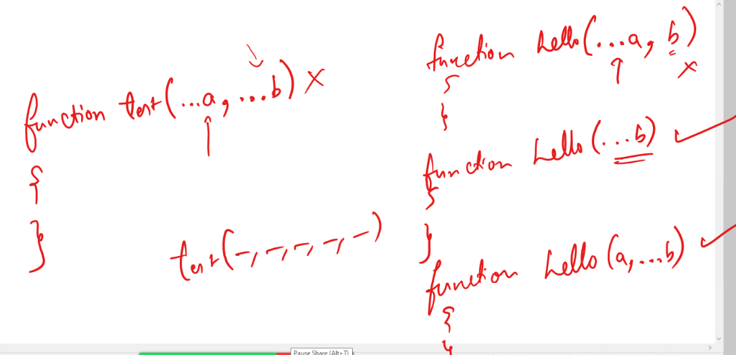

Spread operator: It is used when multiple values to be distributed across multiple parameters of the function.

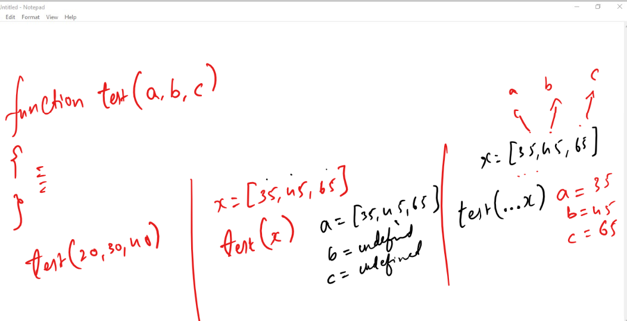

Here the test() accepts 3 parameters, it means you can spread x across all the 3 parameters via …x, however if the x has more than 3 values, then test() must have one rest operator at the end to receive rest of the values.

function test(a, b, …c) { }

If x = [12, 13, 15, 18, 29, 30]

test(x); a = [12, 13, 15, 18,29,30], b = undefined, c =

test(…x); a = 12, b = 13, c = 15, 18, 29, 30

Example without rest

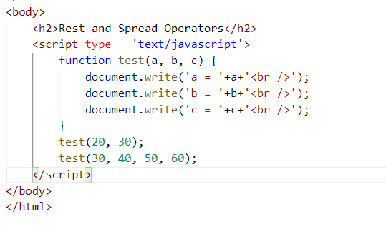

Here the call made by test(30, 40, 50, 60), will lose 60 as there is no extra parameter

Output:

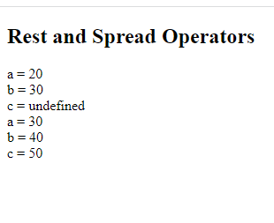

Here the value 60 is lost, to avoid that you can use rest operator

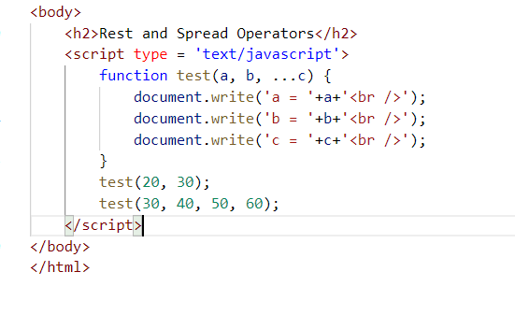

Output:

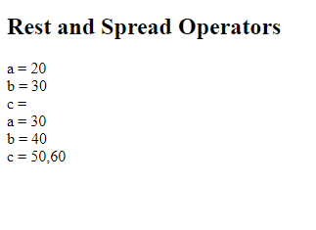

Note: It must be 3 dots only for creating rest operator

Spread operator can be used when you want multiple values to be spread across the function parameters

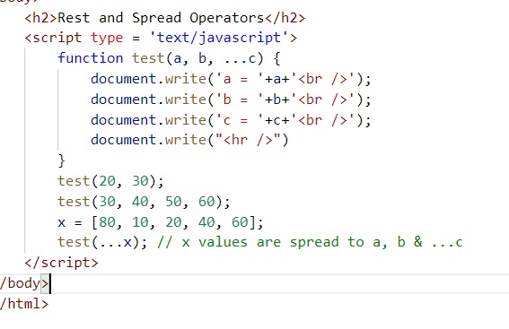

Output:

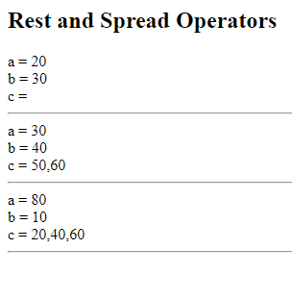

Note: By default rest operator parameter acts like an array, you can use c.length and iterate each item present in c.

Activity:

1. Try all the above activities
2. Create a function that takes 2 parameters a & …b, call this function by passing more than 3 arguments and print the sum of the numbers supplied, minimum number in those numbers & maximum number in those numbers:

Ex: if calci(a, …b) is a function then it must print below result on the   
 input: calci(10, 20, 30, 5, 15)

output: Sum = 80, Min = 5, Max = 30

Template String literals

It allows you to create strings and write javascript expression without breaking the string with + operator

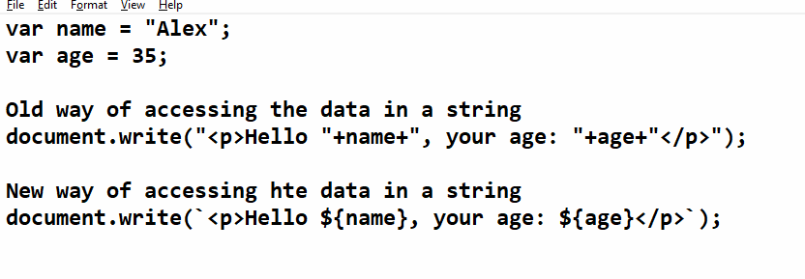

ex1templateliterals.html

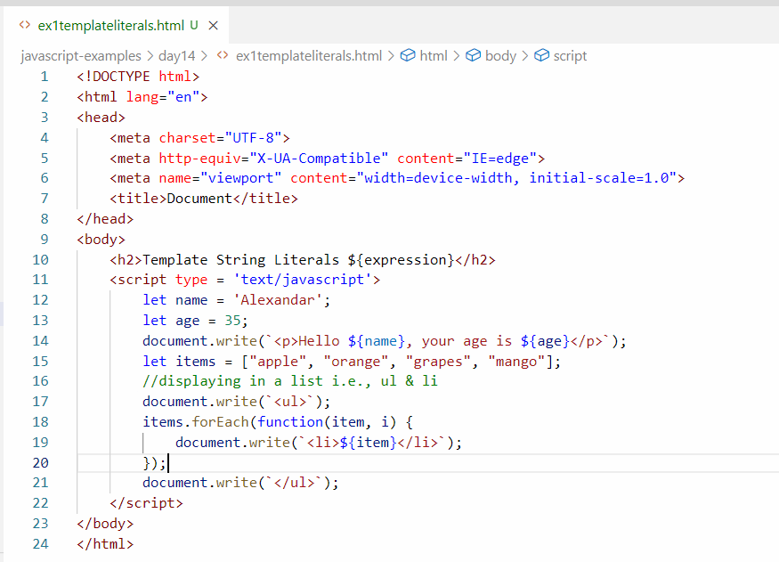

Output:

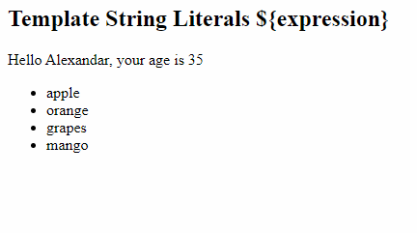

Arrow functions:

It simplifies writing the callbacks or anonymous functions by reducing some unwanted lines.

(a, b) => a + b; this returns a + b;

(a, b) => { return (a + b); } this returns a + b again

(a, b) => { console.log(a, b); return (a + b) } this prints a & b and returns a + b again

(a, b) => console.log(a, b); this prints a & b

(a, b) => { console.log(a, b); } this prints a & b, but not returning anything.

Suppose you have an anonymous function like below:

function(x, y) {  
 console.log(x+’ ‘+y);  
 return (x + y);  
}

Then corresponding arrow function to the above anonymous function is

(x, y) => {  
 console.log(x +’ ‘+y);  
 return (x + y);  
}

Suppose you have an anonymous function like below:

function(x, y) {   
 return (x + y);  
}

Arrow function will be:

(x, y) => x + y;

Suppose you have an anonymous function like below:

function (x, y){   
 console.log(x + ‘ ‘+y);   
}

Arrow function will be:

(x, y) => console.log(x+’ ‘+y);

ex3arrow.html

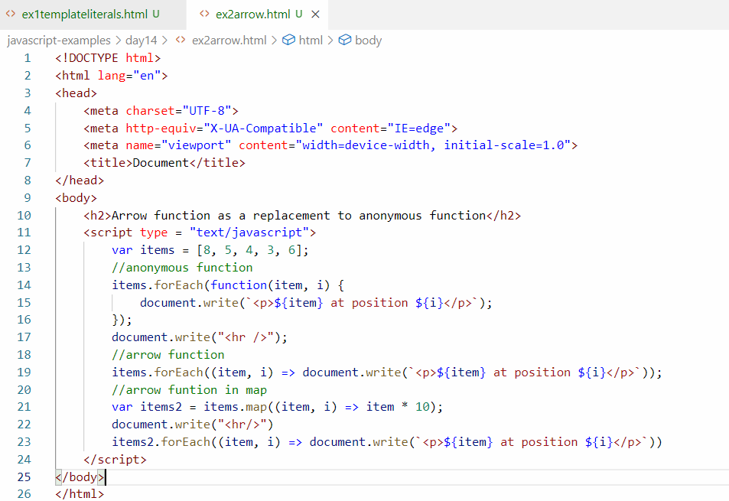

Output:

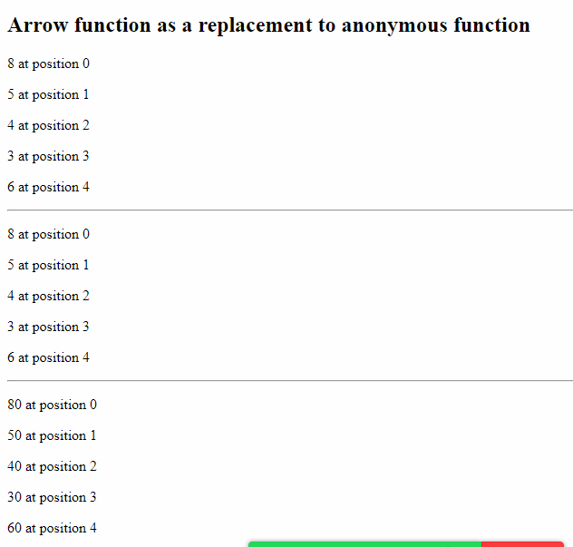

Default values to the parameters

When you have a function with parameters and when you call it you have to pass right number of arguments, else the parameters would be initialized with undefined, to avoid that you can give default value if in case the argument is not passed.

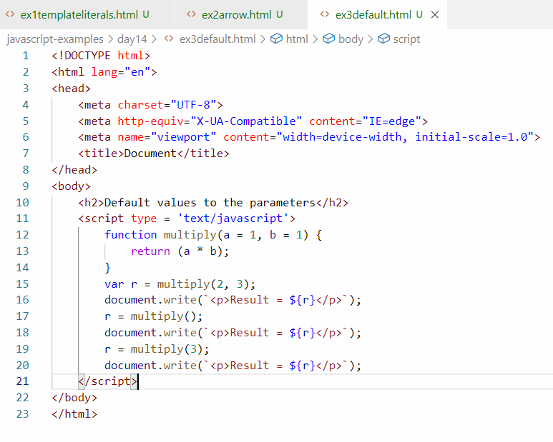

Output:

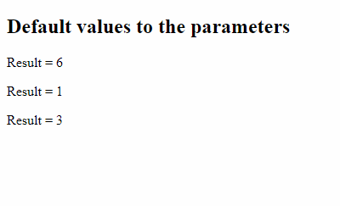

Object destructuring

It is a simplest way to create multiple variables and initialize the properties of the object in a single statement

Suppose you have an object

emp = {id: 100, name : “Raj”, salary:35000}, now if you want to assign these properties to separate variables

var id = emp.id;

var name = emp.name;

var salary = emp.salary.

The above 3 lines would create 3 variables & take properties of employee object, but in a new syntax you can create variables and assign values of the object in one line

var {id, name, salary} = emp;

Here id would get emp.id, name would get emp.name & salary would get emp.salary.

This syntax destructures the object to multiple variables.

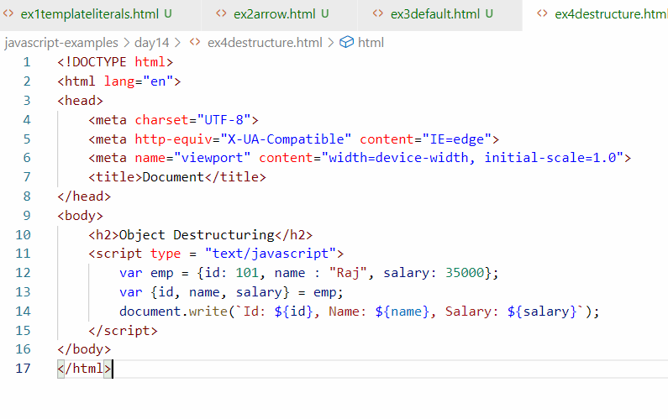

Output:

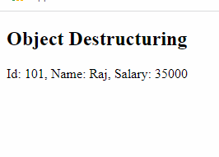

Static: It is a member of a class that can be accessed directly from the class name without creating object, it is mainly used when multiple object need common configuration

ex: multiple employees having same company name, multiple customer having same bank name and so on

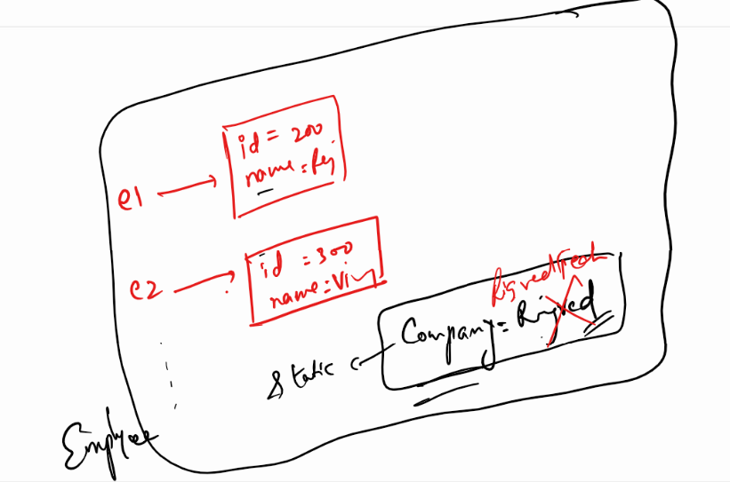

Suppose you want multiple employee objects to have a common value to a company name, then you can create a static variable company name, if you modify this company name, then it will reflect to all the employee object.

Static function: These are the functions that can be called without creating any object, usually static functions are used to perform operation on multiple objects.

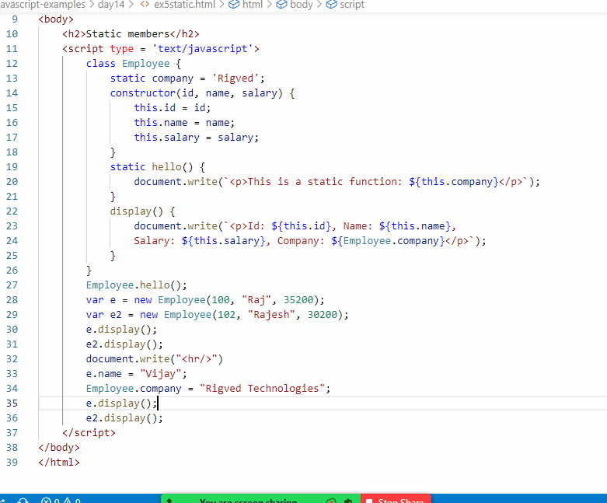

Output:

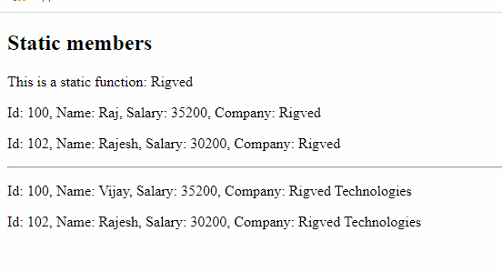

Generators

It is a special type of function that can return value by pausing its execution, it can return multiple values without completely executing the function, like returns value in instalment.

It uses yield keyword to return the value, generators mainly useful when server would give different results on the same method calls.

ex6generators.html

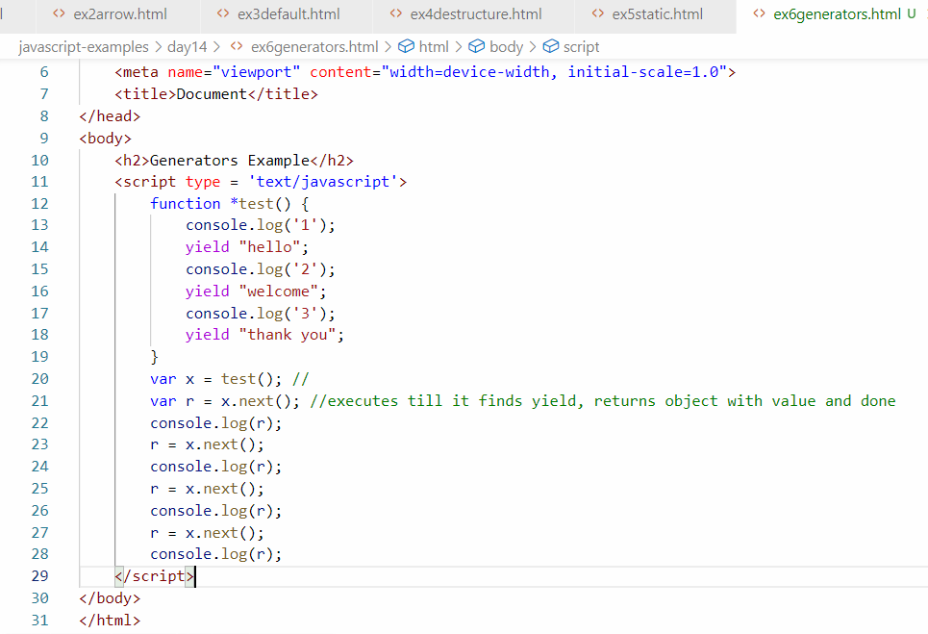

The test() function would return the generator object from that you can call next() which would execute the function until it finds yield, the next() would return the object with value & done, where value would be the value what yield gives & done would be true/false, if false, it means still the execution is not complete, when next() is called again, it starts from where it paused and executes till it finds the yield, if there’s no yield then it returns value = undefined, done = true

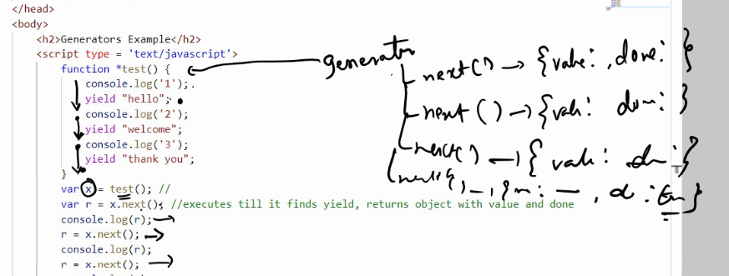

Output:

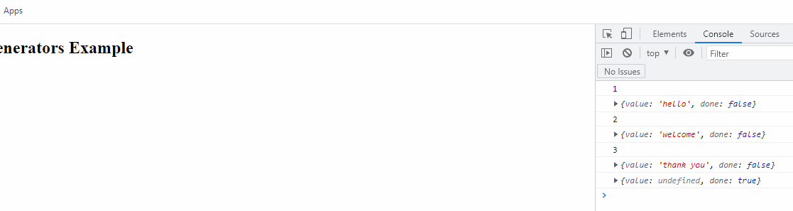

Exponential Operator

It is used to find the power of a number in a simple expression using **, it is an alternate approach of Math.pow(),

If Math.pow(3, 2) returns 9, then 3 ** 2 also returns 9

Trailing commas:

Earlier extra commas in the javascript used to give errors, but now the extra commas are removed automatically if the developers forget to add anything after command

ex: arr = [1, 2, 3, 4, ] there after 4 there’s an extra comma, earlier javascript used to give error, but now it doesn’t give any error

Arrays.includes:

It is a new function added in the array used to find whether the element is present or not

ex: fruits = [“apple”, “mango”, “orange”]

fruits.includes(“apple”); gives true

fruits.includes(“grapes); gives false

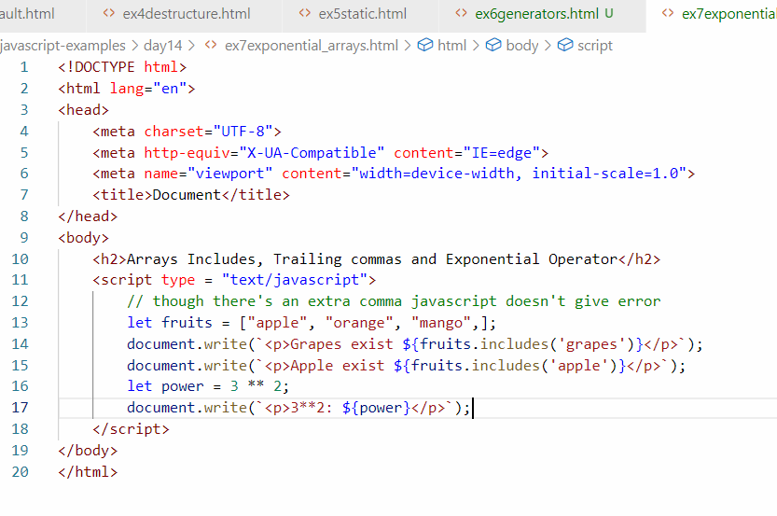

Optional Chain(?.):

This is used to avoid errors when you are accessing nested properties which may not be present in some objects

Consider the array having 3 elements i.e., 3 user objects, but one object doesn’t have address property

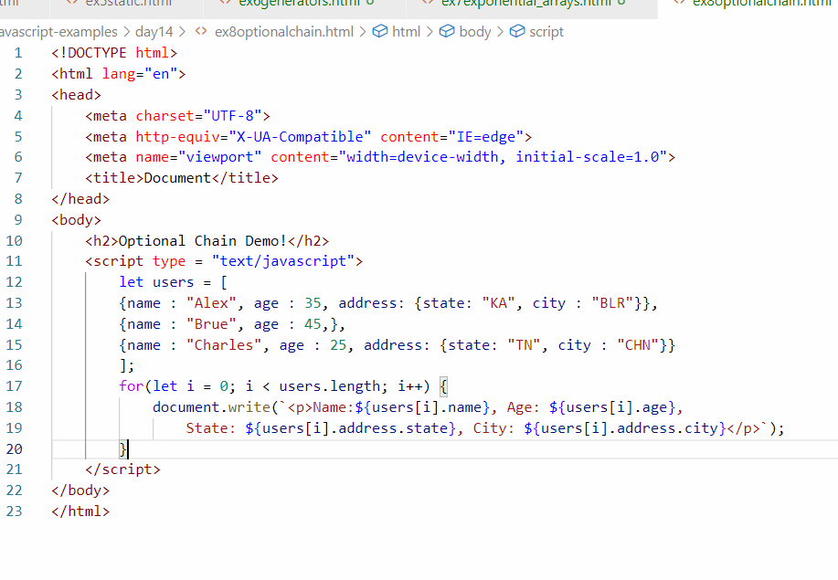

In the second iteration, i value will be 1, it will access 2nd element, so users[1].address.state would raise error, because there’s no address property in the 2nd element, if state is accessed with undefined, it will give below error, without iterating the next record the program stops.

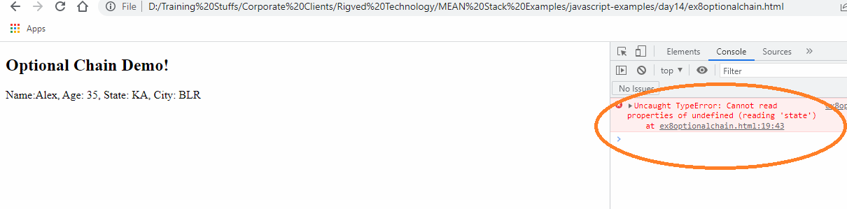

Developers used to write conditions to access the nested properties

Below is the code that avoids the error

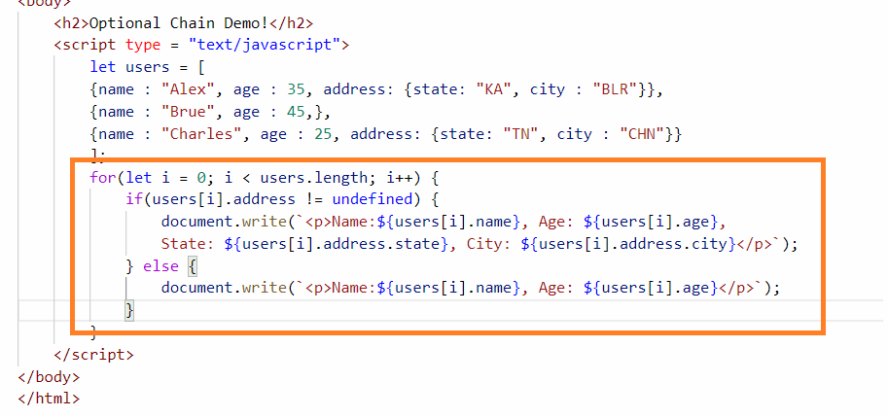

Since you have written a if & else to check undefined you don’t’ get any error,

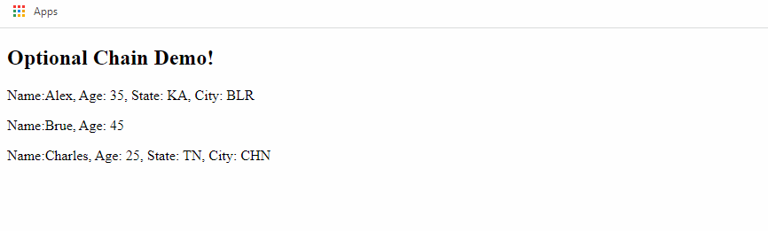

But here the if & else condition increase if there are many nested properties, hence ECMAScript came up with a optional chain syntax, which allows you to access the property only if it exists i.e.,

object?.property: Here ? means if the property after . exists then only evaluate further.

object?.property?.property?.property and so on

i.e.,

user?.address.state: This will access address if address property is present, then only it will access address.state, if address is not present it will stop evaluating

You can use ?. on all the properties without having any conditions i.e.,

user?.address?.state: Here if address present it goes to access nested property of address, if state present it will access state else it stops.

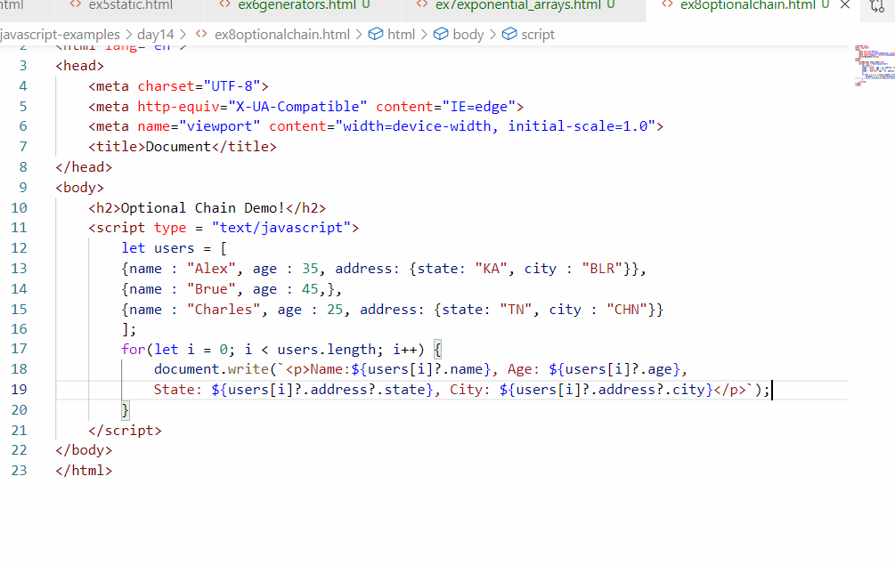

Output:

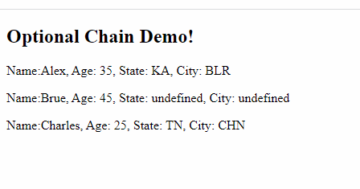

padStart and padEnd

These are the newly added functions in the javascript to add extra characters in the beginning or at the end of strings

ex9padstrings.html

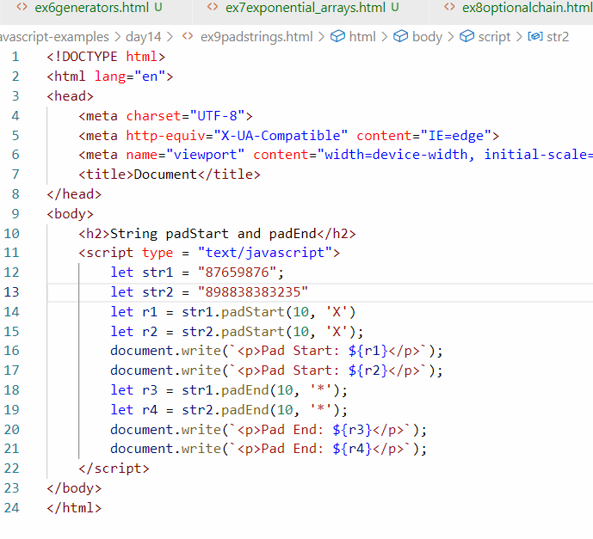

Output:

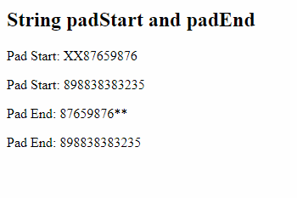

If the length of string is more than what you want to pad then the extra characters wouldn’t be padded, i.e., if string length is 10 & you want to pad ‘X’ with the size 10, then it can’t pad ‘X’ because the size of the string itself is 10

Summary of ES new features

1. let, const, class, constructor, super, extends, static,
2. Generators
3. Object Destructuring
4. Arrow functions
5. Template strings
6. Exponential operator
7. Trailing commas
8. Arrays includes
9. padStart & padEnd
10. default values
11. optional chain

Activity:

1. Try all the ES new features
2. Using Template strings & other new ES features if required create a table for an array of users given below:

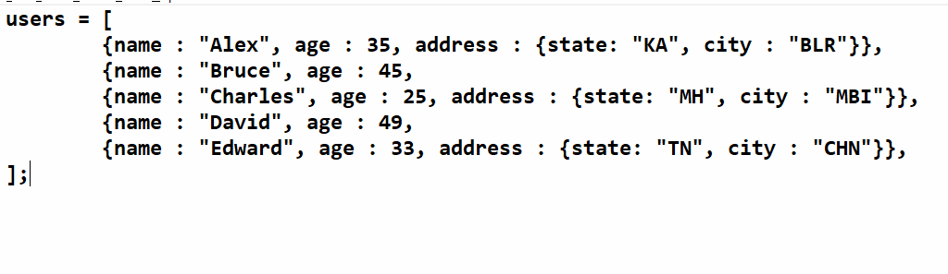

Output must be in a table which will have 4 columns, wherever address is not there it can print undefined in the state & city columns

1. Generate a random number of 6 digits and pad extra 0’s to the beginning so if the random number is not 6 digit, it happens when the random number gets 0 after .

i..e, if random number is 0.00323529, then the integer form wouldn’t be 003235, instead it will be 3235, you need to pad 0 and display 003235